BIPM Technical Memorandum, TM182_Improve-Long-Link-Asia-Europe.doc
V0.0: 28/11/2010

Improve Very Long UTC Time Links and the BIPM Calibration Scheme
- Example of the BIPM Pilot Study: Strengthening Asia-Europe UTC Time Links

Z. Jiang, G. Petit, F. Arias, W. Lewandowski and L. Tisserand
zjiang@bipm.org
Department of Time, Frequency and Gravimetry
Bureau International des Poids et Measures Pavillon de Breteuil (BIPM)
F-92312, SEVRES CEDEX, France

Résumé:

TW and GPS PPP are the major techniques in UTC time transfer. Each has its advantages and is indispensable. However, since last year, two phenomena seem contrast rise: the quality of TW degrades and that of the GPS PPP is improved. The best solution is not to give up the TW and replace it by GPS PPP but to combine the two techniques. This is the strategy of strengthening the Asia-Europe very long baselines for UTC time transfers.
We discussed in this TM:
- PPP assisted direct and indirect TW time transfer : combination TW+PPP
- PPP assisted calibration: the BIPM scheme TW-PPP
- The expected uncertainties
u_{B} ≤ 2 ns
u_{A} ≤ 0.3 ns
The prospect is encouraging. The methods applied in this TM can be extended to the whole UTC time transfer worldwide network through coordination with Euramet and APMP. The uncertainty is expected to be significantly ameliorated globally.

1. Introduction 3
2. Present status of TW time transfer 4
Fig. 2.1 The 68 official UTC/TAI links in Des. 2010 4
Fig. 2.2 The time transfer techniques used in UTC/TAI time transfers in Des. 2010 4
2.1 Participation of TW in UTC 5
2.1.1 USNO-PTB X band link 5
Fig. 2.3 Comparison of the TDev of USNO-PTB TW X band and KU band links 5
2.1.2 The KU band links 5
Fig. 2.4 Evolution of the TW participants in UTC computation since last 7 years 6
2.2 The evaluation of the stability of TW in UTC 6
Fig. 2.5 Three major UTC TW links and the comparison of the TDev of last three years 7
Fig. 2.6 10 years’ evolution of the uncertainties of the UTC time links 7
3. The BIPM pilot study: how strengthen the inter-continental links ? 8
Fig. 3.1 Asia-Europe TW links via AM2 9
3.2 Combination of the direct TW and GPS PPP 9
Fig. 3.2 Comparison of the TDev between TW KU band, TW X band, GPS PPP and the combination of the TW KU and GPS PPP over the baseline USNO-PTB 9
Tab 3.1 Gains of the combination obtained by comparison with the TW X band link 9
3.2 Combination of the indirect TW and GPS PPP 10
Fig. 3.3 Demonstration of an indirect link and its combination with GPS PPP 10
4. The Asia-Europe very long time link calibrations 11
4.1 The definition of the total delay 11
4.1.1 The total delay of a GNSS receiver 11
Fig. 4.1 The total delay of a GNSS receiver (Dly_{R}) at Lab(k) 12
Why we should use the “Total Delay” ? 12
Tab. 4.1 The delays of the BIPM cable C101 measured by different laboratories 12
Tab. 4.2 Discrepancies of the delays of other BIPM cables measured by different laboratories 13
4.1.2 The total delay of a time link 13
Fig. 4.2 The total delay of the link Lab(i)-Lab(j): Dly_{L} (i-j)=Dly_{R}(i)-Dly_{R}(j) 13
4.2 The BIPM scheme to calibrate a Dly_{L} 13
4.2.1 Step 1: Start at BIPM 14
Fig. 4.3a Step 1a: The Side-by-side common-clock short-baseline set-up and the total delay Std(1)-Std(2): Dly_{L}(1-2)=Dly_{R}(1)- Dly_{R}(2) 15
Fig. 4.3b Step 1b: The Side-by-side common-clock short-baseline set-up and the total delay Std-Ref_{B}: Dly_{L}(Std_{B}-Ref_{B})=Dly_{R}(Std)-Dly_{R}(Ref_{B}) 16
4.2.2 Step 2: Go to PTB 16
Fig. 4.4 Step 2: The Side-by-side common-clock short-baseline set-up and the total delay Std_{B}-Ref_{PTB}: Dly_{L}(Std_{B}-Ref_{PTB})=Dly_{L}(Std_{B})- Dly_{R}(Ref_{PTB}) 17
4.2.3 Stpe3: Go to Lab(k) 17
Fig. 4.5 Step 3: The Side-by-side common-clock short-baseline set-up and the total delay Std_{B}-Ref_{k}: Dly_{L}(Std_{B}-Ref_{k})=Dly_{R}(Std_{B})-Dly_{R}(Ref_{k}) 18
4.2.4 Step 4: Closure at BIPM 18
Fig. 4.6 Step 4 closure measurement set-up: The Side-by-side common-clock short-baseline set-up and the total delay Std_{B}-Ref_{B}: Dly_{L}(Std_{B}-Ref_{B})=Dly_{R}(Std_{B})-Dly_{R}(Ref_{B}) 18
4.3 Discussions 19
4.3.1 Convert a link calibration to a GNSS receiver calibration 19
4.3.2 Convert the “relative” receiver calibration to the absolute one 20
4.3.3 Record the total delay in the CGGTTS header 20
4.3.4 Some important remarks 21
4.3.4.1 Triangle closures: the redundancy in the BIPM calibration scheme 21
Fig. 4.7 Redundancy of the BIPM calibration scheme by the simultaneous calibration measurements 21
4.3.4.2 A remark on the absolute receiver calibration 21
4.3.4.3 The BIPM scheme is a unified calibration 22
4.3.4.4 The BIPM scheme is more accurate and less manpower, time and money consuming 22
4.3.4.5 Simple versions of the BIPM scheme 22
4.4 The uncertainty 23
4.4.1 The u_{B} of a UTC link Lab(k)-PTB 23
4.4.2 Aging of the u_{B} 23
Tab. 4.4 Evolution of u_{B} (in ns) increasing with time as a random walk process 23
4.5 The Experiment set-up 24
4.5.1 General set-up 24
Fig. 4.8 Configuration between the pulse distributor linked with the master clock and the receivers of Ref_{PTB}, Ref_{Lab(k)} and Std_{BIPM} 24
4.5.2 Two examples of the experiment set-up at PTB and NICT 25
Fig. 4.9 Configuration at PTB between the pulse distributor linked with the master clock, the reference receiver Ref_{PTB} and the BIPM standard Std_{BIPM} (based an earlier calibration tour with TW no show) 25
Fig. 4.10 Configuration at NICT between the pulse distributor linked with the master clock, the receivers of Ref_{NICT} and the Std_{B} (based on an earlier calibration tour with TW no show) 25
4.6 Criterion of the participants of the pilot experiences 26
Tab. 4.5 EIRP and Elevation of the AM2 TW satellite from the Labs 26
Fig. 4.11 Coverage of the AM2 TW satellite and the EIRP/dBW 27
Fig. 4.12 Up-plot: comparison of the GPS PPP (circle) and TW (cross) links on the baseline OP-PTB for UTC1009; Low-plot: different of TW-PPP 27
4.7 The schedule of the Asia-Europe pilot experience 27
4.8 Comparison between the new BIPM scheme and the so far BIPM differential receiver calibration 28
Tab. 4.5 Comparison of the new BIPM calibration scheme and the traditional one 28
5. Summary 28
Reference 29
Annex I: Quality of the indirect TW links 30
Fig. A1 Indirect links over the baseline OP-PTB (a) Time difference (b) Frequency stability 31
Annex II: Dr. Arias to the Labs involved: Announcement of the BIPM pilot study plan 32

1. Introduction
Use of the GNSS carrier phase information in precise time transfers is the most import event in recent years in UTC generation and is comparable to the use of TW 10 years ago. Both have being produced significant progresses in UTC computation and trigged the studies in new methods in accurate time-frequency transfer, e.g. combination of the TW and GPSPPP and GPSPPP assisted time link calibration etc. Through example of strengthening the Asia-Europe UTC time links, we discuss how to improve the very long UTC time transfer baselines.
Asia region is very active in the TW in the history and at present. However for numerous raisons, the TW data, particularly the redundant data, are not fully used in the UTC computations. The satellite AM2 covers a part in Europe and almost all the Asia region (Fig. 4.11) is a good base to strengthen the Asia-Asia and Asia-Europe time/frequency links. This requires new numerical methods.
The TW time transfer makes an important role in the UTC generation of which the contribution from the Asia regions is increasing. However the state-of-the-art of the TW does not allow us an optimal estimation of its future: the participant is decreasing, the measurement uncertainty u_{A} is degrading (> 0.5 ns) and the calibration uncertainty u_{B} is keeping at the low level of 5 ns [1].
On the other hand, the GPS PPP demonstrates its high quality, particularly in its measurement uncertainty u_{A} of 0.3 ns.
We propose in this TM strengthening the very long Asia-Europe UTC time links by combining the TW and the GPS PPP. Technically, the advantages of the combination have been proven in [2]. The combination can use the direct TW links but also the indirect TW links. The combination increases therefore both the uncertainty of the time links and the TW participants in the UTC generation.
Another important issue is the time link calibration. There are two kinds of concepts in the calibration in time transfer practices:
a) Receiver calibration
b) Time link calibration
As discussed in [3], the u_{B} in Circular T [1] is the calibration uncertainty of UTC-UTC(k), of which the dominant part is in fact the time link uncertainty. The so far TW calibration is based on the b) concept, i.e., the time link calibration and that is why the u_{B} of TW link reaches 1 ns [4] while the GNSS receiver calibration using the concept a) [5] remains still in 5 ns. Let us underline: for UTC computation, the calibration concept b) is required. In the following discussion, we will point out that the gains of the new BIPM calibrations scheme are not only in the uncertainties u_{B} but also in the organization facility and the costs in maneuvers and economy.
Since 2007, the investigations of the GNSS link calibration have been made to apply the concept b). [6] of May 2008 used the TW links to calibrate all the GPS PPP links and [7] of Dec. 2008 used also TW link to calibrate the GPS MC time link BEV-PTB, which is at present the only concept-b)-calibrated GPS link and its u_{B} is the lowest 3 ns since Sept. 2008 (CirT 247) in all the GNSS links of the BIPM Circular T. [8] made also mathematic study and proved that we can convert the link calibration to the absolute receiver calibration if at least one of the receivers in the linking network is absolutely calibrated. [8,9,12] generalized the link calibration to all the UTC time link calibrations and proposed the unification of the UTC time link calibrations. [10, 11] proposed a link calibration scheme using a traveling GPS receiver and realized the link calibrations on the baselines ROA-PTB and CH-PTB.
All these theoretical and practical works output encouraging results. Based on these earlier studies and towards a standardization of the UTC time transfer calibrations, this TM proposes the BIPM calibration scheme as the example, we investigate the BIPM pilot study program.
Below, Section 2 presents the status of the TW in UTC computation and points out that it is a necessity to combine TW with PPP to guaranty the quality of UTC time transfer; Section 3 demonstrates the details in the BIPM pilot study; Section 4 focuses on the set-up of the BIPM calibration scheme and finally in the Annexes, the discussion on the indirect TW and the announcement of Dr. Arias the BIPM pilot study on strengthening the Asia-Europe time links.
The goal of the pilot study is to reach to the expected uncertainties in the UTC time links:
u_{A} ≤ 0.3 ns
u_{B} ≤ 2 ns
If this pilot study will be successful, the experiences, mainly the combination of TW+PPP and the BIPM calibration scheme will be extended to the all the UTC time links, in particular, to the very long inter-continental baselines. An urgent issue would be the triangle PTB-USNO-NIST, where found of the calibration conflictions was declared [13].

2. Present status of TW time transfer
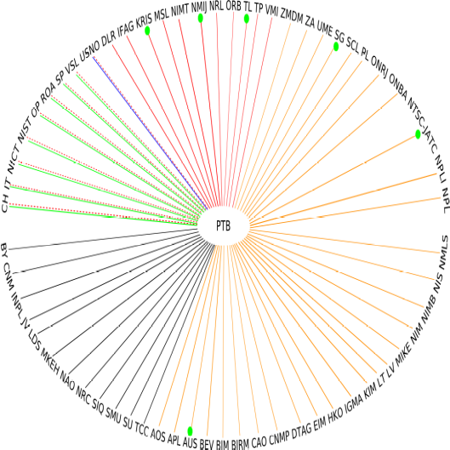

Fig. 2.1 The 68 official UTC/TAI links in Des. 2010
GPSSC 3 (4%)
GPSMC
28 (42%)
GPS3 8
(12%)
GPSPPP
18 (26%)
Other
2 (3%)
TW 8
(12%)
GLN 1

Fig. 2.2 The time transfer techniques used in UTC/TAI time transfers in Des. 2010
BIPM computes monthly more than 200 time links of multi-techniques: TW, GPS MC, GPS SC, GPS P3, GPS PPP and GLN etc. However, there are only 69 national UTC laboratories composing 68 official UTC time links (Fig. 2.1 and 2.2). The present strategy is that one link one technique and the order of priority of the techniques is TW, GPS PPP, GPS P3, GPS/GLN MC and GPS SC. The rich redundancy is not used. The major techniques used is still the 28 GPS C/A code MC time transfer witch makes 42% of the total 68 UTC links. The 18 GPS PPP links make 26%, 8 GPS P3 12%, 1 GLN link between SU-PTB.
The 8 TW links take 12% of the total 68 UTC links. In the follows, we will present the evolution of the role of TW in UTC computation by the three indicators:
- The participation of TW in UTC
- u_{A}: its short term stability
- u_{B}: its calibration uncertainty

2.1 Participation of TW in UTC

2.1.1 USNO-PTB X band link
The most important loss in TW in 2010 is the switch off of the USNO-PTB TW X band link after 5 and half years’ service in UTC since Jan. 2004 to 5 June 2010, Mjd 55365. Already, the USNO is the most contributing lab to UTC with its 19% clocks and 28% clock weight and the X bans link is the most accurate and precise link. Regular calibrations certified its accuracy and as illustrated in Fig. 2.3, its stability is largely better than the KU band. Not only has it contributed to the UTC generation but also to the scientific studies, such as: GPS P3, GPS AV, GPS PPP, GNSS+TW combination, TW network transfer and UTC link calibrations. All these new techniques developed at BIPM in the recent years were tested firstly on the USNO-PTB baseline using the X band data.
3h
4h
12h
day
3day
week
2.8
2.7
3.6
4.6
5.5
7.7
10.4
h
1.3
1.4
1.9
2.7
4.0
5.0
6.3
8.3
3.4
3.8
4.2
4.6
5.0
5.4
5.8
-10
-9.8
-9.6
-9.4
-9.2
-9.0
-8.8
Ku band
TDev./ s⁻¹⁰
USNO-PTB
TW0901
Mjd 54829-54859
X band
σ_{x}

Fig. 2.3 Comparison of the TDev of USNO-PTB TW X band and KU band links

2.1.2 The KU band links
Fig. 2.4 shows the number of the TW labs took part in the UTC computation. There the participating number is the yearly average before 2010 and that of monthly average since Jan. 2010. The population reached its summit in mid-2009 when there were 12 TW labs and is stabled at 8–9 labs since 2010. The population of the TW in UTC is decreasing. It is a big pity that some important TW Labs, such as, USNO (X band), TL and NICT gave up.

Number of TW links in Circular T since 2004
6
7
8
8
10
12
10
8
9
9
9
9
8
0
2
4
6
8
10
12
14
2004-
08
2005-
06
2006-
06
2007-
06
2008-
06
2009-
06
2010-
01
2010-
02
2010-
03
2010-
04
2010-
05
2010-
06
2010-
07

Fig. 2.4 Evolution of the TW participants in UTC computation since last 7 years

2.2 The evaluation of the stability of TW in UTC
The dominant error source in TW is the diurnals. Fig. 2.5 illustrates three major UTC links: CH-PTB, USNO-PTB and NIST-PTB and the comparisons of the time stability of last three years. It is clear, particularity after switched to the satellite T-11N, that the diurnals become stronger. The instability is increasing. The quality of the TW links is globally degrading.
-17.3
-19.0
-18.1
-16.7
-14.3
-15.9
55285
55290
55295
55300
55305
55310
55315
-60
-50
-40
-30
-20
-10
0
10
20
CH-PTB TW LINK 1004
Diurnals present
σ = 0.497 ns
ns
3.6
5.6
4.3
2.6
3.3
5.2
9.1
2.1
2.3
3.2
4.3
6.1
9.0
16.1
2.0
2.1
2.9
3.2
3.7
4.7
5.5
d/8
d/4
d/2
day
3d
week
-10.0
-9.8
-9.6
-9.4
-9.2
-9.0
-8.8
σ_{x}
Averaging time
TDev. / s⁻¹⁰
TW CH-PTB
3 year comparison
0804/0904/1004
1004
0904
0804
diurnals

-27.0
-23.1
-22.6
-20.4
-19.5
-20.7
55285
55290
55295
55300
55305
55310
55315
-60
-50
-40
-30
-20
-10
0
10
20
USNO-PTB TW LINK 1004
Diurnals present
σ = 1.270 ns
9.7
10.4
13.3
8.0
7.6
10.7
11.3
4.5
5.5
6.1
5.5
6.7
8.9
10.3
2.2
2.3
2.9
3.4
3.9
5.4
3.2
*
d/8
d/4
d/2
day
3d
week
-10.0
-9.8
-9.6
-9.4
-9.2
-9.0
-8.8
-8.6
-8.4
-8.2
-8.0
Averaging time
σ_{x}
TDev. / s⁻¹⁰
TW USNO-PTB
3 year comparison
0804/0904/1004
1004
0904
0804
1.5
2.6
2.8
4.6
4.2
4.7
55375
55380
55385
55390
55395
55400
55405
-40
-30
-20
-10
0.0
10
20
30
40
NIST-PTB TW LINK 1007
Diurnals present
σ = 0.272 ns
diurnals
2.1
3.1
3.3
1.8
1.5
2.2
2.3
4.0
4.8
5.6
5.0
6.0
8.1
15.2
2.0
2.1
3.0
3.3
4.0
4.5
5.2
d/8
d/4
d/2
day
ddd
wk
-10.0
-9.8
-9.6
-9.4
-9.2
-9.0
Averaging time
σ_{x}
TDev. / s⁻¹⁰
TW NIST-PTB
3 year comparison
0804/0904/1004
1007
0904

Fig. 2.5 Three major UTC TW links and the comparison of the TDev of last three years
(Top CH-PTB, Middle USNO-PTB and Bottom NIST-PTB)
Uncertainty
Type A
Type B
/ns
4
3
0
2
1
5
7
6
u_{B} /CA/GNSS
u_{B} /C|P/GNSS/TW
MC/CV
MC/AV
P3/AV
TW/PPP
u_{A}
u_{B}/TW
GPS SA ON | Off
2000 2003 2005 2009 2010
PPP
TW

Fig. 2.6 10 years’ evolution of the uncertainties of the UTC time links
An unavoidable difficulty in the calibration of the intercontinental very-long baselines is that, due to the double transponders on satellite board, the TW links are not possibly calibrated by a portable ground station, as did in inner-Europe and inner-Asia-region. So all the inter-continental baselines, except USNO-PTB X band, were calibrated through GPS and therefore have their u_{B}(TW)=u_{B}(GPS)=5ns.
Fig. 2.6 is the 10 years’ tendency of the evolutions of the uncertainties u_{A} and u_{B}. Compared with 10 years ago, the uncertainties are reduced almost an order. However, since 2009, both the u_{A} and u_{B} (in Europe) of TW are increasing.
To conclude above, the present situation is that
- after leaving TL-PTB, USNO-PTB X band and NICT-PTB etc. the participants of TW in UTC is decreasing;
- u_{B} has not be improved for the inter-continental baselines and slightly increasing in inner-Europe baselines;
- u_{A} is increasing with the diurnals stronger
The quality of TW is globally degrading since 2009. It is not very clear to where the situation leads us, unfortunately this trigged some UTC labs decided to switch their official UTC links from TW to GPS. TW is facing a serious challenge since its introduction into UTC in about 1999.

3. The BIPM pilot study: how strengthen the inter-continental links ?
The robustness of the UTC time links is based on the multi-techniques: TW and GNSS. A balance of both in UTC generation is important. Because TW has in several aspects the advantages vs. GNSS and there are few TW links (Fig. 2.1, 2.2), the present priority strategy is the direct TW links first and then GNSS. Only one link, either a TW or a GNSS, is used.
On the other side, there is a large number of high quality redundant TW data, such as, the indirect TW links and GPS PPP links. The basic idea of strengthening the Asia-Europe time links is the fully use these redundant data to improve the u_{A} of time transfers and u_{B} of the calibrations.
The methods have been fully discussed in [2, 8, 9 and 12]. The related programs have been developed and installed in the UTC/TAI computation software package Tsoft. Hereafter (Sections 3.2, 3.3) is only a quick recall of the results, cited from the reference papers.
We take always the Asia-Europe baseline as example. Fig. 3.1 is the Asia-Europe TW network via the Russian satellite AM2 which covers most of the Asian TW labs and many European labs including PTB. At present PTB, NICT, TL, NIM and NTSC are operational; SU, NPLI, KRIS and NMIJ will join in later; VSL and OP operated TW links with Asia via satellite IS-4 until it switched off and hopefully return through another satellite. AM2 however is too low for them. Except for NPLI, all labs have the geodetic GPS receivers and therefore the PPP facility. A few labs have also the GLN facility.
The key point to strengthen the Asia-Europe links is to use the redundant data, mainly: the indirect TW links (the non UTC TW links) and the GPS PPP. The whole idea is based on the assistance of GPS PPP: by adding PPP (TW+PPP, sections 3.1 and 3.2) we combine TW and PPP to improve the time transfer and by differential PPP (TW-PPP, section 4) we make the calibration.

PTB
NIM
TL
NPLI
NTSC
NMIJ
KRIS
NICT
Europe
Asia-Pacific
OP
VSL
SU

Fig. 3.1 Asia-Europe TW links via AM2
(PTB, NICT, TL, NIM and NTSC are operational at present; SU, NPLI, KRIS and NMIJ will join in later; VSL and OP operated TW links with Asia before and hopefully to return but through a higher satellite, AM2 is too low for them. Except for NPLI, all labs have the GPS PPP facility)

3.2 Combination of the direct TW and GPS PPP

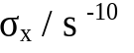
1.6
1.5
2.9
3.9
4.2
2.2
2.3
3.4
3.5
3.2
0.5
0.7
0.9
5.7
0.2
0.5
1.1
2.0
2.9
2.8
3.0
3.6
3h
6h
d/2
day
3d
7d
h
TW Ku
band
TW X
band
GPS
PPP
Combined
TW Ku+PPP

USNO-PTB 0804
MJD 54552-54586
Averaging time

Fig. 3.2 Comparison of the TDev between TW KU band, TW X band, GPS PPP and the combination of the TW KU and GPS PPP over the baseline USNO-PTB

Tab 3.1 Gains of the combination obtained by comparison with the TW X band link
Link type | N | Mean/ns | Std dev./ns | Gain
TW Ku | 345 | 0.610 | σ₁ = 0.332 | (σ₁ – σ₃)/σ₁ = 33%
PPP | 345 | 0.833 | σ₂ = 0.607 | (σ₂ – σ₃)/σ₂ = 63%
TW Ku + PPP | 345 | 0.613 | σ₃ = 0.221

Fig. 3.2 is a typical example of the TDev comparisons where the TW X band link is more stable on all the average time and that of the PPP is better than TW X while the combination of the TW KU and the PPP is the best. The combination contains a smoothing operator which may leads optimism TDev in the short terms. We need other proof than statistic estimation, that is, the Tab. 3.1. In section 2.1.1, it was pointed out that the TW X band link was the most precise and accurate of all the UTC links. It can be then a good reference to evaluation the gain of the combination of TW+PPP. Compared to the X band link, the discrepancies of KU, PPP and KU+PPP are σ₁ = 0.332, σ₂ = 0.607 and σ₃ = 0.221. The smallest one is that of the KU+PPP. The relative gains for KU and PPP are 33% and 63%.
In normal case, the combined TW+PPP link is advantageous than a TW-only or a PPP-only link.

3.2 Combination of the indirect TW and GPS PPP
Fig. 3.1 illustrates the AM2 TW network under in an ideal case where all the Asia labs link directly with PTB, configuring the so call UTC links. However this is never the case in the history. The only operational Asia-Europe links were NICT-PTB and NTSC-PTB. TL-PTB worked for a while but not contributed to UTC. This happened times in Europe and Europe-America baselines, i.e. the direct links do not work while the indirect ones do.
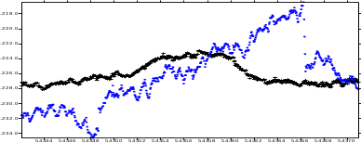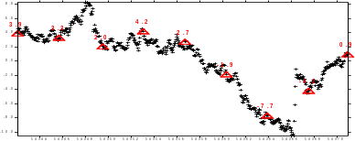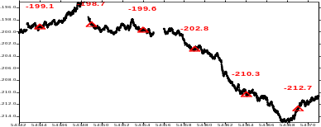
NICT
TL
PTB
TW1
TW2
TW : TL-PTB = (TL-NICT) – (PTB-NICT)
TL-NICT
PTB-NICT
TW : TL-PTB =
(TL-NICT)–(PTB-NICT)
PPP
PPP : TL-PTB
0.4
0.5
0.8
1.4
2.3
3.6
5.7
12.4
16.9
0.7
0.9
1.3
1.9
2.8
4.1
15.9
2.6
2.6
3.5
5.6
6.0
11.1
21.0
*
*
h/2
h
d/8
d/4
d/2
day
ddd
wk
TL-PTB via
NICT~12000 km
TDev/s⁻¹⁰
Diurnal in Indirect TW
with diurnal
Combined PPP+TW
PPP

Fig. 3.3 Demonstration of an indirect link and its combination with GPS PPP
Fig. 3.3 is an demonstration of an indirect link and its combination with GPS PPP. We notice that the TDev is improved. In particular, the diurnals are disappeared. Diurnals are the dominant error source in the TW transfers and they become important when the distance increases. This is the typical trouble for Asia-Europe links where there are the longest baselines in the worldwide UTC network. Combination of TW+PPP is a good solution. It increases, in addition to the improvement in the precision, the robustness of the UTC time transfer system.
We usually think in the most cases the precision of a direct link is better than that of an indirect link. [15, 16 and the Annex II] give contrast cases. Sometimes an indirect link may be better than the direct one. Nevertheless, our studies show that the quality of the combination of PPP with an indirect is as good as with a direct one: the noises due to longer distances of the indirect paths can be well improved by the PPP which has the advantage of the highest precision of all present techniques.
The u_{A} of the GPS PPP is 0.3 ns [1]. The u_{A} of the combination of TW+PPP is expected to be less than 0.3 ns.

4. The Asia-Europe very long time link calibrations
The total uncertainty of the UTC-UTC(k) is the u_{B} in Section 1 of Circular T [1], of which the dominant term is the calibration uncertaity of time transfer. As pointed out above, u_{A}(TW)=0.5 ns, u_{A}(PPP)=0.3 ns and u_{B}(TW)=1.0 (by the portal station calibration [4]). However the u_{B}(TW)=1.0 ns has never been realized between Asia-Europe. The present u_{B}(Asia-Europe) is 5ns. The radio of the u_{A} and u_{B} is higher than 10. In view of the total uncertainty in UTC generation, the major difficulty to improve the quality of Asia-Europe time transfer is the calibration.
In the introduction, we reviewed the UTC calibration concepts which can be grouped into two: a) receiver absolute/differential calibration and b) link differential calibration. We emphasized that the state-of-the-art of the UTC calibrations is that the concept b) reaches u_{B}=1ns and that for UTC computation the concept b) is required [3].
We recalled also in the introduction the recent studies of the link calibrations [6, 7, 8, 9, 10, 11, 12]. In fact, in the UTC computation, we apply a calibration correction to the UTC links obtained by an alignment operation, e.g., we align a GPS link to TW and when the TW is in trouble we use GPS with the calibration correction, which is nothing but the total delay defined in the next section.
In the following sections, we first define the total delay, then the set-up of the total delay calibration and finally the schedule of the calibration tour. The whole procedure is the so called BIPM scheme aiming at the standard UTC time link calibration.
The following notations are repeated frequently in the following discussions:
- Dly_{R/i}: the total delay of a receiver system at Lab(i), i = BIPM, PTB, Lab(k), …
- Dly_{L/ij}: the total delay of a time link system which is the difference of Dly_{Ri} and Dly_{Rj}
- Ref_{i}: the reference/master receiver at Lab(i), i = BIPM, PTB, Lab(k), …
- Std_{B} or Std_{BIPM} : the BIPM traveling standard consisted of N GNSS receivers
- UTCP_{i}: the UTC point at Lab(i), i = BIPM, PTB, Lab(k), … cf. Fig. 4.8
- CLBP_{k}: the calibration point at Lab(i). i = BIPM, PTB, Lab(k), … The Dly_{R/i} is the total delay between this point and the phase center of the antenna(i), cf. Fig. 4.1, 4.8

4.1 The definition of the total delay
The total delay of the link is the difference of the total delays of two GNSS receivers at the ends of the link.

4.1.1 The total delay of a GNSS receiver
The total delay of a GNSS receiver (Dly_{R}) at Lab(k) is the total electronic delay between the phase center of the antenna and the UTC point of Lab(k). It is the sum of all the delays of the cables and equipments. It may include the receiver, the splitter(s), the frequency distributor(s), the amplifier(s), the phase micro stepper(s) … and the cables between the antenna and the receiver as well as the cables among all the laboratory equipments on the road of the satellite signal passage from the antenna to the UTCP_{k} (Fig. 4.1 and 4.8)
GNSS Sat.
Rcv
Dly_{R}
Lab K
UTC point
Antenna
phase
center

Fig. 4.1 The total delay of a GNSS receiver (Dly_{R}) at Lab(k)
(the total electronic delay is the delay between the phase center of the antenna and the UTC point of Lab(k))

Why we should use the “Total Delay” ?
During the so far BIPM calibrations, the sub-delays are measured separately by BIPM and the Lab(k). BIPM makes the total delay by summing the sub-delays and computes the calibration results. The problem is that this practice may introduce extra-errors. Tab. 4.1 shows the discrepancies of the BIPM antenna cable delay measured by the different labs using different methods and the measurement uncertainties (SD). If we account only the results accompanied with the uncertainties, the minimum delay is 183.0±0.5 ns and the maximum is 186.2±0.01 ns. The difference is 3.2 ns largely over the given uncertainties. If we account all including those without the uncertainties accompanied, the difference reaches 6.3 ns (NIST/NMIJ) ! Tab. 4.2 gives the comparison of the delays of other four cables measured by different labs during the BIPM calibration tours.

Tab. 4.1 The delays of the BIPM cable C101 measured by different laboratories
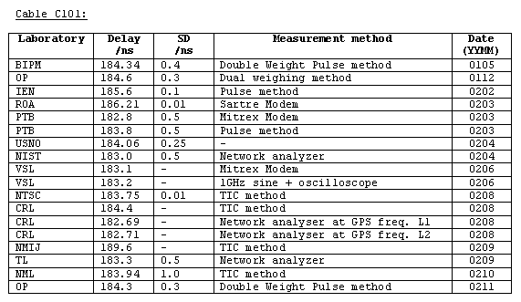
For only a simple cable, the differences reach as big as 3 ns (for those the uncertainties supplied). The delays of other complex equipments would be worse. All these errors should be added into uncertainty budgets of the calibration. It is wiser to avoid all these non necessary measurements. By using the total delay, all these measurements of the sub-delays are avoided. Of cause, a Lab(k) can always measure the sub-delays and this is encouraged. The sub-delays information may be helpful in case of doubts.

Tab. 4.2 Discrepancies of the delays of other BIPM cables measured by different laboratories
Cables | Year | Max. /ns | Min. / ns | Max dif. / ns
C101 | 2003~2004 | 179.0±0.5 | 181.1±0.3 | 2.1
C123 | 2002~2005 | 177.4±0.1 | 179.9±0.3 | 2.5
C128 | 2004~2006 | 186.3±0.4 | 187.8±0.4 | 1.5
C130 | 2005~2009 | 135.8±0.1 | 136.3±0.2 | 0.5

4.1.2 The total delay of a time link
The total delay of a receiver (Dly_{R}) defined by the above section is not measurable with only the BIPM scheme. It can be determined with extra absolute calibration information. Section 4.3 gives the equations to convert the total link delay to the Dly_{R}. The Dly_{R} serves here to define the Dly_{L}, the total delay of a time link between Lab(i) and Lab(j) in the BIPM scheme:
Dly_{L}(i-j)=Dly_{R}(i)-Dly_{R}(j)
for a UTC link, it becomes:
Dly_{L}(k-PTB)=Dly_{R}(k)-Dly_{R}(PTB)
Numerically the total delay of a time link Dly_{L} is not something new but the CALR of a TW link, i.e. Dly_{L}=CALR in the case of TW. However, the methods to obtain it are quite different. Fig. 4.2 illustrates the configuration of the geometry of the Dly_{L} which is directly measurable in the BIPM scheme.
Dly_{Ri}
GNSS Sat.
GNSS link
Lab(i)
Antennai
Rcvi
UTCPi
Antenna
Rcvj
Dly_{Ri}
Lab(j)
UTCPj

Fig. 4.2 The total delay of the link Lab(i)-Lab(j): Dly_{L} (i-j)=Dly_{R}(i)-Dly_{R}(j)
By default, the total delay in the following sections is always that of the time link Dly_{L}.

4.2 The BIPM scheme to calibrate a Dly_{L}
As proven in the earlier studies, the BIPM standard receivers do not need to be calibrated. Even its long-term stability is not required. The only require is that it must be stable during a calibration tour. As we know that the u_{A} of a GPSPPP link is only 0.3 ns. The uncertainty due to u_{A} is u_{A}/√N, N is the number of the total measurements. This is ignorable vs. the state-of-the-art of the u_{B}. The total uncertainty of the calibration depends mainly on the instability of the travelling standard which is designed in the BIPM scheme as that of a multi-receivers system. Such a system greatly reduces the risk of the jumps in the receive reference during the calibration tour because we can know exactly, with the closure measurement at BIPM and the side by set-up at Lab(k), where, when, which and how much a jump.
Compared with the earlier BIPM calibration, the new scheme is characterized by:
- the key point is the stability of the BIPM traveling standard which is composed of N-GNSS receivers, of which there is one fixed receiver staying at BIPM and a traveling standard composed of N receivers (N≥2). For this pilot study, the BIPM standard (STD) is consisted of three GPS receivers: a reference receiver Ref_{B} stays at BIPM plus a traveling standard of two GPS receivers: Std_{B}
- As we know that the clock result of a PPP solution is associated with the phase center variation of the antenna, i.e., the Antenna is self-positioned on function of time geocentrically and accurately. Therefore, the Std_{B} must be of GNSS geodetic receivers
- The common point of the two traveling receivers is a splitter sharing a cable leading to the calibration point (CLBP), cf. Fig. 4.8. All the calibrations are made with the CLBP as reference
- The CLBP_{k} of Lab(k) is referred to UTCP_{k}. The Lab(k) should measure and need only measure the delay between the CLBP_{k} and UTCP_{k}
- The calibration result is the total delay of a link Dly_{L} as defined above. We calibrate the total delay of all the time links on the roads at PTB and at Lab(k). The link(s) to calibrate can be that of GNSS P and C/A codes or of TW
- During a calibration tour, all the equipments of the all the Labs in the schedule should be operational correctly, e.g., even when the Std_{BIPM} is at the Lab(k), the time transfer equipments of GNSS and TW at the BIPM, PTB and Lab(k), k=1,2,3 … should be correctly operational
- The main goal is to calibrate the UTC links. So PTB is always included. In addition, as starting and closing point, BIPM is automatically included in the calibration tour.
The BIPM scheme has four major steps:
- Starting measurement from BIPM
- Go to PTB
- Go to Lab(k), k=1, 2, 3, …
- Closing measurement at BIPM

4.2.1 Step 1: Start at BIPM
As mentioned above, the BIPM calibration standard system Std_{B} is consisted of N GNSS receivers. The inner-variation of the system is the major source of the uncertainty, that is, if N=2, the discrepancy of them demonstrates the instability of the Std_{B}. Having two parts Step 1a and Step 1b, the side-by-side comment-clock short-baseline setting up at BIPM before each calibrating tour is aimed at:
- Inner-calibration by inter-comparisons. To easy the following computations, the calibration differences are adjusted to be zero (through Tsoft CLB_GNSS.Lsit). The Std_{B} is self-consisted
- By comparing the closing setting-up (step 4), we verify the possible reference variation(s) of the Std_{B}
Fig. 4.3a is the set-up of the Step 1a: it is a side-by-side common-clock short-baseline set-up and we:
- Compute the total delay between the two receives Std(1)-Std(2): Dly_{L}(1-2)=Dly_{R}(1)-Dly_{R} (2)
- Fix the calibration to that of the Std(1), i.e. set the relative calibration correction = Dly_{L}(1-2) in the file CLB_GNSS.Lst
- Add the correction to Std(2)’: Std(1) = Std(2)’= Std(2)+Dly_{L}(1-2). To be simple, replace the Std(2)’ by Std(2). Therefore Std(1)=Std(2)
- To be simple, write Std_{B} =Std(1)&Std(1)=[Std(1)+Std(2)]/2, take the mean of Std(1) and Std(2)
GNSS Sat.
At BIPM: Total delay =Dly_{R/1}-Dly_{R/2}=0
CLBP=calibration point, UTCP=UTC point
Antenna1
Dly_{R/1}
Std1
Antenna2
Std2
Dly_{R/2}
CLBP
UTCP

Fig. 4.3a Step 1a: The Side-by-side common-clock short-baseline set-up and the total delay Std(1)-Std(2): Dly_{L}(1-2)=Dly_{R}(1)- Dly_{R}(2)
Similarly, Fig. 4.3b is the set-up of the Step 1b. By replacing in Fig.4.3a and equation the Std(1) by Std and Std(2) by Ref_{B}, we have:
- Std_{B}-Std(Ref_{B}): Dly_{L}(Std_{B}-Ref_{B})=Dly_{R}(Std_{B})- Dly_{R}(Ref_{B})
- Fix the calibration to that of the Std_{B}, i.e. set the relative calibration correction = Dly(Std_{B}-Ref_{B}) in the file CLB_GNSS.Lst
- This results in Std_{B}=Ref_{B}’=Ref_{B}+Dly_{L}(Std_{B}-Ref_{B}). To be simple, we write Ref_{B} instead of Ref’_{B.} Therefore Std_{B}=Ref_{B}
To simplify the discussions above and below, the starting set-up was separated into two. In fact, the sub-step 1a and 1b can be merged together which takes 3 days’ simultaneous and continued measurements.

GNSS Sat.
At BIPM: Total delay =Dly_{R}(Std)-Dly_{R}(Ref_{B})=0
CLBP=calibration point, UTCP=UTC point
Antenna1
Dly_{R/B}
Ref_{B}
Antenna2
Std_{B}
Dly_{R/B}
CLBP
UTCP

Fig. 4.3b Step 1b: The Side-by-side common-clock short-baseline set-up and the total delay Std-Ref_{B}: Dly_{L}(Std_{B}-Ref_{B})=Dly_{R}(Std)-Dly_{R}(Ref_{B})

4.2.2 Step 2: Go to PTB
The Step 2 is carried out at PTB. It is exactly the same set-up as that of Step 1b, except that we replace Ref_{BIPM} by Ref_{PTB} that is the PTB standard GPS receiver.
Fig. 4.4 is the set-up of the Step 2 performed at PTB. Similarly as above in step 1b, we have:
- Std_{B}-Ref_{PTB}: Dly_{L}(Std_{B}-Ref_{PTB})=Dly_{R}(Std_{B})-Dly_{R}(Ref_{PTB})
- To easy the computation followed, we can also fix the calibration to that of the Std_{B} or to that of the Ref_{PTB}, i.e. set the relative calibration correction = Dly_{L}(Std_{B}-Ref_{PTB})= in the file CLB_GNSS.Lst: correct either the Std_{B} or Ref_{PTB}
- This results in Std_{B}= Ref_{PTB}’= Std_{B}+Dly_{L}(Std_{B}-Ref_{PTB}). To be simple, we write Ref_{PTB} instead of Ref_{PTB}’
- PTB should supply and needs only to supply the delay between the CLBP_{PTB} of the Std_{B} and the UTCP_{PTB}, cf. section 4.5.2 PTB
- Perform 5 days’ simultaneous and continued measurements so as to reduce the effects of the multi-paths in GPS

GNSS Sat.
At PTB: Total delay =DlyR(Std_{B})-DlyR(Ref_{PTB})=0
CLBP=calibration point, UTCP=UTC point
Antenna
Dly_{R/P}
Ref_{PTB}
Antenna
Std_{B}
Dly_{R/B}
CLBP
UTCP

Fig. 4.4 Step 2: The Side-by-side common-clock short-baseline set-up and the total delay Std_{B}-Ref_{PTB}: Dly_{L}(Std_{B}-Ref_{PTB})=Dly_{L}(Std_{B})- Dly_{R}(Ref_{PTB})

4.2.3 Stpe3: Go to Lab(k)
The Step 3 is carried out at Lab(k). It is exactly the same set-up as that of the Step 2, except that we replace the Ref_{PTB} by Ref_{k} whish is the standard GPS receiver of the Lab(k). Fig. 4.5 is the Step 3 setting-up: the Side-by-side common-clock short-baseline set-up and the total delay at Lab(k) Std_{B}-Ref_{k}: Dly_{L}(Std_{B}-Ref_{k})=Dly_{R}(Std_{B})-Dly_{R}(Ref_{k}).
Similarly as in section 4.2.2 and noting that we have adjusted Std_{B}= Ref_{PTB}, we have the simple relations:
- Std_{B}-Ref_{k}: Dly_{L}(Std_{B}-Ref_{k})=Dly_{R}(Std_{B})-Dly_{R}(Ref_{k})
- Because the calibration has been adjusted to be zero, i.e. Std_{B}= Ref_{PTB}, the calibration correction is the difference between the link Std_{B}-Ref_{PTB} and the link Ref_{k}-Ref_{PTB}. This results in Ref’_{k}= Ref_{k}+Dly_{L}(Std_{B}-Ref_{k}). We write simple Ref_{k} instead of Ref’_{k}
- Lab(k) should supply and only supply the delay between CLBP_{k} of Std_{B} and UTCP_{k}
- Perform 5 days’ simultaneous and continued measurements so as to reduce the major uncertainties caused by diurnal in TW and the multi-paths in GPS
By now, we see that the BIPM scheme traveling program seems quite similar to the BIPM traditional calibration tours. We repeat here that the essential difference between the new BIPM scheme and the traditional one is that as illustrated in the Fig. 4.5, the new is a differential “link” calibration (double difference) while the traditional one is a differential “receiver” calibration (single difference). The calibration philosophies are completely different. The uncertainty of the link calibration is easy to get lower than that of the receiver calibration because the latter, strongly correlated in a link, is somewhat cancelled in the link calibration.
GNSS
PTB
TW PTB
PTB
GNSS sat.
Lab(k)
GNSSLab(k)
TW k

TW sat.
Ref_{PTB}
Std_{B}
GNSS K-PTB: Ref_{k}-Ref_{PTB}

TW K-PTB
Std_{B}-Ref_{PTB}

Fig. 4.5 Step 3: The Side-by-side common-clock short-baseline set-up and the total delay Std_{B}-Ref_{k}: Dly_{L}(Std_{B}-Ref_{k})=Dly_{R}(Std_{B})-Dly_{R}(Ref_{k})

4.2.4 Step 4: Closure at BIPM
GNSS Sat.
Antenna_{R}
Dly_{B}
Ref_{B}
Antenna
Std_{B}
Dly_{R}
CLBP
UTCP
At BIPM
Total delay =Dly_{R}(Std_{B})-Dly_{R}(Ref_{B})=0
CLBP=calibration point
UTCP=UTC point

Fig. 4.6 Step 4 closure measurement set-up: The Side-by-side common-clock short-baseline set-up and the total delay Std_{B}-Ref_{B}: Dly_{L}(Std_{B}-Ref_{B})=Dly_{R}(Std_{B})-Dly_{R}(Ref_{B})
Fig. 4.6 illustrates the closing measurement of which the set-up is exactly the same as done in Step 1b so as to monitor the “possible jumps” in the traveling Std_{B}. Because all the receivers at PTB and Lab(k) are operational during the whole calibration tour, a jump can be detected, dated, located and numbered. The closure of the GPS PPP measurement is theoretically √2*u_{A}=0.42 ns (1-σ). Conventionally, maximum closures should be below 0.85 ns (2-σ). Otherwise, a reference jump may be considered. The tolerance of 0.85 ns can be conventionally determined on the basis of the experiment results.

4.3 Discussions
The discussion in this section is cited from [8] with slight modification to adapt to the terms of this TM.

4.3.1 Convert a link calibration to a GNSS receiver calibration
Till now, we are talking about the link calibration. Following, we will see how to convert the link calibration to the receiver calibration. As pointed out above, the calibration of the BIPM scheme is not the absolute receiver calibration. We are interesting in the quantity which influences the UTC-UTC(k) and also in an arbitrary time link UTC(k)-UTC(j). We call the result the receiver calibration correction (calibration for short) which is added to the RefGps value (the raw receiver reading in the CCTF CGGTTS GPS data files).
Taking example of the baseline TL-PTB: suppose the traditional absolute delay of the GPS receivers is X_{o} for PTB and X_{u} for TL; Link_{g} is the non calibrated GPS link between TL-PTB; Link_{G} and Link_{B} are the calibrated links by carrying out the BIPM scheme. We can compute the calibration value of the TL GPS receiver as follows:

Link_{B} = Link_{G} = [RefGps(TL)+X_{u}] – [RefGps(PTB)+X_{o}] (1)

Introducing C_{u}=X_{u}–X_{o} in above equation, we have:
Link_{G} = [RefGps(TL) + C_{u} + X_{o}] – [RefGps(PTB) + X_{o}] (2)
= RefGps(TL) – RefGps(PTB) + C_{u}
= Link_{g} + C_{u}
= Link_{B}
Above we used the definition of non calibration GPS link:
Link_{g} = RefGps(TL) – RefGps(PTB)
Therefore
C_{u} = X_{u} – X_{o} = Link_{B} – Link_{g} (3)
or
Link_{G}=Link_{g} + C_{u} = [RefGps(TL) + C_{u}] – RefGps(PTB) (4)
Here C_{u} is namely the calibration correction for the TL GPS receiver. As for the receiver of PTB, it is calibrated or not becomes meaningless for obtaining the calibrated link_{G}. To be general, we replace the TL by Lab(k) and Lab(j) separately and obtain the GPS receiver calibrations at Lab(k) and Lab(j):
C_{k} = X_{k} – X_{o} = Link_{B}(Lab_{k} – PTB) – Link_{g}(Lab_{k} – PTB) (5)
and
C_{j} = X_{j} – X_{o} = Link_{B}(Lab_{j} – PTB) – Link_{g}(Lab_{j} – PTB) (6)
Equation (5) minus equation (6), we have:
C_{k} – C_{j} = X_{k} – X_{j} = Link_{B}(Lab_{k} – Lab_{j}) – Link_{g}(Lab_{k} – Lab_{j}) (7)
Or
Link_{B}(Lab_{k} – Lab_{j}) = Link_{g}(Lab_{k}-Lab_{j}) + C_{k} – C_{j} (8)
Similar as the equation (1), the calibrated GPS link equals:
Link_{G}(Lab_{k} – Lab_{j})= [RefGps(Lab_{k}) + C_{k}] – [RefGps(Lab_{j}) + C_{j}] (9)
In above equation (9), C_{k} and C_{j} are the GPS receiver calibration corrections. Introducing equations (6) and (7) into (9), we have the GPS link with the traditional absolute calibrations X_{k} and X_{j}:
Link_{G}(Lab_{k} – Lab_{j})= [RefGps(Lab_{k}) + X_{k}–X_{o}] – [RefGps(Lab_{j}) + X_{j}–X_{o}]
= [RefGps(Lab_{k}) + X_{k}] – [RefGps(Lab_{j}) + X_{j}] (10)
Here Xo is the absolute calibration value for PTB GPS receiver and is cancelled in any arbitrary links. Equations (9) and (10) give the same link result (within their uncertainties) but with completely different calibration setting up. Equation (9) is meaningful: the GPS calibration obtained through Link_{B} are transferred as the receiver calibration and they differ from their absolute delays by a common constant: X_{o} (the absolute delay of the PTB GPS receiver). However, the X_{o} can be determined at any lab(k). As mentioned in the introduction, the disadvantage of equation (10) is not only that it is man-labor, time and money costing but also its u_{B} (5ns). Equation (9) uses the already available BIPM scheme calibration and its u_{B} is well reduced. In fact, the equation (9) allows a simultaneous multi GPS receiver calibration between N laboratories that operate both GPS PPP time transfer facilities. Simultaneous measurement is impossible by applying the traditional calibration (eq. 10) which requires the BIPM master standard receive traveling and occupying sequentially all the laboratories in separate periods. Such the possible biases due to, for example, the long-term variations of the internal reference of GPS receiver and the geodesic hypothesis etc., are not evadable.

4.3.2 Convert the “relative” receiver calibration to the absolute one
An absolute calibration is to determine the delay of the antenna and the receiver. The rest, such as the delays of the cables and the equipments are measurable by the Lab(k). The sum of the all is the total delay (Dly_{R}) which is such absolutely measurable. The direct output of BIPM scheme is defined with respect to the standard receiver Std_{BIPM}. We see from relation (2) that in link_{G} the absolute delay of the GPS receiver at PTB is X_{o} that is cancelled and that to determine C_{u} the two remote clocks are cancelled too. For the time transfer, the correction C_{u} makes the real role of the calibration. One by one, we can determine this way all the calibration for all the GPS receivers. The total absolute delay at Lab(k), here is TL, is X_{u}=X_{o}+C_{u}. If the TL GPS receiver is absolutely calibrated, we can determine the PTB absolute delay at TL by equation (3): X_{o}=X_{u}-C_{u}. This implies, it is enough to absolutely calibrate one of the GPS receivers at an arbitrary Lab_{k}, we can then determine the PTB absolute delay X_{o}. Such for a third Lab_{j}, its absolute calibration can be obtained by X_{j}=C_{j}+X_{o}. If there are more than one receivers absolutely calibrated in the BIPM scheme, the redundant calibrations will improve the calibration uncertainty.

4.3.3 Record the total delay in the CGGTTS header
A practical question is that how to introduce into the CGGTTS data file the receiver calibration corrections converted by the total delay (which is not composed as the sum of the sub-delays as in the traditional calibration: INT DLY, CAB DLY and REF DLY) obtained in the BIPM scheme. The practice of the TW ITU data format may be referred, i.e., we record the total delay (as CALR) in the term of REF DLY and the terms INT DLY and CAB DLY will be considered as the ESDVAR. In other words, REF DLY= the receiver calibration correction obtained in the BIPM scheme while INT DLY and CAB DLY will be assigned/updated by the Lab(k) when the local set-up changed. For example, if a cable with a delay of 2.5 ns is added, the Lab(k) should record/update it in CAB DLY=2.5 ns. See below:

To record the total delay in the header of the CGGTTS file:
INT DLY = 0.000 ns (internal delay correction by lab(k), yy mm dd)
CAB DLY = 0.000 ns (cable delay correction by lab(k), yy mm dd)
REF DLY = Total delay (receiver delay correction by BIPM Scheme, yy mm dd)
COMMENT: Total delay calibration of the BIPM Scheme yy mm dd

4.3.4 Some important remarks

4.3.4.1 Triangle closures: the redundancy in the BIPM calibration scheme
Fig. 4.7 illustrated the redundancy in the BIPM calibration scheme: the BIPM Std_{B} travels from BIPM then goes to PTB, NICT, TL and closes back to BIPM. Because all the receivers are operational during the tour, the calibrations are carried out no mater where stays the Std_{B}, e.g., as in Fig. 4.7 to be at TL to calibrate the link TL-PTB. There are two redundant calibrations performed through the two indirect links: TL-NICT-PTB and TL-Ref_{BIPM}-PTB. So there will be three calibration results. In terms of triangle closure, they may not be zero. The final calibration result may need to be adjusted. A simple and good enough way is to take the weighted mean value: [(TL-PTB)+½(TL-NICT-PTB)+½(TL- Ref_{BIPM}-PTB)]/2.

Ref_{BIPM}
NICT
TL
Std_{BIPM}

Std_{BIPM}

Std_{BIPM}
Std_{BIPM}

PTB

Fig. 4.7 Redundancy of the BIPM calibration scheme by the simultaneous calibration measurements
(solid line: Time links between UTC Labs; dot links: links between Std_{BIPM} and UTC Labs)
It is interesting to notice that the triangle closures of TL-PTB-NICT and TL-PTB-Ref_{BIPM} should be zero in the normal cases whatever the jumps, calibration and measurement errors in the receivers: the site depended errors are cancelled in the composition a triangle. However the BIPM scheme is a “link” calibration, the closure of the triangle composed by the links may not be zero in case of the jumps or calibration errors. To remove the discrepancies, we can use simply the weighted mean value above and when the network is complex, i.e., there are many UTC Labs involved in the BIPM scheme, a least squares adjustment of the network as a whole may be necessary.

4.3.4.2 A remark on the absolute receiver calibration
In section 4.3.1, we give the equation to convert the link calibration to the absolute receiver calibration. Assuming in Fig. 4.7, there are two receivers of PTB and TL have been absolute calibrated, how to deal with the discrepancies such produced ? Yes, we just need to add one more unknown in the least squares adjustment of the network.

4.3.4.3 The BIPM scheme is a unified calibration
By Fig. 4.5, the setting up of the BIPM scheme at Lab(k) calibrates all the time links between Lab(k) and PTB: TW and GNSS with whatever the types of the observables: C/A, P3 or PPP. This is the so-called unifying all the UTC time links to the unique BIPM standard [12].
Advantages of the unified approach realized by the BIPM scheme are:
- The calibration results will be affected only by the short-term instability of the Std_{B};
- Calibration of the TW links and in particular of inter-continental TW links is possible;
- Improvement of the calibration uncertainty u_{B} for most UTC time links, and consequently reducing the uncertainty of [UTC − UTC(k)] in the Circular T from to 2 ns, see below;
- Simplifying the organization of UTC calibration campaigns;
- Simplifying the procedure of monitoring of these calibrations;

4.3.4.4 The BIPM scheme is more accurate and less manpower, time and money consuming
In the traditional BIPM calibrations, we travel separately the different BIPM standards for different GNSS receivers calibrations: GPS C/A code receivers, GPS P3 code receivers as well as the Glonass receivers. TW is still another type of calibration of which the inter-continental link calibration is impossible. During the calibrations, the UTC labs have to supply the position of the antenna, the sub-delays of all the cables and the equipments on the road of the satellite signal passage. All these are time and manpower consuming and increase the total uncertainty.
The new BIPM scheme allows one link calibration for all types of links on a baseline and the Labs measures and supplies only the delay between UTCP(k) and CLBP(k). This saves time, manpower and reduces the terms in the uncertainty budget.
Generally speaking, if the uncertainty of a receive calibration is u, the total uncertainty in UTC-UTC(k) will be about u_{B}=√2*u. For a link calibration, the u_{B} ≤ u.
Same work outputs different results. In metrological practice, an optimally designing the measurement schedule is essential.

4.3.4.5 Simple versions of the BIPM scheme
As repeated, the stability of the Std_{B} is the key point of the scheme. It is easy to prove its stability by inter-comparisons between the Ref_{B}, Std(1) and Std(2) as well as Ref_{OP} and Ref_{PTB}. If after several calibration tours and we can prove that the two receivers Std(1) and Std(2) of the Std_{B} and the Ref_{PTB} are stable enough, the four steps BIPM scheme can be simplified. For example:
Version 1: Do first the step 1 with Std(1) and Std(2) at BIPM and then Std(1) goes to PTB to compare with Ref_{PTB} and then the Std(1) goes to Lab(k), k=1,3,5 … while Std(2) goes directly from BIPM to Lab(k), k=2,4,6 … Both finish at BIPM for closing measurements
Version 2: As version 1, but do not need to go to PTB if it is sure the Ref_{PTB} is stable. In normal case, it is hopeful that the stationary PTB GNSS receiver, as the unique pivot of the worldwide time transfer network, is stable. This is not only the fundamental hypotheses for the calibration but also for the whole GNSS UTC time transfer.

4.4 The uncertainty
The discussion in this section is cited from [12] with slight modification to adapt to the subject of this TM.

4.4.1 The u_{B} of a UTC link Lab(k)-PTB
Uncertainty of the “unified” calibration for the link Lab(k)-PTB can be estimated by:
u_{B}²(k-PTB)=[u_{A}²(k-PTB)+u_{A}²(Std_{BIPM})+c²(Std_{BIPM})]/N (4-4-1)
here N is the number of the BIPM traveling receivers; c is the conventional short-term-link-instability of the Std_{BIPM} for a typical calibration tour that consists of 4 occupations of 4 steps: BIPM➔PTB➔Lab(k)➔BIPM. If we set c = 2 ns (as is shown to be achievable by Esteban et al [12] and others) and N=1, the u_{B} of the calibrations are: u_{B}(GNSS P) ≈ 2.23 ns (for u_{A} = 0.7); u_{B}(GNSS C/A) ≈ 2.60 ns (for u_{A} = 2.0) and u_{B}(TW) ≈ 2.17 ns (for u_{A} = 0.5). The above estimations are very conservative because:
- the measurement uncertainty u_{A} should be averaged out by a factor of the root of n, with n the number of the total measured points
- the redundant calibrations are not considered (Section 4.3.4.1). This may reduce the uncertainty in equation (4-4-1) by a factor of √2
- in the Std_{BIPM}, there are N=3 GPS geodesic receivers. This may reduce the uncertainty in equation (4-4-1) by a factor of √3
Totally and in the ideal case, the u_{B} in equation (4-4-1) may be reduced by a factor of 2.4, that is, about 1 ns for the GNSS P3 code calibration.

4.4.2 Aging of the u_{B}
In this section, we discuss the evolution of u_{B} with time.
It is logic that without re-calibration or an independent check, the maximum life of a “free running” u_{B} is limited, saying about 10 years, e.g., for each of the techniques u_{B}(>10 year) = 10 ns. A “free running” u_{B} increases with time. For the purpose of automatic computation, it is useful to design an analytical model for u_{B} evolution. For example, a model based on a random walk phase noise or on a flicker phase noise (or on a combination of both) could be used. In the following, examples are shown for a random walk model, although the resulting values are probably overly pessimistic for the long-term
u_{B}²(T − T₀)_{k-PTB} = u_{B}²(T₀)_{k-PTB} + (T − T₀) × u_{A}²_{k-PTB}
Here T-T₀ is the time since calibration in months and u_{A} is the random walk part of the 1-month Type A uncertainty of the link taken to be: u_{A}(GNSS C/A code) ≈ 0.7 ns; u_{A}(GNSS P codes) ≈ 0.5 ns and u_{A}(TW) ≈ 0.3 ns. Based on above hypothesis, Tab. 4.4 demonstrates the evolution of u_{B}(T − T₀) with time.

Tab. 4.4 Evolution of u_{B} (in ns) increasing with time as a random walk process
Link u_{B}(T₀) u_{A} u_{B}(1yr) u_{B}(3yr) u_{B}(5yr) u_{B}(10yr) u_{B}(>10yr)
TW 1.0 0.3 1.4 2.1 2.5 3.4 10
GNSS P 2.0 0.5 2.6 3.6 4.4 5.8 10
GNSS C/A 3.0 0.7 3.9 5.2 6.2 8.2 10

4.5 The Experiment set-up
After the general set-up demonstration, we give two example of the set-up at PTB and NICT based on the earlier setting-up configuration. These configurations were picked out from the earlier calibration reports and may need to be updated.

4.5.1 General set-up
Suppose that a Lab(k) has all the time transfer techniques: TW, GLN and GPS C/A, P3 and PPP ect. The configuration between the pulse distributor driven by the master clock and the receivers of Lab(k) as well as the BIPM traveling standard is illustrated as show in Fig. 4.8. Note here that the BIPM traveling Std_{B} is composed of two standard GPS receivers driven by the same mast clock as do as the other receivers at Lab(k). The pulse passes first through the CLBP(k) of the distributor then the BIPM receiver cable to the BIPM splitter where divided into two signals to the two BIPM individual standard receivers. The delay of the assemble of the BIPM Std from the antennas to the CLBP(k) is same at all the Labs and will be canceled in the time links. The difference of the links of the Std_{BIPM} and that of the Lab(k)-PTB is nothing but the calibration correction.
The Lab(k) needs only to measure and supply the delay (the Δ in Fig. 4.8) between UTCP(k) and CLBP(k). Lab(k) needs not to supply the other delays nor the antennas positions.
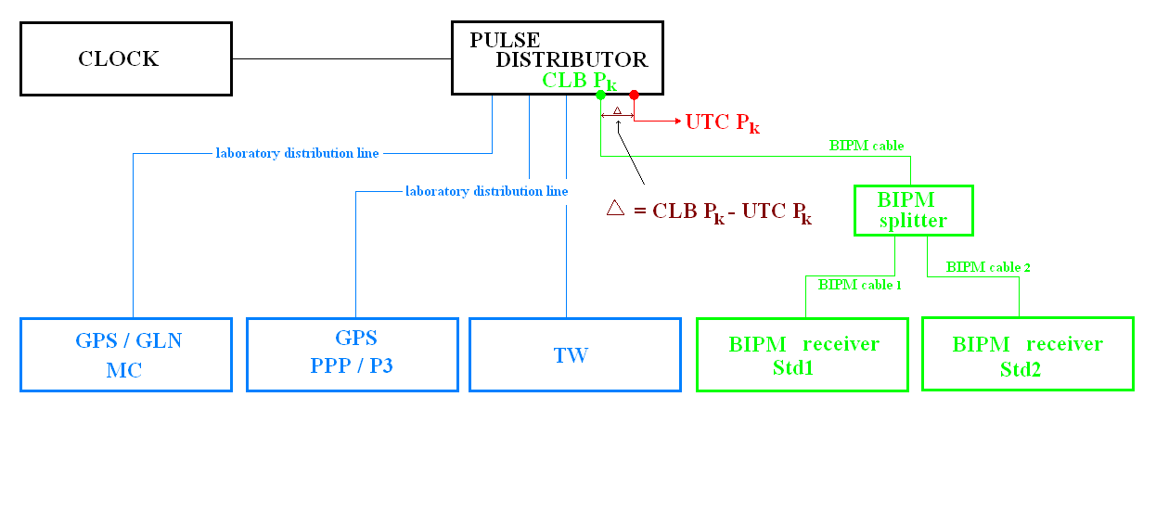
The differential delay Δ between the UTCP_{k} of lab (k) of the UTC point and the CLBP_{k} (calibration point) is measured by Lab(k) and reported to BIPM. The delay between CLBP and the antenna of Std_{BIPM} is constant during the whole calibration tour.

Fig. 4.8 Configuration between the pulse distributor linked with the master clock and the receivers of Ref_{PTB}, Ref_{Lab(k)} and Std_{BIPM}

4.5.2 Two examples of the experiment set-up at PTB and NICT
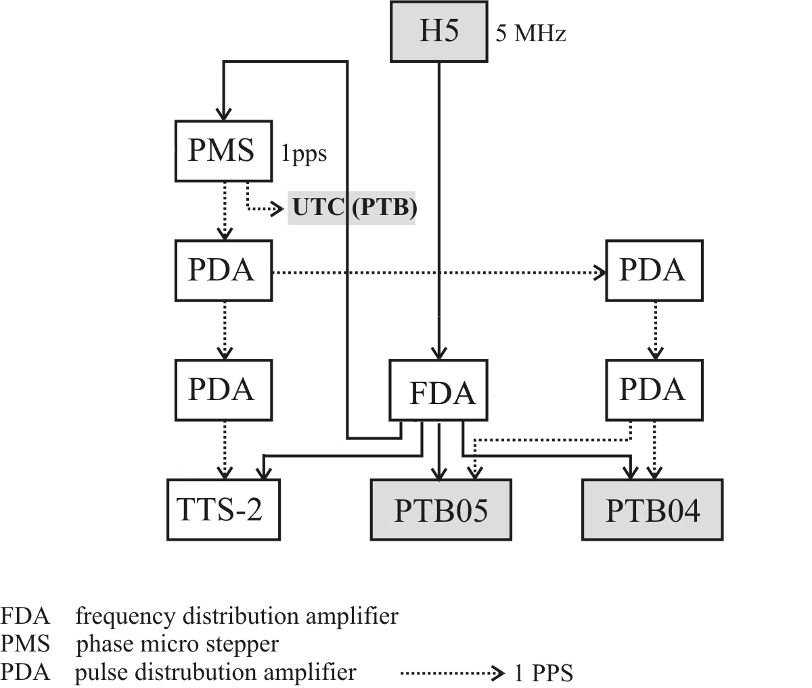
CLBP_{PTB} Linking to Std_{BIPM}

Fig. 4.9 Configuration at PTB between the pulse distributor linked with the master clock, the reference receiver Ref_{PTB} and the BIPM standard Std_{BIPM} (based an earlier calibration tour with TW no show)
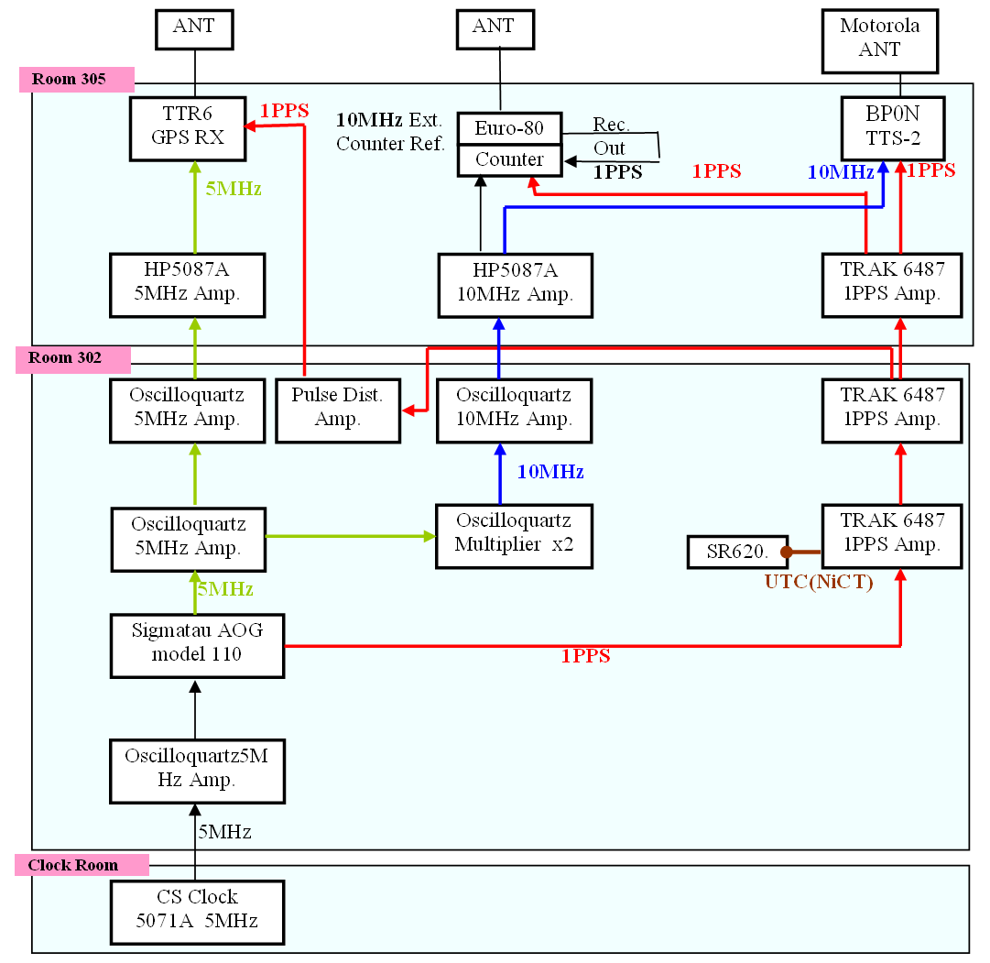
CLBP_{NICT} Linking to the Std_{BIPM}

Fig. 4.10 Configuration at NICT between the pulse distributor linked with the master clock, the receivers of Ref_{NICT} and the Std_{B} (based on an earlier calibration tour with TW no show)

4.6 Criterion of the participants of the pilot experiences
Compared with the traditional BIPM calibrations, the new BIPM scheme is completely different. The scale of the first pilot calibration program should neither too large nor too small: large enough to test the method with the first result; small enough to evade any complicity. The candidatures of the participating Labs in the Asia-Europe pilot study are better to satisfy:
- 2 labs in Europe including PTB and 2 labs in Asia including NICT
- Operating PPP and TW (for Europe Labs, this implies two stations one for T-11N and the other for AM2)
- GPS P3 or TW have been traditionally calibrated so as to be able to use as a reference
- GPS-GLN MC as option

Tab. 4.5 EIRP and Elevation of the AM2 TW satellite from the Labs
Lab EIRP/dBW Elevation # of Ground stations
PTB 42 3.9° 2
TL 35 36.0° 1
PL 43 8.4° 1
AOS 43 7.8° 1
TUG 40 8.4° 1
SP 44 3.3° 1
CH 40 3.2° 1
IT 38 3.7° 2
VSL 42 0.1° 2
OP 45 < 0.0° 2
The Tab. 4.5 and Fig. 4.11 demonstrate the visibility of the Russian satellite AM2 seen from the Asia and the Europe Labs [14], also cf. http://www.satbeams.com/footprints?beam=5408. Higher EIRP level and elevation means better TW measurement condition.
The AM2 covers all the Asian Labs with good elevation and EIRP. Among them, PTB, NTSC, TL, NIM and NICT are already operational. KRIS and NMIJ, NPLI, including SU in Russia, will come soon. However in Europe, the coverage of AM2 is poor. Only a few Labs have the visibility: AOS has only one station fixed on T-11N. The elevation of IT is 3.7° and had two ground stations, of which, one is out of use. OP and VSL have two stations and operated the TW links with Asian Labs via IS-4 years ago. But their elevations are too low for the AM2.
Taking into account of the above criterion, PTB, NICT and TL are ideal. NTSC and NIM may be backup the Asian region. There is not a second one satisfied in Europe. We have to degrade the condition for the Labs in Europe. OP has a special position: it is in Paris near BIPM and a good record of the TW and GPS calibrations. Fig. 4.12 is the comparison of the GPS PPP and TW links on the baseline OP-PTB for UTC1009. The differences of the two links and the standard deviation are 0.568 ± 0.705 ns. Their calibrations agree with each other very well and they may serve as a good reference for the pilot study. Therefore OP is the most favorable Lab in Europe after PTB, except for that it has no AM2 visibility unfortunately.

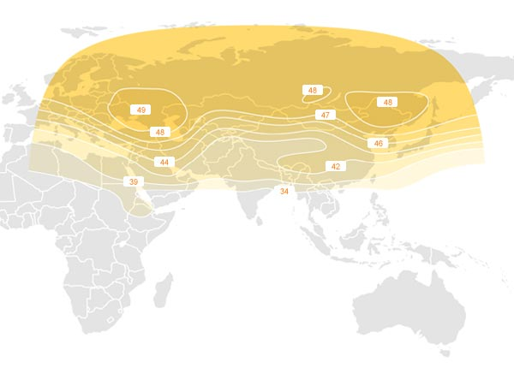
PTB
OP
AOS
NTSC
NIM
NICT
TL
NMIJ
KRIS
SU
NPLI

Fig. 4.11 Coverage of the AM2 TW satellite and the EIRP/dBW
(PTB, NTSC, TL, NIM and NICT are operational since Aug. 2010. SU, NPLI, KRIS and NMIJ will come soon)

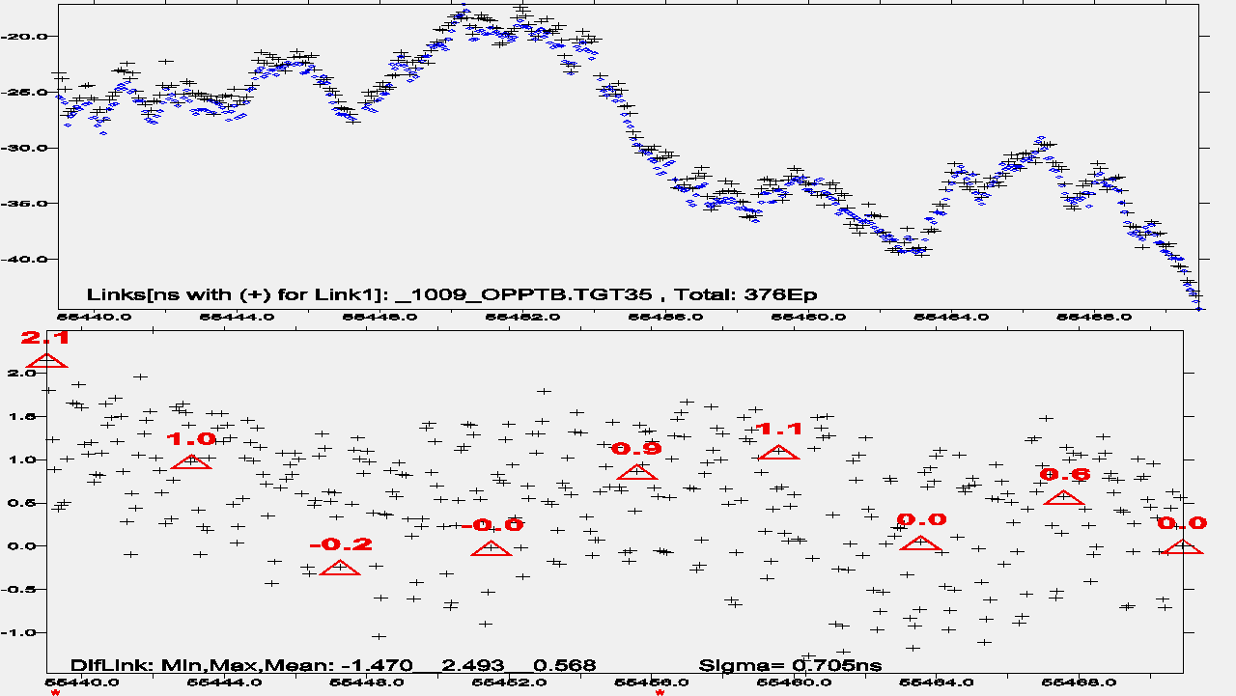

Fig. 4.12 Up-plot: comparison of the GPS PPP (circle) and TW (cross) links on the baseline OP-PTB for UTC1009; Low-plot: different of TW-PPP

4.7 The draft schedule of the Asia-Europe pilot experience
Four UTC Labs (one occupation of 5 day measurement each) plus the pilot Lab BIPM (two occupations with 3 day measurement each) are involved. Including the transport and the setting up preparation, the calibration tour will take about 50 to 80 days in total.
The draft schedule is:
- March 2011: Announcement and discussion of the pilot program among the Labs directly involved and tests at BIPM
- March and April 2011: tests at BIPM and OP
- May or June 2011: start the calibration tour (PTB, NICT and TL)
- July 2011: end the calibration tour and start data processing
- July-Aug.: report of the calibration results (u_{B} ≤ 2ns)
- Application of the calibration results in related UTC links

4.8 Comparison between the new BIPM scheme and the so far BIPM differential receiver calibration
In section 4.3.4, we gave some characters of the new BIPM scheme which are advantageous than the traditional calibrations: supply redundant calibration results, convertible to absolute receiver calibration, one for all link calibrations and more effective and less costs. Tab. 4.5 is a comparison that summarizes the characters of the old and new calibration schemes.

Tab. 4.5 Comparison of the new BIPM calibration scheme and the traditional one
No. | Traditional Scheme | New Scheme
 | Differential receiver calibration. (single dif.) | Differential link calibration (double dif.)
 | Calibrate only one type of time equipment | Calibrate all types of time equipments
 | Inter-continental TW is impossible | Inter-continental TW is possible
 | Receiver is operational only at Lab(k) | All receiver at BIPM, PTB, Lab(k) are all operational
 | No redundant calibration | Yes redundant calibrations
 | BIPM standard: one GNSS receiver | BIPM standard: 1 fix + 2 traveling GPS receivers
 | Antenna positions measured by Lab(k) | Antenna positions are self-positioned by PPP
 | Conventional U_{B} is 5 ns | Conventional U_{B} is 2 ns

5. Summary
TW and GPS PPP are the major techniques in UTC time transfer. Each has its advantages and is indispensable. However, since last year, two phenomena seem contrast rise: the quality of TW degrades and that of the GPS PPP is improved. The best solution is not to give up the TW and replace it by GPS PPP but to combine the two techniques. This is the strategy of strengthening the Asia-Europe very long baselines for UTC time transfers.
We discussed in this TM:
- PPP assisted direct and indirect TW time transfer : combination TW+PPP
- PPP assisted calibration: the BIPM scheme TW-PPP
- The expected uncertainties
u_{B} ≤ 2 ns
u_{A} ≤ 0.3 ns
The prospect is encouraging. The methods applied in this TM can be extended to the whole UTC time transfer worldwide network through coordination with Euramet and APMP. The uncertainty is expected to be significantly ameliorated globally.

Reference
- BIPM Circular T 267, ftp://ftp2.bipm.org/pub/tai/publication/cirt.267
- Jiang Z, Petit G, Combination of TWSTFT and GNSS for accurate UTC time transfer, Metrologia 46 (2009) 305-314
- W. Lewandowski, Matsakis D, Panfilo G, Travella P, The evaluation of uncertainty in [UTC-UTC(k)], Metrologia 43, pp 278 – 286, 2006
- D. Piester, A. Bauch, L. Breakiron, D. Matsakis, B. Blanzano, O. Koudelka, Time transfer with nanosecond accuracy for the realization of International Atomic Time, Metrologia, Vol. 45, No. 2. pp. 185-192, 2008
- G. Petit, Z. Jiang, P. Moussay, J. White, E. Powers, G. Dudle, P. Uhrich, “Progresses in the calibration of "geodetic like" GPS receivers for accurate time comparisons,” Proc. EFTF 2001
- Jiang Z, Transfer the UTC Calibration from TWSTFT to GPS PPP, BIPM TM 151 May 2008
- A. Niessner, W. Mache, B. Blanzano, O. Koudelka, J. Becker, D. Piester, Z. Jiang, and F. Arias, Calibration of the BEV GPS receiver using TWSTFT, Proc. PTTI 2008
- Z. Jiang et N. A. Niessner, Calibrating GPS with TWSTFT for Accurate Time Transfer, Proc. PTTI 2008
- E.F. Arias and Z. Jiang, Considerations on unifying the TWSTFT and GPS Calibration for UTC time transfer, presented at the CCTF WG on TWSTFT Workshop 2008
- H. Esteban, J. Palacio, F. J. Galindo, T. Feldmann, A. Bauch, D. Piester, A GPS calibration trip expeerience between ROA and PTB, Proc. EFTF 2009
- PTB-CH calibration paper EFTF 2010
- Jiang Z, Arias F, Lewandowski W, Petit G, Toward new procedures in TWSTFT and GNSS delay characterization for UTC time transfer, Proc. EFTF2010
- Matsakis D. (USNO): personal comunication, email to Jiang Z, 18 Nov. 2010
- Tseng W., Y. Lin (TL): personal comunication, emails to Jiang Z, Sept. 2010
- Wen-Hung Tseng, Shinn-Yan Lin, and Kai-Ming Feng, “Analysis of the Asia-Pacific TWSTFT network,” Proc. of the 2008 IEEE International Frequency Control Symposium (IFCS) and Exposition, Honolulu, HI, USA, pp. 487-492, 2008
- Wen-Hung Tseng, Shinn-Yan Lin, Kai-Ming Feng, Miho Fujieda, Hideo Maeno, “Improving TWSTFT Short-Term Stability by Network Time Transfer, “IEEE Transactions on Ultrasonics, Ferroelectrics, and Frequency Control, vol. 57, no. 1, pp. 161-167, Jan, 2010

Annex I: Quality of the indirect TW links

Email discussions with M. Wen-Hung Tseng of TL. Edited by Z. Jiang.
The following studies are based mainly on the TW network data in the Asia-Pacific region. The TW measurements are characterized by the synchronization of the measuring epochs on the integer hours. We may draw some interesting conclusions which may or may not be generated to other TW network covered by other satellites. Further investigations are required.

Tseng et al. [15] concludes:
- The analysis of Modified Allan Deviation confirms that the stability of data via relay station is in competition with the direct TWSTFT link.
- The result of indirect link is possibly better than the direct link.
- In synchronous measurements, the TW links via relay station may be competitive with a direct link.

Tseng et al. [16] points out:
- Some indirect links through relay stations show better short-term stabilities than the direct link because the measurement noise may be neutralized in a simultaneous measurement network.
- The analysis of the Asia-Pacific TWSTFT network was presented in a previous study. The links in this network meet closure to the 100 ps level, even when not calibrated, and there are several indirect links showing better qualities than the direct links. These redundant links provide useful data that may assist us in improving the time transfer precision.
- We justified the better transfer quality obtained from some indirect links than that from the direct link.
- In this paper, the single baseline TWSTFT link is specified as the direct link to distinguish it from the indirect link, which comprises 2 or more links.
- Information from the indirect links can be as valuable as from the direct link.

Discussions:
It is the worst link but the best that decides the quality of an indirect link transfer. For example, Kris-Nict is a high quality link, and Nict-Ptb is a noisy link. the indirect link Kris-Nict-Ptb is as noisy as Nict-Ptb.

The plot below illustrates the indirect link OP-NICT-PTB via IS-4 satellite. It is better than the direct OP-PTB via T-11N. In fact the OP-NICT and PTB-NICT has the same type of diurnals which are well cancelled in the indirect link.

The noise types of TW are not well understood. The two-way method is employed in canceling propagation delays due to the reciprocity of signal paths. However, the measured signal delay may differ from the physical propagation delay.

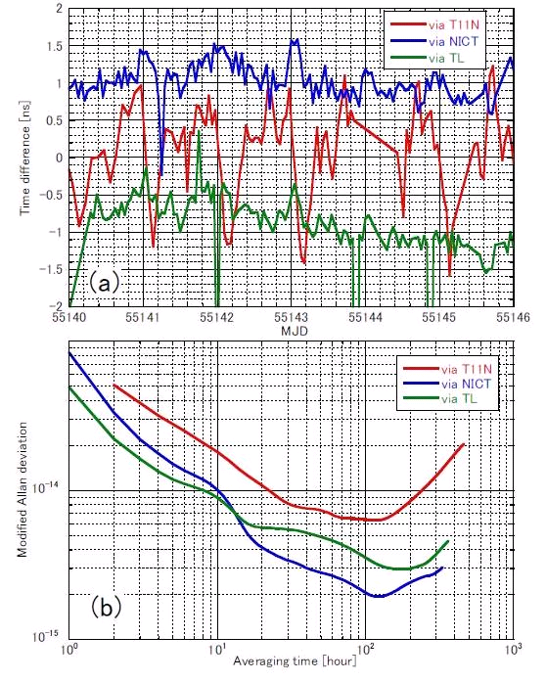

Fig. A1 Indirect links over the baseline OP-PTB (a) Time difference (b) Frequency stability
(After Fujieda ATF 2010)

Annex II: Dr. Arias to the Labs involved: Announcement of the BIPM pilot study plan
draft
To PTB, OP, NICT and TL

Dear colleagues,
During the CCTF TW working group meeting held at Beijing in Sept 2010, the BIPM launched a pilot study to strengthen the Asia-Europe time links. The basic idea is to use the multi-techniques, mainly TW and GPS PPP, in these very long UTC time transfer baselines.
It is my pleasure to inform you that you 4 laboratories are invited to participate in the pilot study, of which the key point is the calibration through the BIPM scheme.
A pre-study has been made and a Technical Memorandum, TM 182 is prepared. You can download the latest version from: ftp://tai.bipm.org/TimeLink/LkC/ .
The chapter 4 presents in details the BIPM calibration scheme. The section 4.7 is the proposed schedule. Comments welcome.
The BIPM will participate in the calibration tour with three geodesic receivers. We are at present making some material preparations and tests at BIPM and later at OP. If everything goes well, we will start the calibration soon after. A draft schedule is given in the section 4.7.
Thank you in advance for your cooperation.

A direct link stands for the link Lab(K)-PTB. An indirect link is a link via an intermediate lab to PTB: Lab(K)-Lab(J)-PTB.
There is a default in the PPP solution, cf [2]. This example proves, by the default is well corrected in the KU+PPP solution.
This is made with the help of the Tsoft menus X0 and M1 using the files MdLink.Lst and CLB_GNSS.Lst
Keep always in mind, here and after, the term Dly_{R} is not measurable and we do not need to know its true value in the BIPM scheme, cf. section 4.3
If one of the three BIPM receivers has absolutely calibrated, we can fix all the relative calibration corrections to the absolute calibration by adding a constant C=Std_{B}(Abs)-Dly_{L}(Std_{B}), cf. Section 4.3
The order of the Step 2 and Step 3 can be changed. However, if the step 3 includes more than 2 labs, it is better to insert the Step 2 in the middle of the Step 3. But this is not obliged.
The PTB standard Ref_{PTB} must be operational during whole calibration tour from the Step 1 to the Step 4 and its setting up is not allowed changing.
Note, the configuration is common-clock short-baseline
The Lab(Ref_{k}) should be continually operational. In case troubles and any changes of set-up is not allowed. When a jump happens, we can find the cause.
All the GPS antennas wherever at BIPM, PTB or Lab(k) are self-positioned by PPP and can be put anywhere. The only attention is to avoid the effect of the multi-paths.
Note, different to Step 2 (Fig. 4.4), there are three measuring links: the first is the common-clock short-baseline configuration at Lab(k) Ref_{k}-Std_{B}; the second is the long baseline two clock non-calibrated UTC link between Ref_{k}-Ref_{PTB}; the third is the long baseline two clock calibrated UTC link between the Std_{B}-Ref_{PTB} with Std_{B} at Lab(k).
Equivalent isotropically radiated power (EIRP) or, alternatively, Effective isotropically radiated power

