BIPM TM176 (ftp://tai.bipm.org/TimeLink/LkC/) version 23 Oct. 2010

BIPM Calibrations of AOS, IPQ, NPL and USNO TWSTFT Time Links

Z. Jiang, W. Lewandowski, A. Harmegnies and D. Piester

1. Introduction 2
2. Implementation schedule 2
Remark 2
Table 1: Alignment of the TW KU UTC link to TW X or GPS MC 3
Figure 1. Alignment of TW to GPS MC for the baseline IPQ-PTB 3
3. Results 4
Table 2 CALR values of the UTC Links 4
Table 3a CALR/ESDVAR for UTC links 4
Table 3b CALR for Non-UTC links 5
4. Discussions 6
4.1 Statistics of the triangle closures 6
Figure 4.1 the histogram of the triangle closures of PTB, CH and USNO 6
Table 4. Verification of the new CALR values with the Triangle closures data of TW1008 and 1009 MJD 55432-55469 7
4.2 Comparison of the TW and GPS PPP UTC time links 8
Table 5 Differences between TW and GPS over the UTC baselines 8
4.3 Comparison of the TW and GPS PPP Non UTC time links 8
5. References: 8
Annex 1. How to make the Implementation 9
A1.1 ITU data file header entries 9
A1.2 Examples for ITU-format data recordings 10
Annex 2. Link comparisons on the baseline USNO-PTB 11
Annex 3. Link comparisons on the UTC baselines 12
Annex 4. Link comparisons on the calibrated Non UTC baselines 16
Annex 5. Triangle closures of the BIPM 2009 and 2010 calibrated time links 26

Implementation schedule:
- Between 24-30 Oct. 2010: The TW LABs check their own CALR and the related ESDVAR in Table 3a and 3b
- The implementation date is at 0h 55502, 2 Nov. 2010: The TW labs implement the new CALR/ESDVAR and the CI codes in their ITU files (c.f. examples in Annex 1). You can do it during the whole month of Nov. and then upload (re-upload) the corrected ITU files to the BIPM ftp site for the UTC computation. The first MJD of the next Circular T 275 is 55504. The computation of CirT 275 will be performed in the earlier Dec.

1. Introduction

The last “BIPM” calibration was the Restoration of the TWSTFT link calibration using GPS bridging after the satellite switch from IS-3R to T-11N in July/August 2009, carried out in Aug. 2009 and implemented in 55102-55108 (28 Sept - 4 Oct), cf. BIPM TM 166 [1]. After several successful “BIPM” calibrations, a standard procedure is established at BIPM so as to supply these kind of service when necessary, cf. [2] for details. This includes mainly the following operations:
- Restore and/or align the TW to a calibrated link, in most case to GPS
- Compute the CALR values and uncertainties for the UTC links (LAB_{j}-PTB), taking into account of the related ESDVAR values
- Compute the CALR values and uncertainties for the Non UTC links (LAB_{j}-LAB_{i}) with the method TCC (triangle closure calibration), taking into account of the related ESDVAR values
- Assigning the CI code to the new calibration
- Preparing the calibration report (TM)
- Verifications of the results
- The TW Labs implement the new CALR/ESDVAR values and the related CI codes in the ITU data files
- The TW Labs upload/re-upload the corrected ITU files to the BIPM ftp site for the next circular T computation

Due to operation/equipment failures, NPL and AOS did not take part in the last “BIPM” calibration in Aug. 2009. Then NPL and AOS came back separately in the end of 2009 and in Oct. 2010. IPQ participated in UTC generation in July 2010. On the other side, studies showed that the USNO-PTB TW KU link suffered a jump about 3 ns with respected to the TW X band and GPS PPP (cf. Annex 2), it was decided to apply a link correction of 3 ns in three steps of 1 ns each. These steps were performed in Jan., Feb. and March 2010. All these modifications require a new BIPM calibration.
This TM176 presents the results of the calibration which concerns only the links with the 4 labs: AOS, NPL, IPQ and USNO. We give here directly results without discussing the methodology. Please cf. [1,2] for the method used in details.

2. Implementation schedule
- Between the 24-30 Oct. 2010: The TW LABs check their own CALR and the related ESDVAR in Table 3a and 3b
- The implementation date is dated on the 0h 55502, the 2 Nov. 2010: The TW labs implement the new CALR/ESDVAR and the CI codes in their ITU files (c.f. examples in Annex 1). You can do it during the whole month Nov. and then upload (re-upload) the corrected ITU files to the BIPM ftp site for the UTC computation. The first MJD of the next Circular T 275 is 55504. The computation of CirT 275 will be performed in the earlier Dec.

Remark
  - We used the GPS MC to make the alignment because the P3 receivers are not calibrated
  - Due to the 1009 data uncompleted, we used one and half month’s data from Mjd 55420-55469
  - Annex 2 to Annex 5 are mainly for the BIPM documentation of this work. People, who are not interesting in details of the computations, can ignore these annexes.
Table 1 presents the results of the alignment computations. We tried to use all the available data. However, the only available data of the baseline IPQ-PTB were from MJD 55376 to 55387 (Figure 1). The GPS MC and P3 before and after this period were extremely disturbed and were not applicable. As illustrated in the Annex 2, the USNO-PTB KU band link was calibrated through the X band in the end of 2008 by USNO (personal communication with D. Matsakis) and then drifted about 2-3 ns during 2009. Earlier studies showed that this drift was stabled with respect to the X band on about Nov. 2009 after, when the difference was -3.5 ns. The recomputed D of NPL-PTB is almost the same as that of 1 year ago.

Table 1: Alignment of the TW KU UTC link to TW X or GPS MC
Baseline | Aligned to | Common Points | D±StDev | Remark
USNO-PTB | Xband | 340 | -3.5±0.9 | 0911
AOS-PTB | MC | 263 | 165.0±1.3 | 1008/1009
IPQ-PTB | MC | 131 | 188.6±2.2 | 1007
NPL-PTB | MC | 410 | -490.3±0.9 | 1008/1009

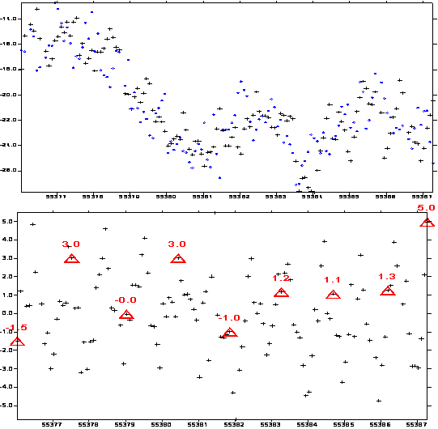
Links[ns with (+) for Link1]: _1007_IPQPTB.TMTA5 , Total: 131Ep
DifLink: Min,Max,Mean: 182.841__194.054__188.584
Sigma= 2.196ns-MeanRmved

Figure 1 Alignment of TW to GPS MC for the baseline IPQ-PTB

3. Results

Table 2 CALR values of the UTC Links

LABi–LABj | CALR  (ns) | CI | S | Alignment  Uncertainty  (ns) | Uncertainty to be  reported in ITU-file header  (ns)
USNO-PTB | 214.5 | 174 | 1 | 0.2 | 3.0
AOS-PTB | -165.0 | 171 | 1 | 0.2 | 7.0
IPQ-PTB | -188.6 | 172 | 1 | 0.4 | 7.0
NPL-PTB | 490.3 | 173 | 1 | 0.2 | 7.0

Table 3a CALR/ESDVAR for UTC links
CI S LABi LABj CALR/ns U/ns ESDVAR/ns

171 1 PTB AOS 165.000 7.0 25.600
1 AOS PTB -165.000 7.0 999999999

172 1 PTB IPQ 188.600 7.0 25.600
1 IPQ PTB -188.600 7.0 999999999

173 1 PTB NPL -490.300 7.0 25.600
1 NPL PTB 490.300 7.0 999999999

174 1 PTB USNO -214.500 3.0 25.600
1 USNO PTB 214.500 3.0 -379.910

TYPE: G.A. (GPS alignment)
Used Since: MJD 55502 (2 Nov. 2010)
Remark: TM176

Table 3b CALR for Non-UTC links
CI Labi Labj S CARL U/ns ESDVAR .
175 AOS CH S=1 43.722 7.0 999999999
CH AOS S=1 -43.722 7.0 8.000
176 AOS IT S=1 315.765 7.0 999999999
IT AOS S=1 -315.765 7.0 999999999
177 AOS IPQ S=1 22.850 7.0 999999999
IPQ AOS S=1 -22.850 7.0 999999999
178 AOS NIST S=1 31.924 7.0 999999999
NIST AOS S=1 -31.924 7.0 -0.724
179 AOS OP S=1 7134.602 7.0 999999999
OP AOS S=1 -7134.602 7.0 999999999
180 AOS ROA S=1 134.121 7.0 999999999
ROA AOS S=1 -134.121 7.0 244.4
181 AOS SP S=1 29.494 7.0 999999999
SP AOS S=1 -29.494 7.0 999999999
182 AOS USNO S=1 -380.016 7.0 999999999
USNO AOS S=1 380.016 7.0 -379.91
183 AOS VSL S=1 306.536 7.0 999999999
VSL AOS S=1 -306.536 7.0 999999999
184 CH IPQ S=1 -20.772 7.0 8.000
IPQ CH S=1 20.772 7.0 999999999
185 CH NPL S=1 -698.956 7.0 8.000
NPL CH S=1 698.956 7.0 999999999
186 CH USNO S=1 -425.517 7.0 8.000
USNO CH S=1 425.517 7.0 -379.91
187 IT IPQ S=1 -292.613 7.0 999999999
IPQ IT S=1 292.613 7.0 999999999
188 IT NPL S=1 -971.260 7.0 999999999
NPL IT S=1 971.260 7.0 999999999
189 IT USNO S=1 -696.084 7.0 999999999
USNO IT S=1 696.084 7.0 -379.91
190 IPQ NIST S=1 9.179 7.0 999999999
NIST IPQ S=1 -9.179 7.0 -0.724
191 IPQ OP S=1 7112.281 7.0 999999999
OP IPQ S=1 -7112.281 7.0 999999999
192 IPQ ROA S=1 110.920 7.0 999999999
ROA IPQ S=1 -110.920 7.0 244.4
193 IPQ SP S=1 8.266 7.0 999999999
SP IPQ S=1 -8.266 7.0 999999999
194 IPQ USNO S=1 -404.188 7.0 999999999
USNO IPQ S=1 404.188 7.0 -379.91
195 IPQ VSL S=1 285.542 7.0 999999999
VSL IPQ S=1 -285.542 7.0 999999999
196 NPL OP S=1 7790.249 7.0 999999999
OP NPL S=1 -7790.249 7.0 999999999
197 NPL ROA S=1 788.880 7.0 999999999
ROA NPL S=1 -788.880 7.0 244.4
198 NPL SP S=1 685.324 7.0 999999999
SP NPL S=1 -685.324 7.0 999999999
199 OP USNO S=1 -7515.554 7.0 999999999
USNO OP S=1 7515.554 7.0 -379.91
200 ROA USNO S=1 -516.927 7.0 244.4
USNO ROA S=1 516.927 7.0 -379.91
201 SP USNO S=1 -411.545 7.0 999999999
USNO SP S=1 411.545 7.0 -379.91
202 NIST ROA S=1 -18.702 7.0 -0.724
ROA NIST S=1 18.702 7.0 999999999
203 USNO VSL S=1 686.291 7.0 -379.91
VSL USNO S=1 -686.291 7.0 999999999

TYPE: T.C. (triangle closure)
Used Since: MJD 55502 (2 NOV. 2010)
Remark: TM176

Remarks: there were almost not data for the NPL concerned links with AOS, CH, NIST, USNO and VSL. These links are not calibrated in this computation.

4. Discussions

In this section, we will make some detailed discussions which are rather for the BIPM technical back up and documentation of this work. This may be helpful for those who want to deeply study the TW error source including the diurnals, calibration variations, TW triangle behaviors, time link comparisons etc. Those who are not interesting in these details can ignore this section.

4.1 Statistics of the triangle closures

The last BIPM calibration was in Aug. 2009. All the UTC calibrations were restored after the satellite change with the method of the GPS bridge. All the non UTC links in the TW network, except for AOS, IPQ and NPL, were recalibrated with the method TCC [1].

Now 13 months after, are the TW calibrations change and how much if yes ? As we know that, after the calibration, the triangle closures should be zero and non zero closures are the errors and they are the “true errors”. Table 4 and the Annex 5 illustrate statistic results. In Table 4, the d is the non zero closure of the triangle composed by the link in the table with the two adjacent UTC links. All the d concerned links with AOS, IPQ, NPL and USNO, for example AOS-NIST, demonstrate the residuals of this computation. All the others, for example, NIST-OP, demonstrate the variations (in addition to the computation residuals) since last calibration (Aug. 2009) of the calibrations of the related three links in the triangle of NIST-OP-PTB. Annex 5 illustrates the histograms of the closures. The data used are between MJD 55430 to 55469.

The TCC uncertainty is 2 ns, cf. [1,2]. We observe that in the Table 4 and Annex 5, most of the d are less than 1 ns. Considering the uA of TW is 0.5 and the TW quality is degraded since the switch to the new satellite, the calibration is very stable. A few (in blue) are bigger than 1 ns, by looking at the plots in Annex 2, 3 and 4, we think that these anomaly closures are from some causes other than the TW measurements or calibrations, e.g. some IT concerned links were obviously biased by an inconstant slop (e.g. the last plot in the first page of Annex 3).

Histogram - Link Triangle Closure of T PTB CH USNO , Mean/RMS/SD= -4 731 730

PicoSec|No.| Total In/Out: 456/ 416
-2250| 2| ++
-2000| 1| +
-1750| 5| +++++
-1500| 7| +++++++
-1250| 13| +++++++++++++
-1000| 17| +++++++++++++++++
-750| 38| ++++++++++++++++++++++++++++++++++++++
-500| 38| ++++++++++++++++++++++++++++++++++++++
-250| 56| ++++++++++++++++++++++++++++++++++++++++++++++++++++++++
0| 54| ++++++++++++++++++++++++++++++++++++++++++++++++++++++
250| 56| ++++++++++++++++++++++++++++++++++++++++++++++++++++++++
500| 52| ++++++++++++++++++++++++++++++++++++++++++++++++++++
750| 37| +++++++++++++++++++++++++++++++++++++
1000| 18| ++++++++++++++++++
1250| 10| ++++++++++
1500| 7| +++++++
1750| 2| ++
2000| 2| ++
2250| 1| +

Figure 4.1 the histogram of the triangle closures of PTB, CH and USNO

Table 4. Verification of the new CALR values with the Triangle closures data of TW1008 and 1009 MJD 55432-55469

Labi Labj d+/-StDev N ESIG
AOS CH 0.005 +/- 0.726 388 0.037
CH AOS -0.005 +/- 0.726 388 0.037
AOS IT -0.012 +/- 1.568 372 0.081
IT AOS 0.012 +/- 1.568 372 0.081
AOS IPQ -0.009 +/- 0.795 381 0.041
IPQ AOS 0.009 +/- 0.795 381 0.041
AOS NIST -0.001 +/- 0.590 390 0.030
NIST AOS 0.001 +/- 0.590 390 0.030
AOS OP 0.006 +/- 1.120 390 0.057
OP AOS -0.006 +/- 1.120 390 0.057
AOS ROA 0.002 +/- 0.723 387 0.037
ROA AOS -0.002 +/- 0.723 387 0.037
AOS SP 0.015 +/- 1.199 375 0.062
SP AOS -0.015 +/- 1.199 375 0.062
AOS USNO 0.005 +/- 0.762 379 0.039
USNO AOS -0.005 +/- 0.762 379 0.039
AOS VSL -0.013 +/- 1.324 328 0.073
VSL AOS 0.013 +/- 1.324 328 0.073
CH IT 2.186 +/- 1.530 403 0.076
IT CH -2.186 +/- 1.530 403 0.076
CH IPQ -0.015 +/- 1.056 419 0.052
IPQ CH 0.015 +/- 1.056 419 0.052
CH NIST -0.449 +/- 0.684 431 0.033
NIST CH 0.449 +/- 0.684 431 0.033
CH NPL -0.027 +/- 0.950 118 0.087
NPL CH 0.027 +/- 0.950 118 0.087
CH OP 0.150 +/- 0.815 430 0.039
OP CH -0.150 +/- 0.815 430 0.039
CH ROA -0.685 +/- 0.739 427 0.036
ROA CH 0.685 +/- 0.739 427 0.036
CH SP 0.285 +/- 1.140 372 0.059
SP CH -0.285 +/- 1.140 372 0.059
CH USNO -0.004 +/- 0.730 416 0.036
USNO CH 0.004 +/- 0.730 416 0.036
CH VSL -0.658 +/- 1.085 98 0.110
VSL CH 0.658 +/- 1.085 98 0.110
IT IPQ 0.009 +/- 1.526 318 0.086
IPQ IT -0.009 +/- 1.526 318 0.086
IT NIST -3.131 +/- 1.098 403 0.055
NIST IT 3.131 +/- 1.098 403 0.055
IT NPL -0.011 +/- 0.573 230 0.038
NPL IT 0.011 +/- 0.573 230 0.038
IT OP -1.120 +/- 0.900 403 0.045
OP IT 1.120 +/- 0.900 403 0.045
IT ROA -0.478 +/- 0.296 400 0.015
ROA IT 0.478 +/- 0.296 400 0.015
IT SP -0.740 +/- 0.849 397 0.043
SP IT 0.740 +/- 0.849 397 0.043
IT USNO 0.013 +/- 1.732 391 0.088
USNO IT -0.013 +/- 1.732 391 0.088
IT VSL -0.544 +/- 0.288 10 0.091
VSL IT 0.544 +/- 0.288 10 0.091
IPQ NIST 0.005 +/- 0.726 419 0.035
NIST IPQ -0.005 +/- 0.726 419 0.035
IPQ OP -0.002 +/- 1.194 424 0.058
OP IPQ 0.002 +/- 1.194 424 0.058
IPQ ROA 0.017 +/- 0.853 420 0.042
ROA IPQ -0.017 +/- 0.853 420 0.042
IPQ SP 0.013 +/- 3.763 271 0.229
SP IPQ -0.013 +/- 3.763 271 0.229
IPQ USNO 0.009 +/- 0.953 393 0.048
USNO IPQ -0.009 +/- 0.953 393 0.048
IPQ VSL -0.137 +/- 9.106 112 0.860
VSL IPQ 0.137 +/- 9.106 112 0.860
NIST OP 0.424 +/- 0.693 421 0.034
OP NIST -0.424 +/- 0.693 421 0.034
NIST ROA 0.000 +/- 0.661 427 0.032
ROA NIST 0.000 +/- 0.661 427 0.032
NIST SP 1.733 +/- 0.817 424 0.040
SP NIST -1.733 +/- 0.817 424 0.040
NIST VSL 0.316 +/- 1.202 369 0.063

4.2 Comparison of the TW and GPS PPP UTC time links

The following table gives the differences with the UTC TW links and that of GPS. Annex 3 illustrates the plot of these link comparisons.

The UTC TW links between PTB and CH, IT, OP, SP, USNO and VSL (blue in the following table) are equipment calibrated with uncertainty uB about 1ns. On the other side, the GPS P3 (PPP) were calibrated with uB=5ns. As illustrated in the Table 5 and in the Annex 3, the differences between the links of PTB with IT (PPP), OP, USNO and VSL are less or about 2ns. In particular, as pointed out above, the USNO-PTB TW KU link was aligned to the X link in last November 2009. The difference between the KU and PPP is now only 1.2 ns. This proves the alignment operation in the early of 2010 of the 3ns correction was correct.

Some other links have differences bigger than 5 ns, such as PTB with CH, ROA and SP. The difference between TW and GPS PPP of the baseline of ROA-PTB is 5.1 ns which is rather different than an earlier report [3].

It seems a little strange that for the baseline IT-PTB, the difference between PPP and P3 is 4.7-2.1=2.6 ns while both should have the same calibration ! That was why, I think there is a bias in the related links (see section 4.2 and the last plot of the first page of Annex 3 as well as the plot just after).

Table 5 Differences between TW and GPS over the UTC baselines

0.2 0.0 AOSPTB.TTTT_.lkT +- 1.2 363 ! by AOSPTB.TMTA4
6.9 0.0 CHPTB.TTTT_.lkT +- 0.8 382 ! by CHPTB.TGT34
-4.7 0.0 ITPTB.TTTT_.lkT +- 1.9 342 ! by ITPTB.TPTA4
-2.1 0.0 ITPTB.TTTT_.lkT +- 1.9 342 ! by ITPTB.TGT34
2.9 0.0 NISTPTB.TTTT_.lkT +- 0.4 401 ! by NISTPTB.TGT34
-1.1 0.0 NPLPTB.TTTT_.lkT +- 0.4 118 ! by NPLPTB.TGT34
-0.6 0.0 OPPTB.TTTT_.lkT +- 0.7 400 ! by OPPTB.TGT34
5.1 0.0 ROAPTB.TTTT_.lkT +- 1.2 391 ! by ROAPTB.TGT34
6.2 0.0 SPPTB.TTTT_.lkT +- 0.8 388 ! by SPPTB.TGT34
1.2 0.0 USNOPTB.TTTT_.lkT +- 1.3 372 ! by USNOPTB.TGT34
2.6 0.0 VSLPTB.TTTT_.lkT +- 1.2 372 ! by VSLPTB.TGT34
END ---1009 dLk=Lk1-Lk2=Align Lk1 to Lk2=M1(Lab2-Lab1/Lk1)=CLB(Lab2ofLk1) by F3s34/Z4

4.3 Comparison of the TW and GPS PPP Non UTC time links

Similar to the Annex 3, the Annex 4 gives the link comparisons for the Non-UTC baselines. The differences are that in Annex 3, the TW links are of the original calibrations and in Annex 4, the links are of the TTC calibration.

5. References:
[1] Jiang, Lewandowski and Piester, BIPM TM 166, Restoration the TWSTFT link calibration using GPS bridging after the satellite switch from IS-3R to T-11N in July/August 2009,Aug 2009
[2] Jiang, Piester and Liang, Restoring a TWSTFT Calibration with a GPS Bridge - A standard procedure for UTC time transfer, Proc. EFTF 2010
[3] H. Esteban, J. Palacio, F. J. Galindo, T. Feldmann, A. Bauch, D. Piester, A GPS calibration trip expeerience between ROA and PTB, Proc. EFTF 2009

Annex 1. How to make the Implementation

A1.1 ITU data file header entries
Here are listed examples to be implemented into the “TW” file header. Because the UTC-links are bridged links the header entry should be “CAL 125 BRIDGED” (see CH01 – PTB01), the non-UTC links are recalibrated by the TCC and thus the header entry should be “TRIANGLE CLOSURE”(see CH01 - IT01).

Example 1.

European “TW”-files:
* LINK 12 SAT: TELSTAR 11N NLO: E 322 30 00.000 XPNDR: 999999999 ns
* SAT-NTX: 11004.7200 MHz SAT-NRX: 14304.7200 MHz BW: 2.5 MHz
* LINK 13 SAT: TELSTAR 11N NLO: E 322 30 00.000 XPNDR: 999999999 ns
* SAT-NTX: 11485.5500 MHz SAT-NRX: 14026.5500 MHz BW: 2.5 MHz

US “TW”-files:
* LINK 13 SAT: TELSTAR 11N NLO: E 322 30 00.000 XPNDR: 999999999 ns
* SAT-NTX: 11726.5500 MHz SAT-NRX: 14285.5500 MHz BW: 2.5 MHz

Examples for the additional header entries:
CH01 – PTB01:
* CAL 139 TYPE: CAL 125 BRIDGED MJD: 55043 EST. UNCERT.: 1.000 ns

USNO01 – PTB01:
* CAL 140 TYPE: CAL 114 BRIDGED MJD: 55043 EST. UNCERT.: 1.100 ns

NIST01 – PTB01:
* CAL 141 TYPE: CAL 113 BRIDGED MJD: 55043 EST. UNCERT.: 5.000 ns

IT01 – PTB01:
* CAL 142 TYPE: CAL 113 BRIDGED MJD: 55043 EST. UNCERT.: 1.200 ns

OP01 – PTB01:
* CAL 143 TYPE: CAL 134 BRIDGED MJD: 55043 EST. UNCERT.: 1.100 ns

ROA01 – PTB01:
* CAL 144 TYPE: CAL 118 BRIDGED MJD: 55043 EST. UNCERT.: 5.000 ns

SP01 – PTB01:
* CAL 145 TYPE: CAL 119 BRIDGED MJD: 55043 EST. UNCERT.: 1.100 ns

VSL01 – PTB01:
* CAL 146 TYPE: CAL 120 BRIDGED MJD: 55043 EST. UNCERT.: 1.200 ns

CH01 – IT01:
* CAL 147 TYPE: TRIANGLE CLOSURE MJD: 55043 EST. UNCERT.: 2.000 ns

Example 2. the header of IPQ)
1 * FORMAT 01
2 * LAB IPQ
3 * REV DATE 2010-11-02
4 * ES IPQ01 LA: N 38 40 16.023 LO: W 9 11 10.033 HT: +0151.20 m
5 * REF-FRAME ITRF 2005
6 * LINK 12 SAT: TELSTAR 11N NLO: E 322 30 00.000 XPNDR: 999999999 ns
7 * SAT-NTX: 11004.7200 MHz SAT-NRX: 14304.7200 MHz BW: 2.5 MHz
8 * LINK 13 SAT: TELSTAR 11N NLO: E 322 30 00.000 XPNDR: 999999999 ns
9 * SAT-NTX: 11485.5500 MHz SAT-NRX: 14026.5500 MHz BW: 2.5 MHz
18 * CAL 172 TYPE: GPS MJD: 55502 EST. UNCERT.: 7.0 ns
10 * CAL 177 TYPE: TRIANGLE CLOSURE MJD: 55502 EST. UNCERT.: 7.0 ns
11 * CAL 184 TYPE: TRIANGLE CLOSURE MJD: 55502 EST. UNCERT.: 7.0 ns
12 * CAL 187 TYPE: TRIANGLE CLOSURE MJD: 55502 EST. UNCERT.: 7.0 ns
13 * CAL 190 TYPE: TRIANGLE CLOSURE MJD: 55502 EST. UNCERT.: 7.0 ns
14 * CAL 191 TYPE: TRIANGLE CLOSURE MJD: 55502 EST. UNCERT.: 7.0 ns
15 * CAL 192 TYPE: TRIANGLE CLOSURE MJD: 55502 EST. UNCERT.: 7.0 ns
16 * CAL 194 TYPE: TRIANGLE CLOSURE MJD: 55502 EST. UNCERT.: 7.0 ns
17 * CAL 195 TYPE: TRIANGLE CLOSURE MJD: 55502 EST. UNCERT.: 7.0 ns
20 * LOC-MON NO
21 * MODEM SATRE 318
22 * COMMENTS:

A1.2 Examples for ITU-format data recordings

Examples for the data lines are listed in the following. Changes to be applied are in bold and blue numbers.

* EARTH-STAT LI MJD STTIME NTL TW DRMS SMP ATL REFDELAY RSIG CI S CALR ESDVAR ESIG TMP HUM PRES
* LOC REM hhmmss s s ns s s ns ns ns ns degC % mbar

TWIPQ55.437

Currently :
IPQ01 PTB01 12 55437 004000 119 0.260344277075 0.114 121 120 0.000000793149 0.090 999 9 999999999 999999999 99999 999 999 9999

Replaced :
IPQ01 PTB01 12 55437 004000 119 0.260344277075 0.114 121 120 0.000000793149 0.090 172 1 -188.600 999999999 99999 999 999 9999

Annex 2. Link comparisons on the baseline USNO-PTB

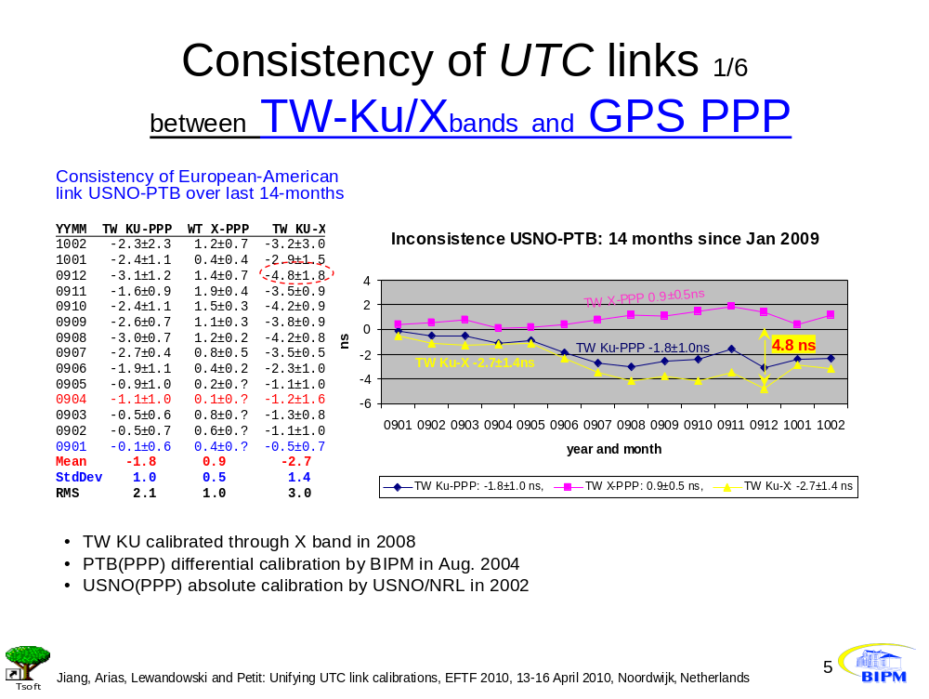

Annex 3. Link comparisons on the UTC baselines

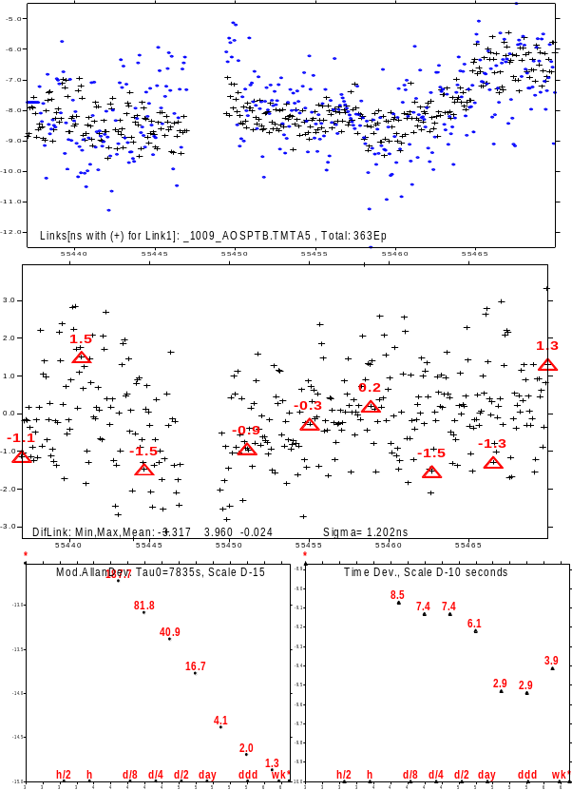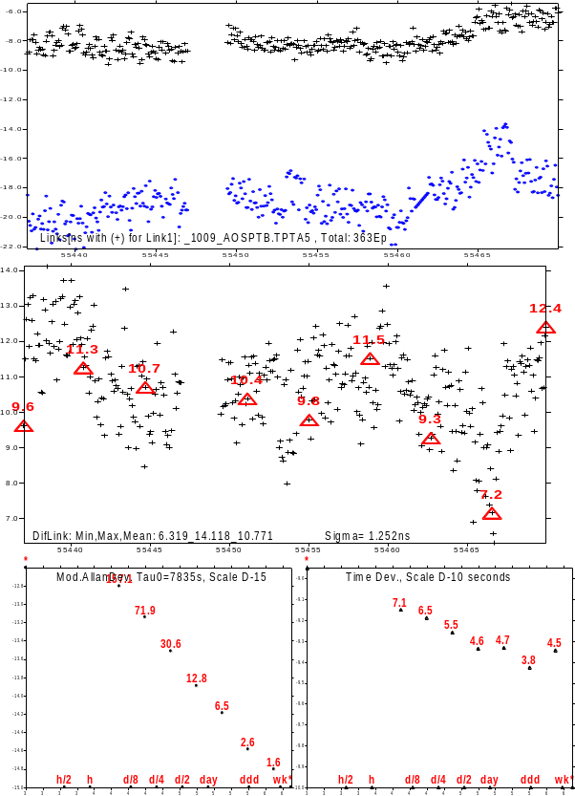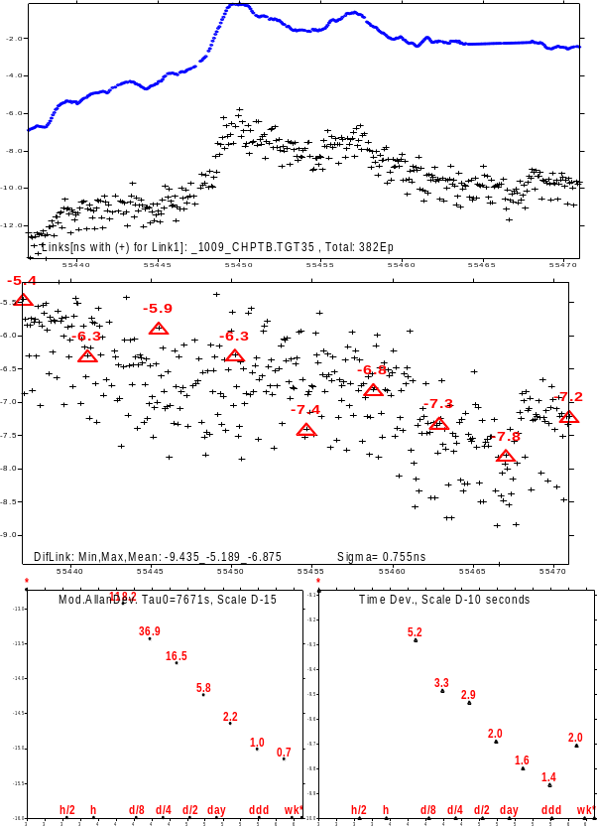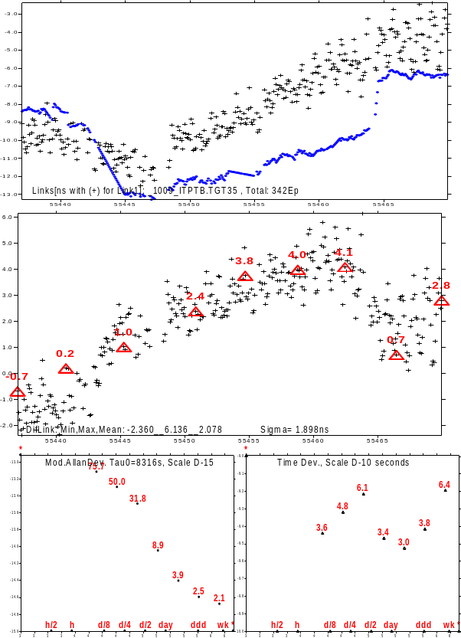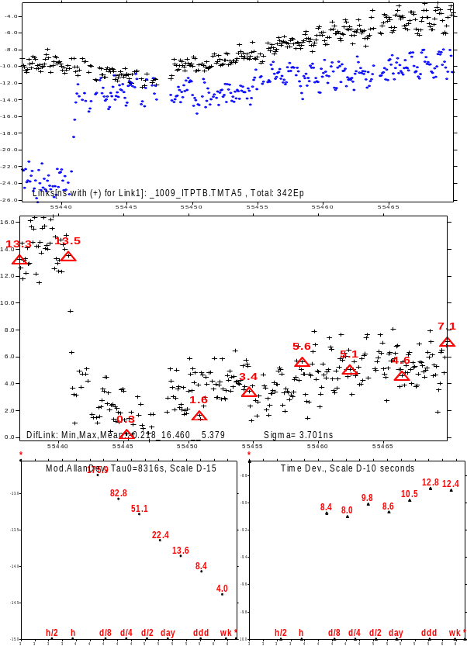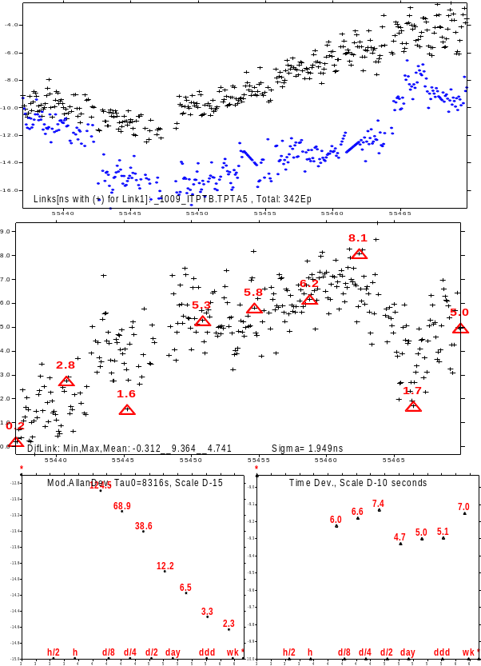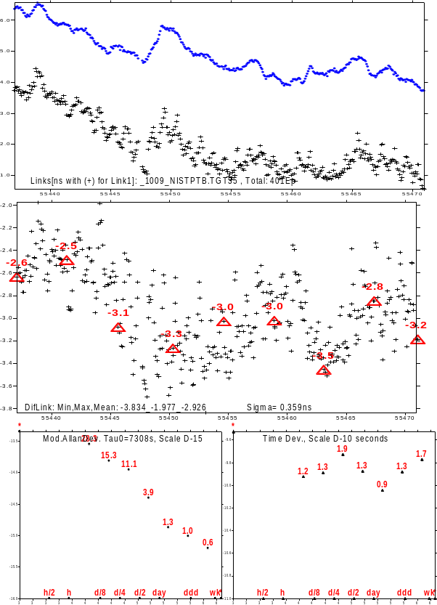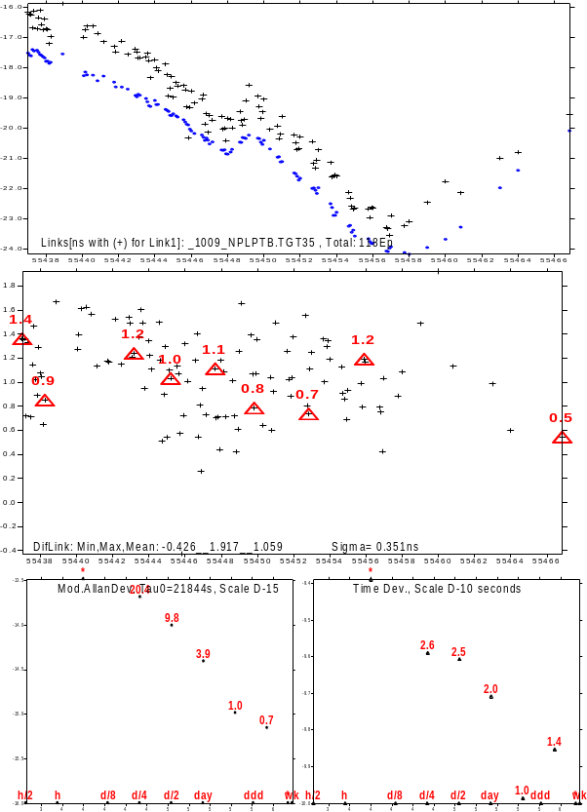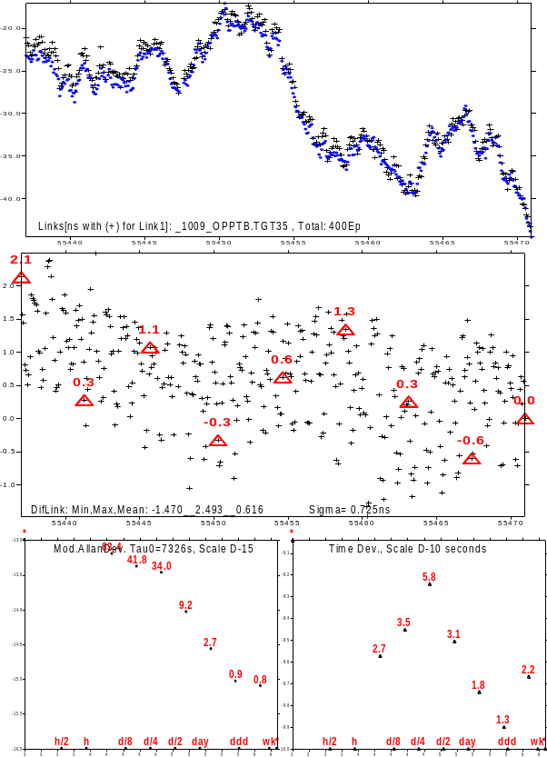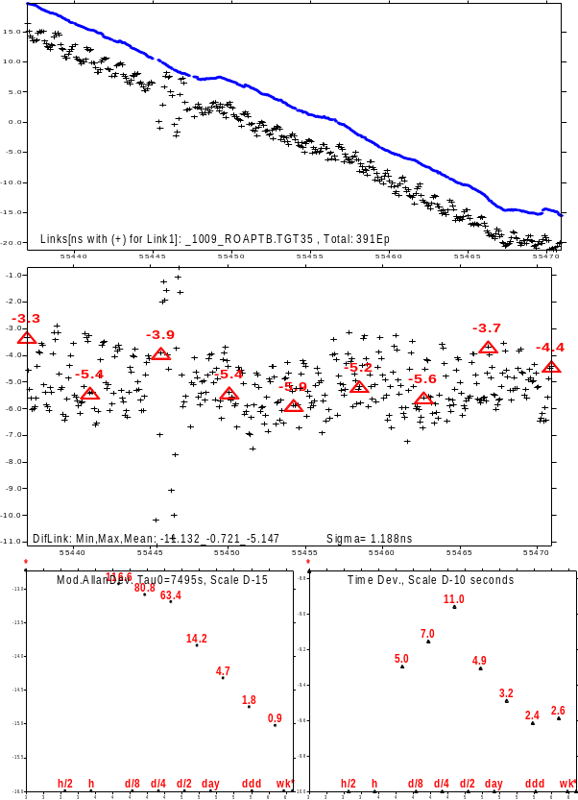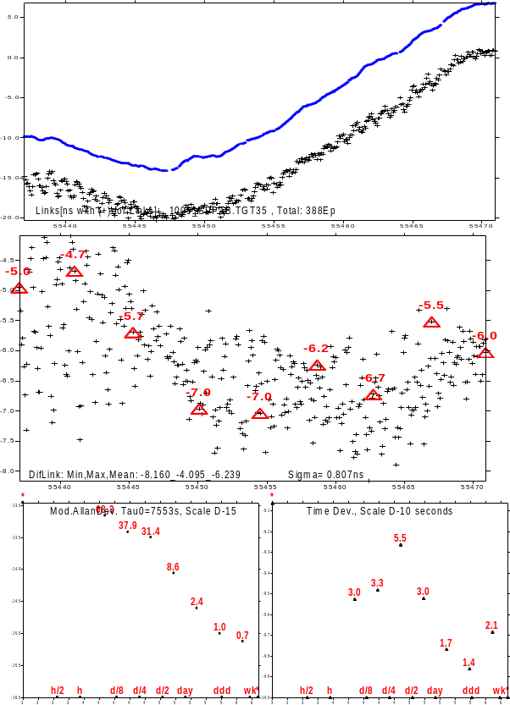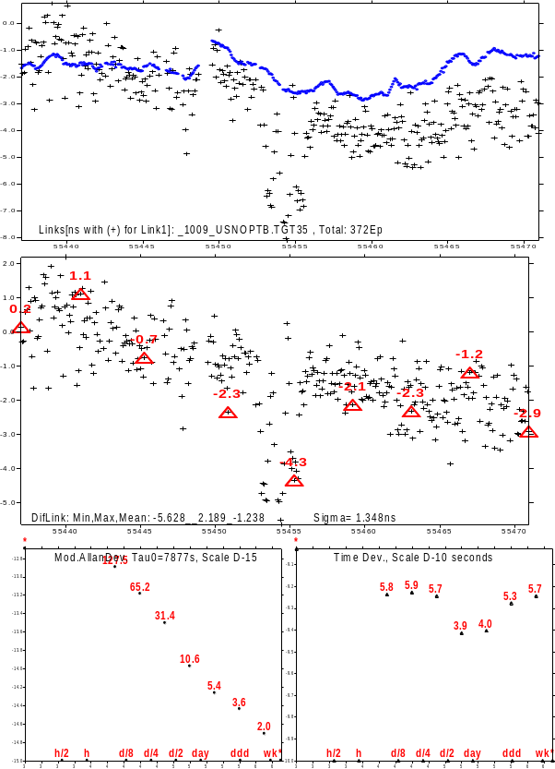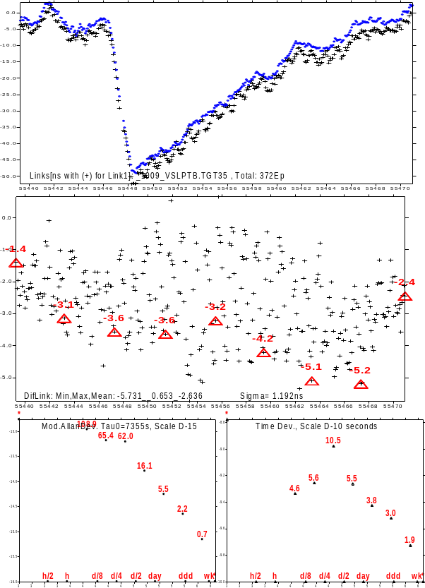

Annex 4. Link comparisons on the calibrated Non UTC baselines
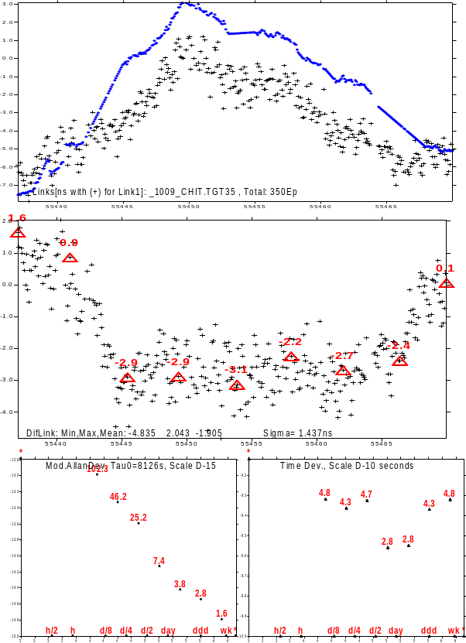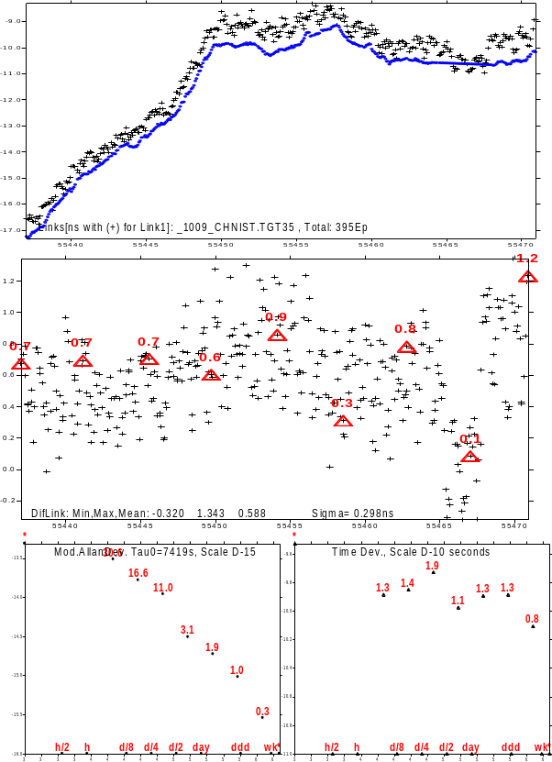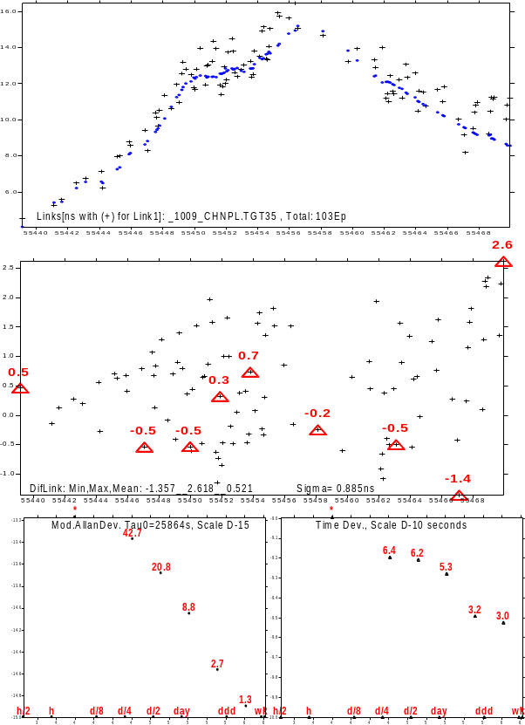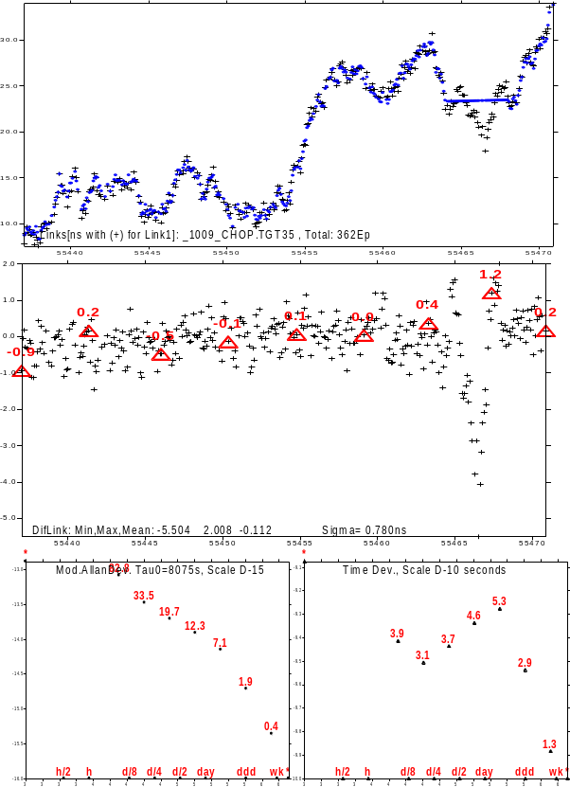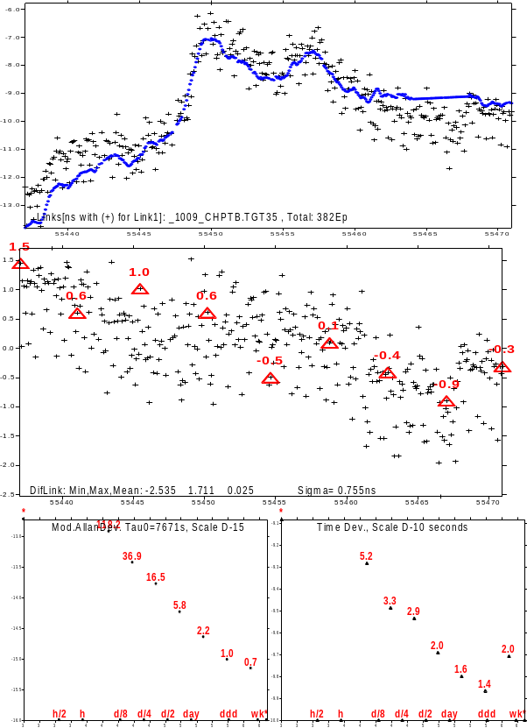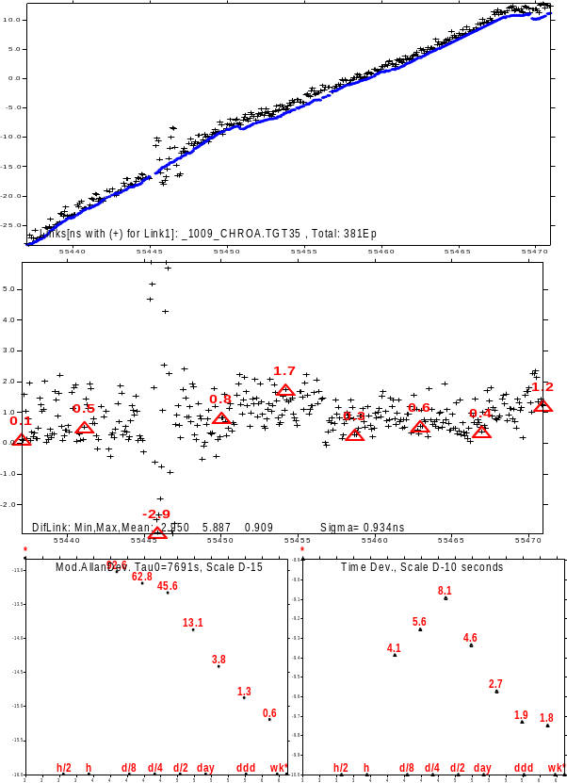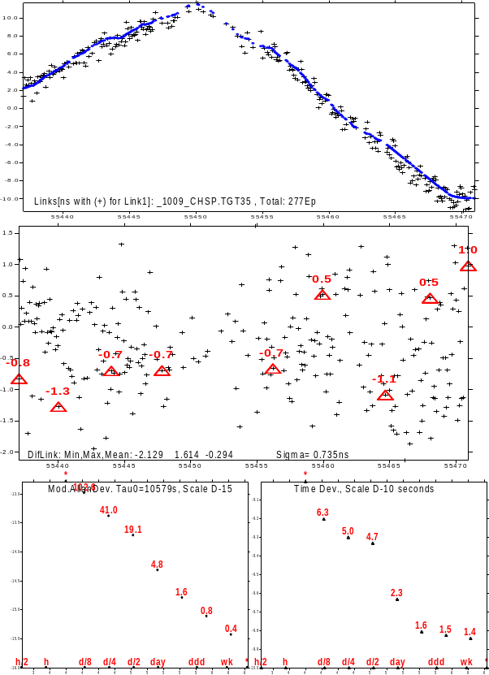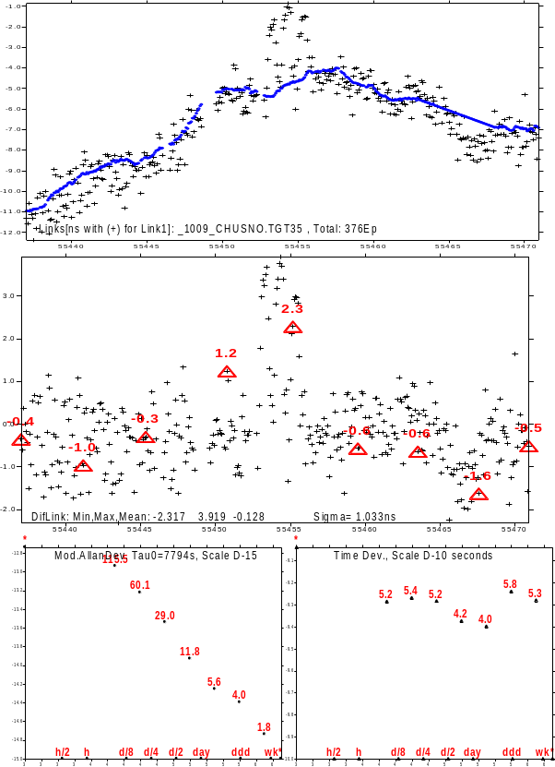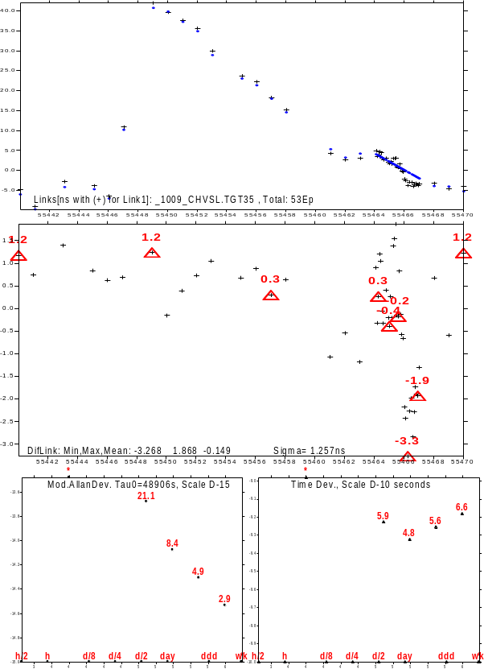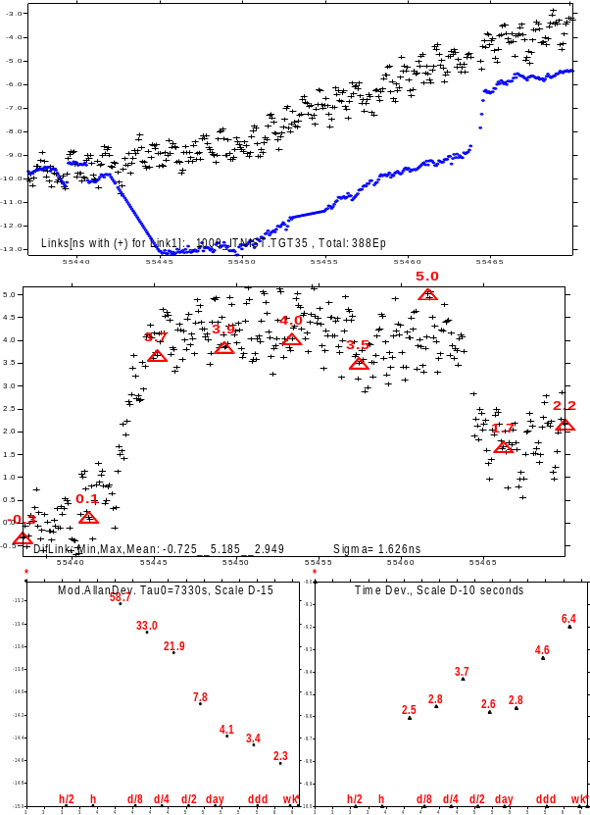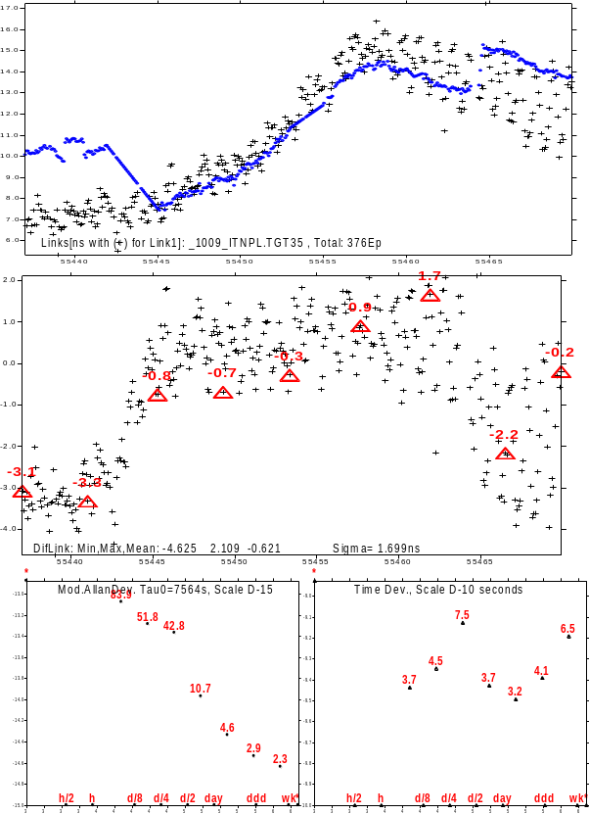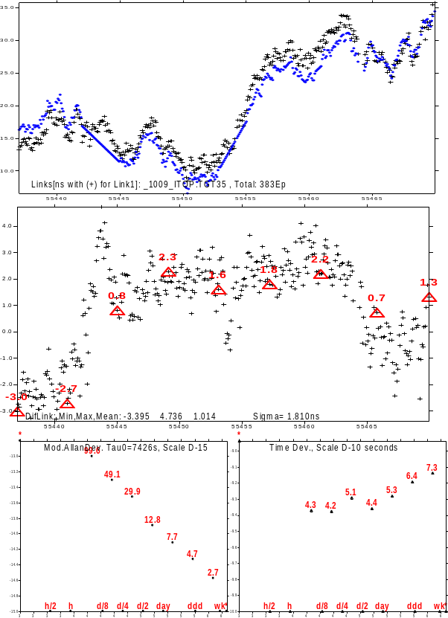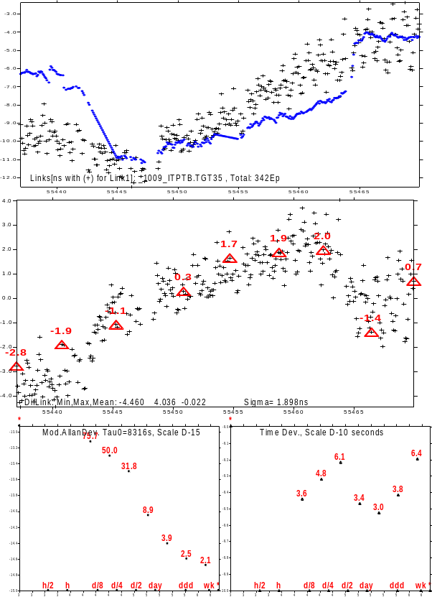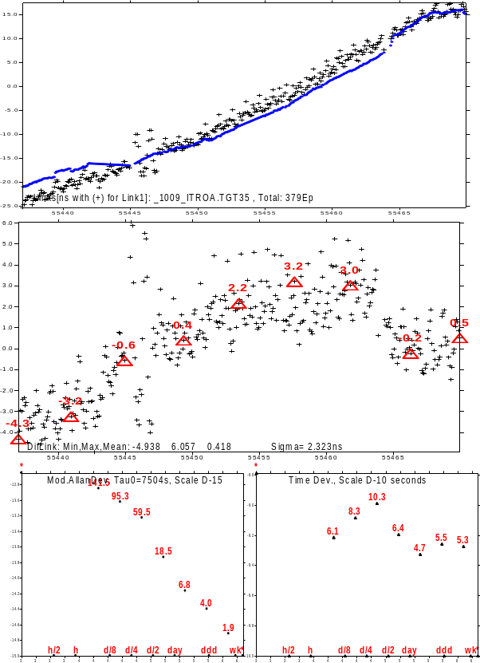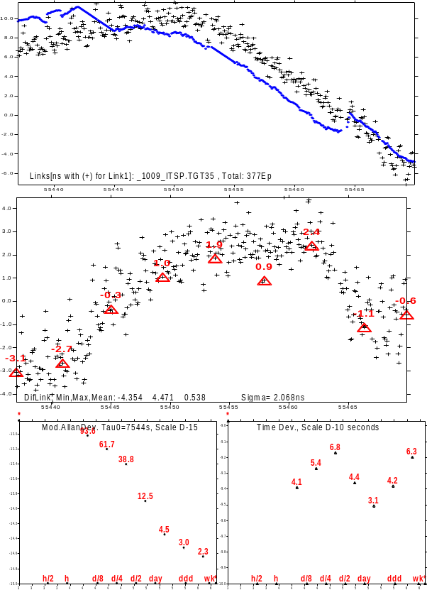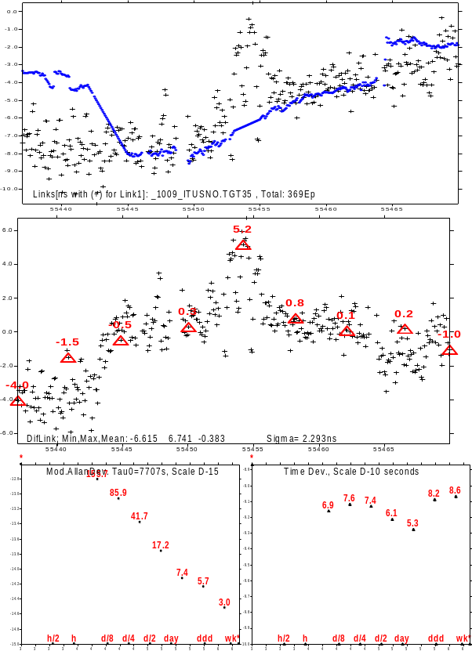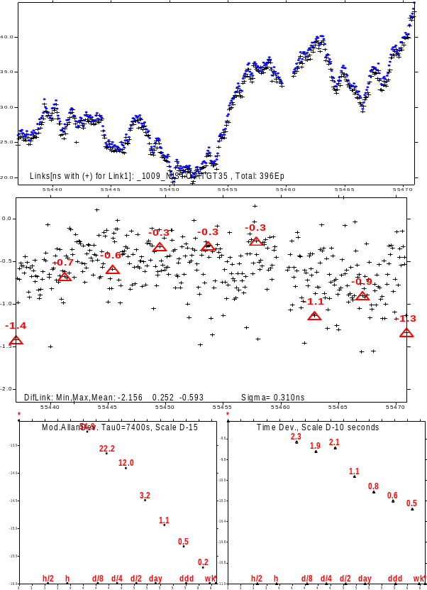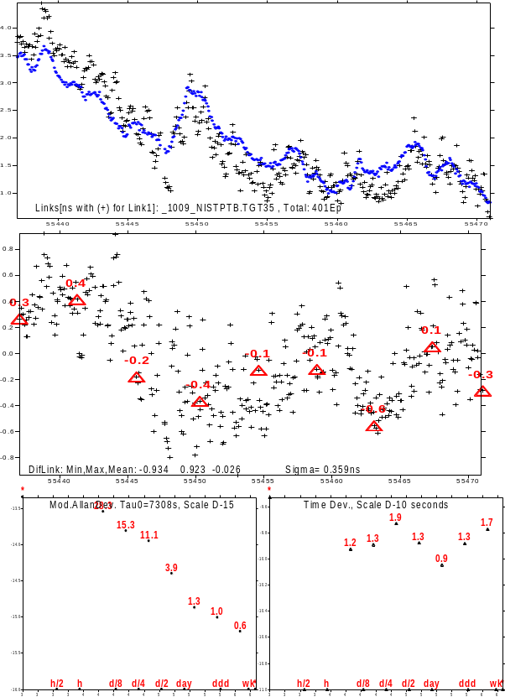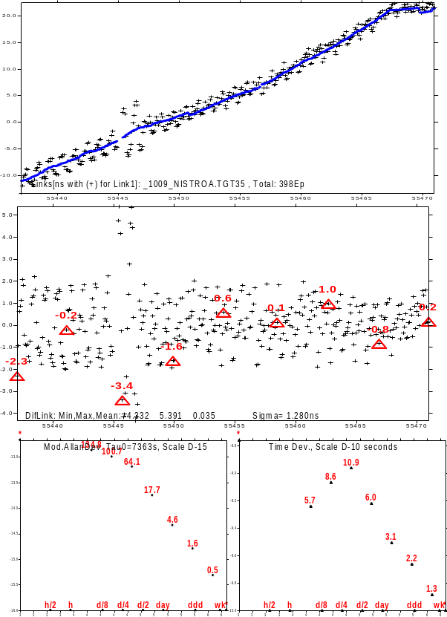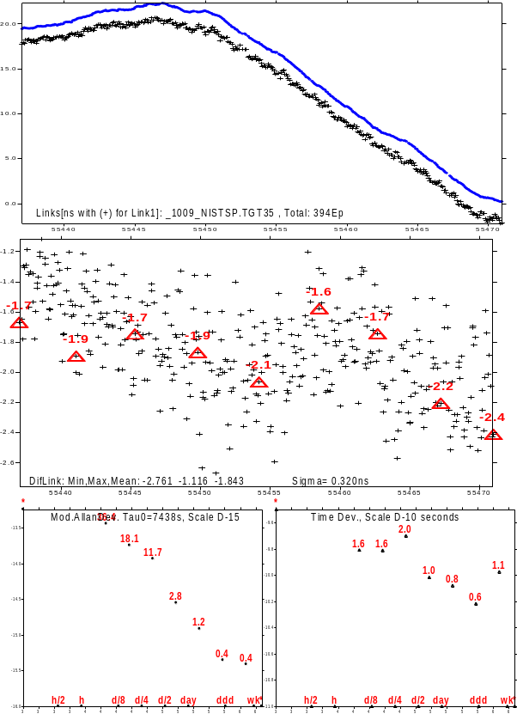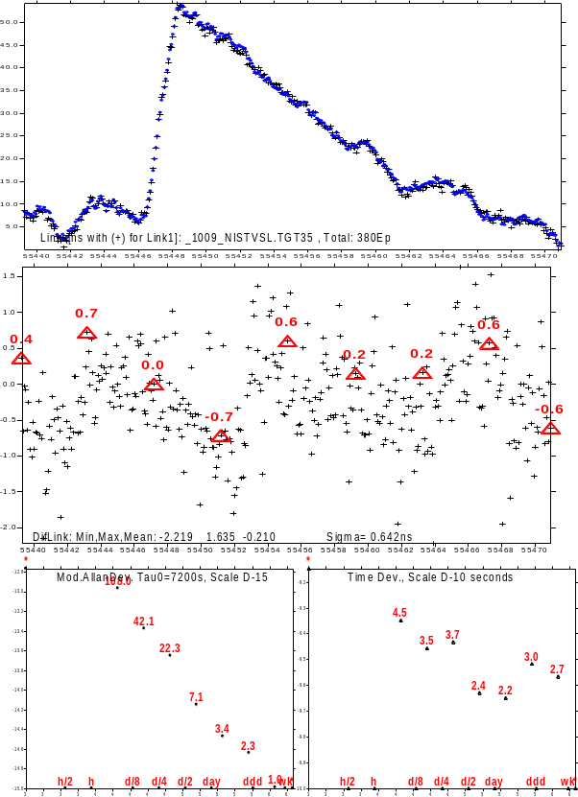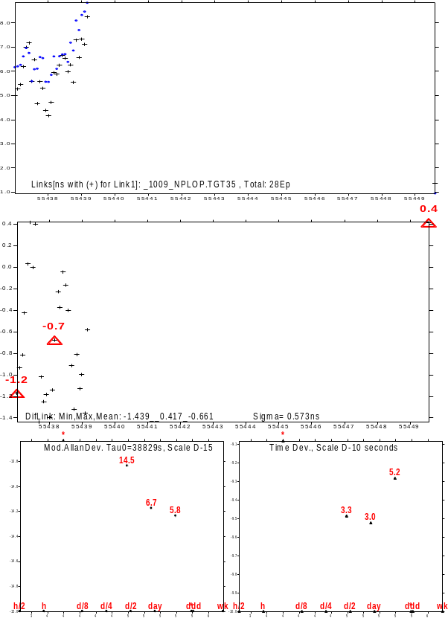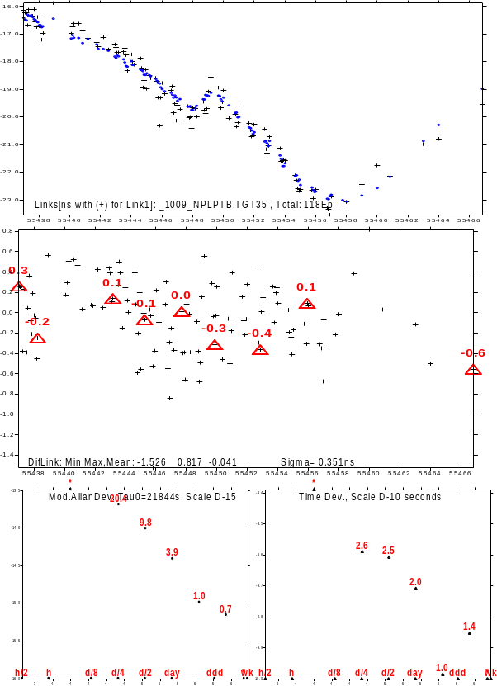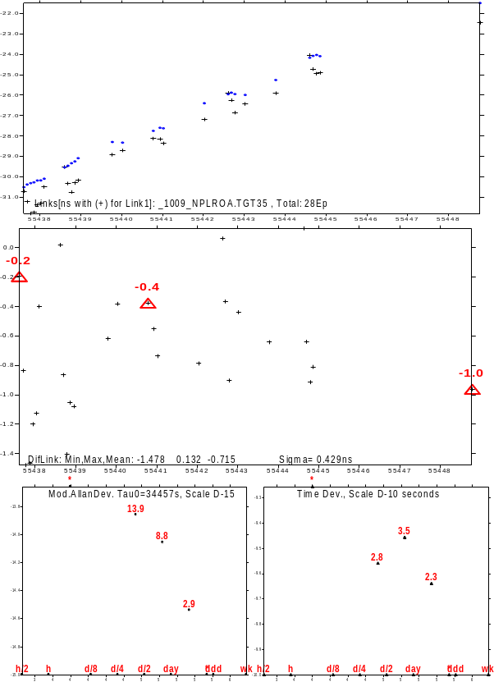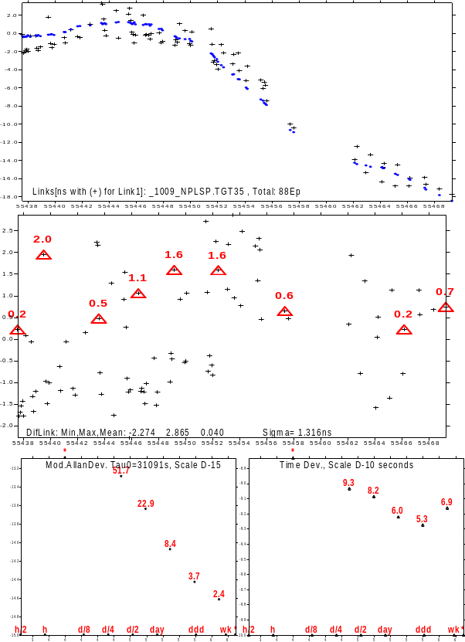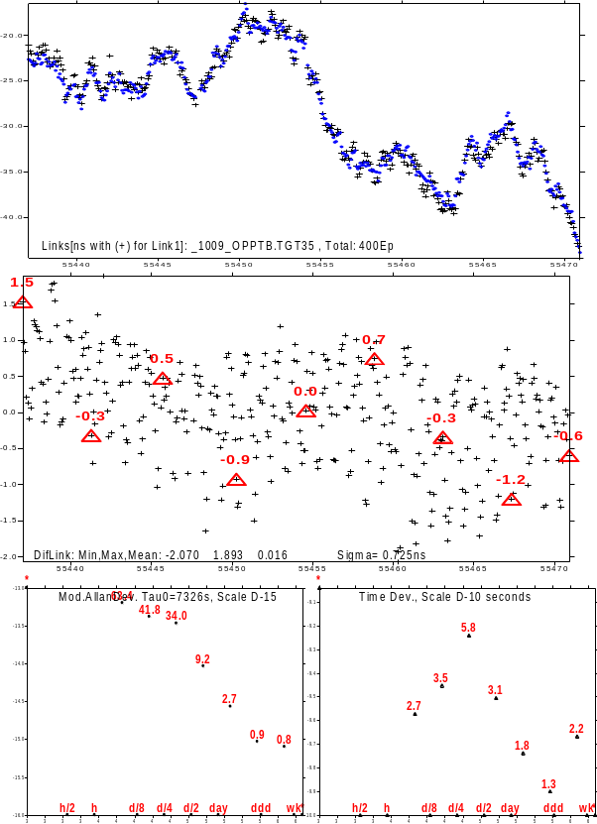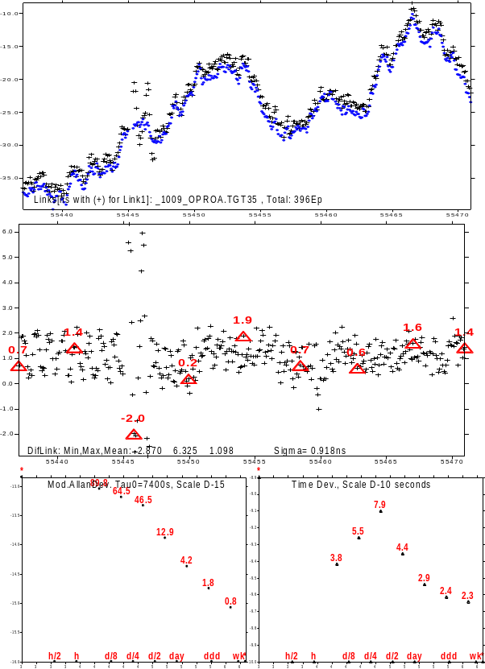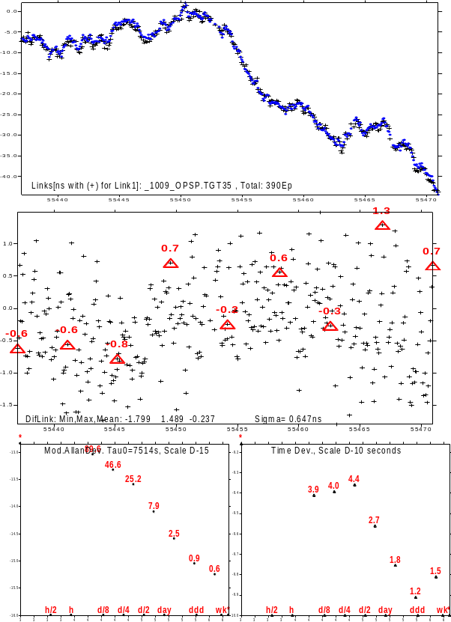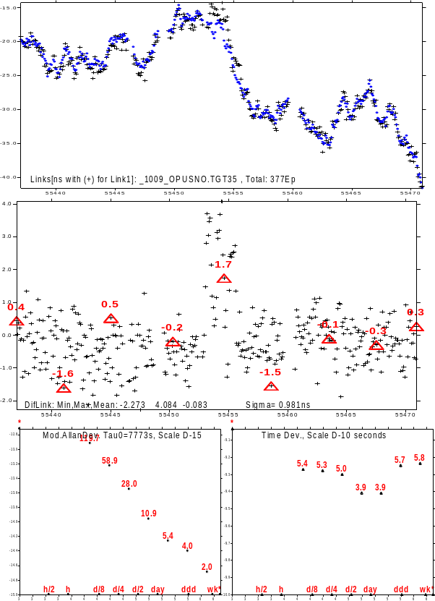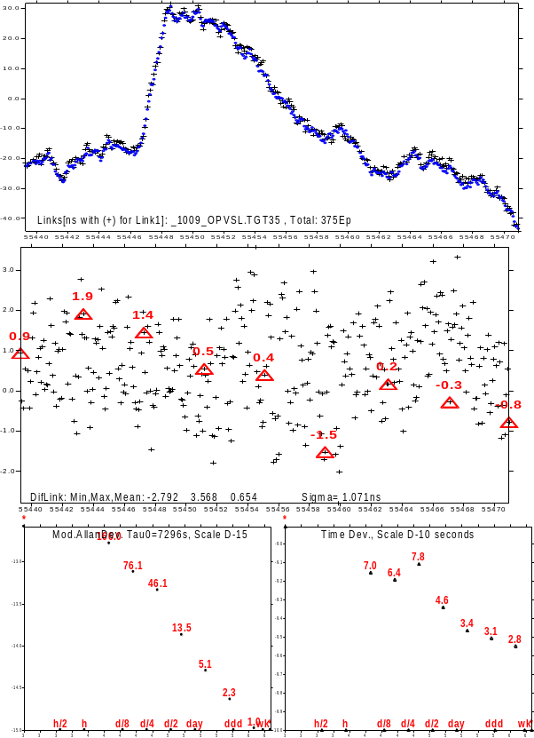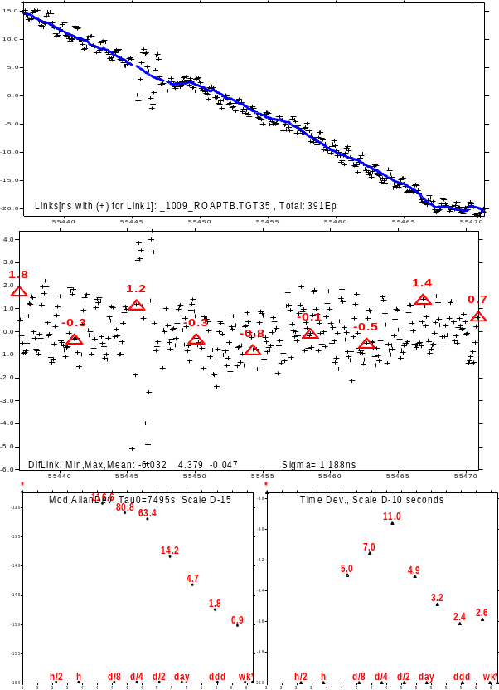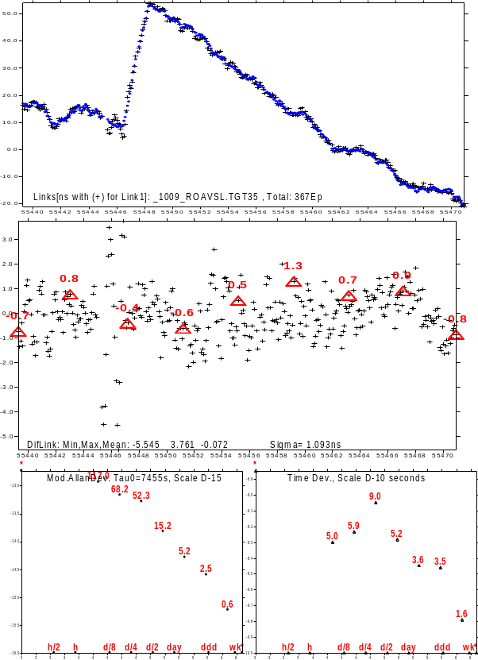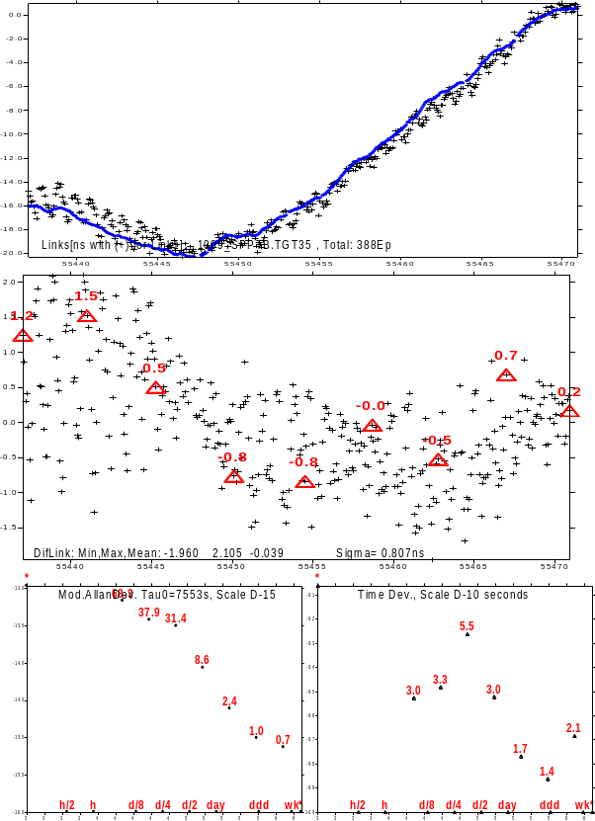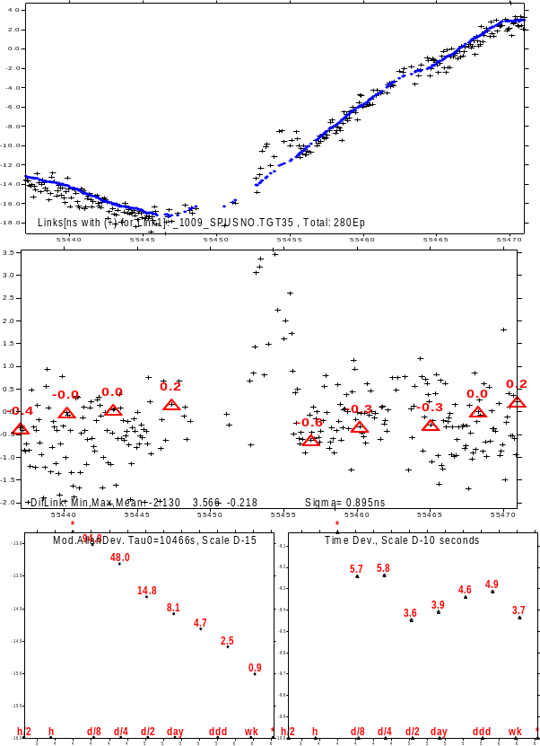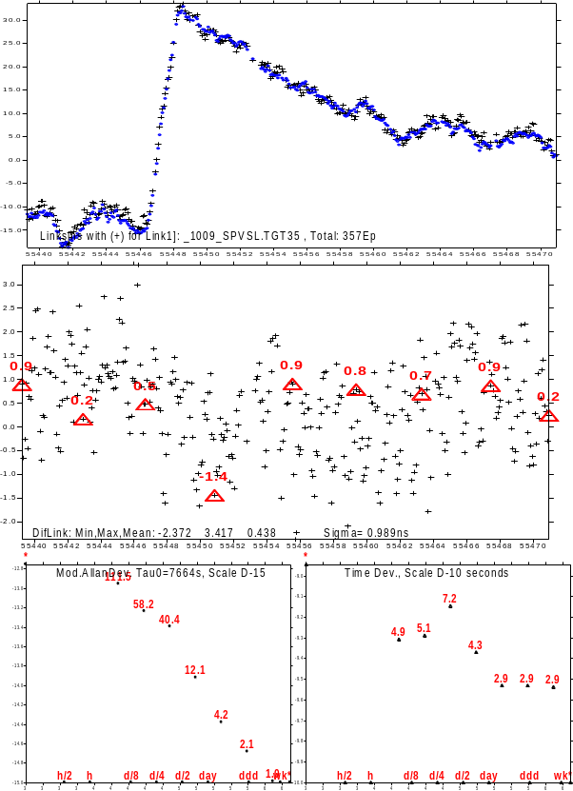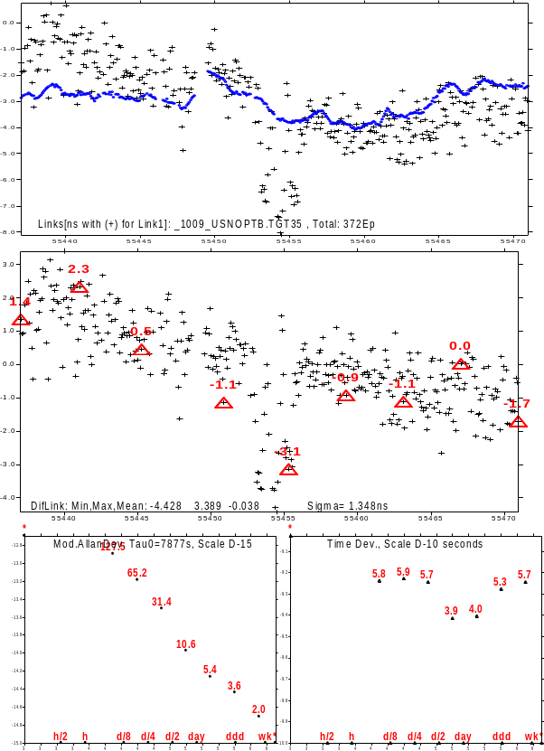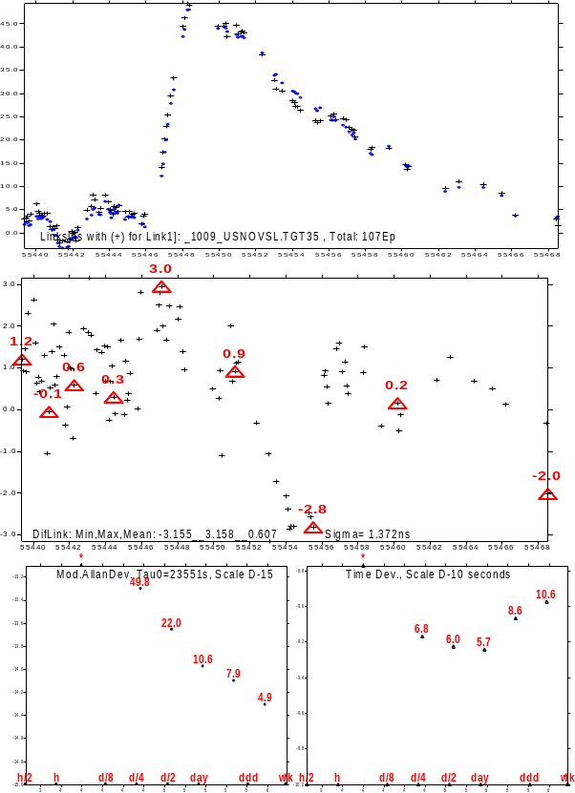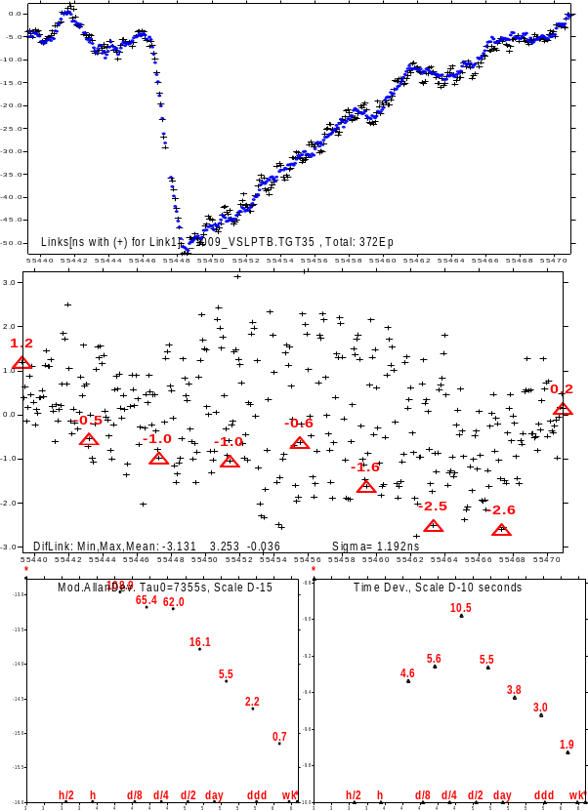

Annex 5. Triangle closures of the BIPM 2009 and 2010 calibrated time links

Histogram - Link Triangle Closure of T PTB AOS CH , Mean/RMS/SD= 5 726 726

PicoSec|No.| Total In/Out: 456/ 388
-2000| 1| +
-1750| 1| +
-1500| 8| ++++++++
-1250| 8| ++++++++
-1000| 21| +++++++++++++++++++++
-750| 35| +++++++++++++++++++++++++++++++++++
-500| 55| +++++++++++++++++++++++++++++++++++++++++++++++++++++++
-250| 49| +++++++++++++++++++++++++++++++++++++++++++++++++
0| 46| ++++++++++++++++++++++++++++++++++++++++++++++
250| 52| ++++++++++++++++++++++++++++++++++++++++++++++++++++
500| 37| +++++++++++++++++++++++++++++++++++++
750| 26| ++++++++++++++++++++++++++
1000| 17| +++++++++++++++++
1250| 18| ++++++++++++++++++
1500| 6| ++++++
1750| 6| ++++++
2000| 1| +
2250| 1| +

Histogram - Link Triangle Closure of T PTB AOS IT , Mean/RMS/SD= -12 1568 1568

PicoSec|No.| Total In/Out: 456/ 372
-3250| 3| +++
-3000| 6| ++++++
-2750| 4| ++++
-2500| 8| ++++++++
-2250| 7| +++++++
-2000| 18| ++++++++++++++++++
-1750| 22| ++++++++++++++++++++++
-1500| 26| ++++++++++++++++++++++++++
-1250| 27| +++++++++++++++++++++++++++
-1000| 14| ++++++++++++++
-750| 15| +++++++++++++++
-500| 10| ++++++++++
-250| 20| ++++++++++++++++++++
0| 20| ++++++++++++++++++++
250| 15| +++++++++++++++
500| 12| ++++++++++++
750| 11| +++++++++++
1000| 17| +++++++++++++++++
1250| 21| +++++++++++++++++++++
1500| 21| +++++++++++++++++++++
1750| 22| ++++++++++++++++++++++
2000| 22| ++++++++++++++++++++++
2250| 15| +++++++++++++++
2500| 8| ++++++++
2750| 4| ++++
3000| 2| ++
3250| 2| ++

Histogram - Link Triangle Closure of T PTB AOS IPQ , Mean/RMS/SD= -9 795 795

PicoSec|No.| Total In/Out: 456/ 381
-3250| 1| +
-3000| 0|
-2750| 0|
-2500| 0|
-2250| 0|
-2000| 0|
-1750| 2| ++
-1500| 10| ++++++++++
-1250| 13| +++++++++++++
-1000| 26| ++++++++++++++++++++++++++
-750| 39| +++++++++++++++++++++++++++++++++++++++
-500| 43| +++++++++++++++++++++++++++++++++++++++++++
-250| 36| ++++++++++++++++++++++++++++++++++++
0| 42| ++++++++++++++++++++++++++++++++++++++++++
250| 39| +++++++++++++++++++++++++++++++++++++++
500| 50| ++++++++++++++++++++++++++++++++++++++++++++++++++
750| 29| +++++++++++++++++++++++++++++
1000| 22| ++++++++++++++++++++++
1250| 11| +++++++++++
1500| 9| +++++++++
1750| 5| +++++
2000| 4| ++++

Histogram - Link Triangle Closure of T PTB AOS NIST, Mean/RMS/SD= -1 590 590

PicoSec|No.| Total In/Out: 456/ 390
-2000| 1| +
-1750| 2| ++
-1500| 1| +
-1250| 6| ++++++
-1000| 7| +++++++
-750| 24| ++++++++++++++++++++++++
-500| 65| +++++++++++++++++++++++++++++++++++++++++++++++++++++++++++++++++
-250| 59| +++++++++++++++++++++++++++++++++++++++++++++++++++++++++++
0| 75| +++++++++++++++++++++++++++++++++++++++++++++++++++++++++++++++++++++++++++
250| 59| +++++++++++++++++++++++++++++++++++++++++++++++++++++++++++
500| 35| +++++++++++++++++++++++++++++++++++
750| 27| +++++++++++++++++++++++++++
1000| 11| +++++++++++
1250| 12| ++++++++++++
1500| 4| ++++
1750| 1| +
2000| 1| +

Histogram - Link Triangle Closure of T PTB AOS OP , Mean/RMS/SD= 6 1120 1120

PicoSec|No.| Total In/Out: 456/ 390
-3250| 1| +
-3000| 0|
-2750| 0|
-2500| 1| +
-2250| 2| ++
-2000| 3| +++
-1750| 12| ++++++++++++
-1500| 18| ++++++++++++++++++
-1250| 30| ++++++++++++++++++++++++++++++
-1000| 29| +++++++++++++++++++++++++++++
-750| 38| ++++++++++++++++++++++++++++++++++++++
-500| 29| +++++++++++++++++++++++++++++
-250| 32| ++++++++++++++++++++++++++++++++
0| 21| +++++++++++++++++++++
250| 27| +++++++++++++++++++++++++++
500| 25| +++++++++++++++++++++++++
750| 25| +++++++++++++++++++++++++
1000| 28| ++++++++++++++++++++++++++++
1250| 24| ++++++++++++++++++++++++
1500| 13| +++++++++++++
1750| 6| ++++++
2000| 12| ++++++++++++
2250| 7| +++++++
2500| 3| +++
2750| 3| +++
3000| 1| +

Histogram - Link Triangle Closure of T PTB AOS ROA , Mean/RMS/SD= 2 723 723

PicoSec|No.| Total In/Out: 456/ 387
-2000| 1| +
-1750| 3| +++
-1500| 6| ++++++
-1250| 14| ++++++++++++++
-1000| 15| +++++++++++++++
-750| 27| +++++++++++++++++++++++++++
-500| 49| +++++++++++++++++++++++++++++++++++++++++++++++++
-250| 53| +++++++++++++++++++++++++++++++++++++++++++++++++++++
0| 68| ++++++++++++++++++++++++++++++++++++++++++++++++++++++++++++++++++++
250| 36| ++++++++++++++++++++++++++++++++++++
500| 46| ++++++++++++++++++++++++++++++++++++++++++++++
750| 31| +++++++++++++++++++++++++++++++
1000| 15| +++++++++++++++
1250| 9| +++++++++
1500| 6| ++++++
1750| 6| ++++++
2000| 0|
2250| 1| +
2500| 0|
2750| 0|
3000| 0|
3250| 1| +

Histogram - Link Triangle Closure of T PTB AOS SP , Mean/RMS/SD= 15 1199 1199

PicoSec|No.| Total In/Out: 456/ 375
-3250| 1| +
-3000| 3| +++
-2750| 3| +++
-2500| 4| ++++
-2250| 4| ++++
-2000| 5| +++++
-1750| 14| ++++++++++++++
-1500| 15| +++++++++++++++
-1250| 24| ++++++++++++++++++++++++
-1000| 15| +++++++++++++++
-750| 19| +++++++++++++++++++
-500| 31| +++++++++++++++++++++++++++++++
-250| 33| +++++++++++++++++++++++++++++++++
0| 24| ++++++++++++++++++++++++
250| 32| ++++++++++++++++++++++++++++++++
500| 32| ++++++++++++++++++++++++++++++++
750| 30| ++++++++++++++++++++++++++++++
1000| 23| +++++++++++++++++++++++
1250| 12| ++++++++++++
1500| 20| ++++++++++++++++++++
1750| 12| ++++++++++++
2000| 4| ++++
2250| 3| +++
2500| 7| +++++++
2750| 2| ++
3000| 2| ++
3250| 1| +

Histogram - Link Triangle Closure of T PTB AOS USNO, Mean/RMS/SD= 5 762 762

PicoSec|No.| Total In/Out: 456/ 379
-2000| 3| +++
-1750| 10| ++++++++++
-1500| 4| ++++
-1250| 9| +++++++++
-1000| 28| ++++++++++++++++++++++++++++
-750| 26| ++++++++++++++++++++++++++
-500| 36| ++++++++++++++++++++++++++++++++++++
-250| 33| +++++++++++++++++++++++++++++++++
0| 51| +++++++++++++++++++++++++++++++++++++++++++++++++++
250| 57| +++++++++++++++++++++++++++++++++++++++++++++++++++++++++
500| 48| ++++++++++++++++++++++++++++++++++++++++++++++++
750| 29| +++++++++++++++++++++++++++++
1000| 19| +++++++++++++++++++
1250| 13| +++++++++++++
1500| 9| +++++++++
1750| 4| ++++

Histogram - Link Triangle Closure of T PTB AOS VSL , Mean/RMS/SD= -13 1324 1324

PicoSec|No.| Total In/Out: 456/ 328
-3750| 1| +
-3500| 0|
-3250| 0|
-3000| 1| +
-2750| 4| ++++
-2500| 4| ++++
-2250| 5| +++++
-2000| 10| ++++++++++
-1750| 12| ++++++++++++
-1500| 13| +++++++++++++
-1250| 23| +++++++++++++++++++++++
-1000| 20| ++++++++++++++++++++
-750| 24| ++++++++++++++++++++++++
-500| 18| ++++++++++++++++++
-250| 27| +++++++++++++++++++++++++++
0| 22| ++++++++++++++++++++++
250| 22| ++++++++++++++++++++++
500| 13| +++++++++++++
750| 19| +++++++++++++++++++
1000| 18| ++++++++++++++++++
1250| 13| +++++++++++++
1500| 13| +++++++++++++
1750| 17| +++++++++++++++++
2000| 8| ++++++++
2250| 10| ++++++++++
2500| 6| ++++++
2750| 4| ++++
3000| 1| +

Histogram - Link Triangle Closure of T PTB CH IT , Mean/RMS/SD= 2186 2668 1530

PicoSec|No.| Total In/Out: 456/ 399
-2500| 1| +
-2250| 0|
-2000| 0|
-1750| 0|
-1500| 0|
-1250| 3| +++
-1000| 8| ++++++++
-750| 5| +++++
-500| 4| ++++
-250| 8| ++++++++
0| 13| +++++++++++++
250| 10| ++++++++++
500| 27| +++++++++++++++++++++++++++
750| 21| +++++++++++++++++++++
1000| 16| ++++++++++++++++
1250| 14| ++++++++++++++
1500| 17| +++++++++++++++++
1750| 15| +++++++++++++++
2000| 18| ++++++++++++++++++
2250| 22| ++++++++++++++++++++++
2500| 22| ++++++++++++++++++++++
2750| 22| ++++++++++++++++++++++
3000| 24| ++++++++++++++++++++++++
3250| 21| +++++++++++++++++++++
3500| 25| +++++++++++++++++++++++++
3750| 31| +++++++++++++++++++++++++++++++
4000| 21| +++++++++++++++++++++
4250| 17| +++++++++++++++++
4500| 12| ++++++++++++
4750| 2| ++

Histogram - Link Triangle Closure of T PTB CH IPQ , Mean/RMS/SD= -15 1056 1056

PicoSec|No.| Total In/Out: 456/ 419
-3500| 1| +
-3250| 0|
-3000| 0|
-2750| 0|
-2500| 1| +
-2250| 4| ++++
-2000| 8| ++++++++
-1750| 13| +++++++++++++
-1500| 14| ++++++++++++++
-1250| 27| +++++++++++++++++++++++++++
-1000| 29| +++++++++++++++++++++++++++++
-750| 32| ++++++++++++++++++++++++++++++++
-500| 29| +++++++++++++++++++++++++++++
-250| 35| +++++++++++++++++++++++++++++++++++
0| 32| ++++++++++++++++++++++++++++++++
250| 36| ++++++++++++++++++++++++++++++++++++
500| 37| +++++++++++++++++++++++++++++++++++++
750| 30| ++++++++++++++++++++++++++++++
1000| 25| +++++++++++++++++++++++++
1250| 26| ++++++++++++++++++++++++++
1500| 14| ++++++++++++++
1750| 13| +++++++++++++
2000| 6| ++++++
2250| 4| ++++
2500| 1| +
2750| 1| +
3000| 1| +

Histogram - Link Triangle Closure of T PTB CH NIST , Mean/RMS/SD= -449 818 684

PicoSec|No.| Total In/Out: 456/ 431
-3250| 1| +
-3000| 0|
-2750| 0|
-2500| 0|
-2250| 3| +++
-2000| 7| +++++++
-1750| 13| +++++++++++++
-1500| 16| ++++++++++++++++
-1250| 33| +++++++++++++++++++++++++++++++++
-1000| 45| +++++++++++++++++++++++++++++++++++++++++++++
-750| 43| +++++++++++++++++++++++++++++++++++++++++++
-500| 54| ++++++++++++++++++++++++++++++++++++++++++++++++++++++
-250| 60| ++++++++++++++++++++++++++++++++++++++++++++++++++++++++++++
0| 62| ++++++++++++++++++++++++++++++++++++++++++++++++++++++++++++++
250| 53| +++++++++++++++++++++++++++++++++++++++++++++++++++++
500| 26| ++++++++++++++++++++++++++
750| 10| ++++++++++
1000| 4| ++++
1250| 1| +

Histogram - Link Triangle Closure of T PTB CH NPL , Mean/RMS/SD= -27 951 950

PicoSec|No.| Total In/Out: 456/ 118
-2750| 1| +
-2500| 0|
-2250| 1| +
-2000| 1| +
-1750| 4| ++++
-1500| 1| +
-1250| 2| ++
-1000| 9| +++++++++
-750| 8| ++++++++
-500| 16| ++++++++++++++++
-250| 16| ++++++++++++++++
0| 9| +++++++++
250| 14| ++++++++++++++
500| 6| ++++++
750| 9| +++++++++
1000| 5| +++++
1250| 8| ++++++++
1500| 4| ++++
1750| 2| ++
2000| 0|
2250| 1| +
2500| 0|
2750| 1| +

Histogram - Link Triangle Closure of T PTB CH OP , Mean/RMS/SD= 150 829 815

PicoSec|No.| Total In/Out: 456/ 430
-2250| 1| +
-2000| 2| ++
-1750| 3| +++
-1500| 6| ++++++
-1250| 17| +++++++++++++++++
-1000| 18| ++++++++++++++++++
-750| 34| ++++++++++++++++++++++++++++++++++
-500| 36| ++++++++++++++++++++++++++++++++++++
-250| 42| ++++++++++++++++++++++++++++++++++++++++++
0| 47| +++++++++++++++++++++++++++++++++++++++++++++++
250| 41| +++++++++++++++++++++++++++++++++++++++++
500| 52| ++++++++++++++++++++++++++++++++++++++++++++++++++++
750| 41| +++++++++++++++++++++++++++++++++++++++++
1000| 43| +++++++++++++++++++++++++++++++++++++++++++
1250| 23| +++++++++++++++++++++++
1500| 12| ++++++++++++
1750| 9| +++++++++
2000| 1| +
2250| 2| ++

Histogram - Link Triangle Closure of T PTB CH ROA , Mean/RMS/SD= -685 1008 739

PicoSec|No.| Total In/Out: 456/ 427
-2750| 1| +
-2500| 4| ++++
-2250| 8| ++++++++
-2000| 12| ++++++++++++
-1750| 15| +++++++++++++++
-1500| 29| +++++++++++++++++++++++++++++
-1250| 43| +++++++++++++++++++++++++++++++++++++++++++
-1000| 49| +++++++++++++++++++++++++++++++++++++++++++++++++
-750| 74| ++++++++++++++++++++++++++++++++++++++++++++++++++++++++++++++++++++++++++
-500| 58| ++++++++++++++++++++++++++++++++++++++++++++++++++++++++++
-250| 47| +++++++++++++++++++++++++++++++++++++++++++++++
0| 35| +++++++++++++++++++++++++++++++++++
250| 16| ++++++++++++++++
500| 12| ++++++++++++
750| 13| +++++++++++++
1000| 6| ++++++
1250| 3| +++
1500| 2| ++

Histogram - Link Triangle Closure of T PTB CH SP , Mean/RMS/SD= 285 1176 1140

PicoSec|No.| Total In/Out: 456/ 371
-3000| 1| +
-2750| 1| +
-2500| 2| ++
-2250| 2| ++
-2000| 4| ++++
-1750| 3| +++
-1500| 13| +++++++++++++
-1250| 14| ++++++++++++++
-1000| 23| +++++++++++++++++++++++
-750| 22| ++++++++++++++++++++++
-500| 21| +++++++++++++++++++++
-250| 21| +++++++++++++++++++++
0| 28| ++++++++++++++++++++++++++++
250| 27| +++++++++++++++++++++++++++
500| 35| +++++++++++++++++++++++++++++++++++
750| 40| ++++++++++++++++++++++++++++++++++++++++
1000| 27| +++++++++++++++++++++++++++
1250| 20| ++++++++++++++++++++
1500| 24| ++++++++++++++++++++++++
1750| 19| +++++++++++++++++++
2000| 13| +++++++++++++
2250| 4| ++++
2500| 4| ++++
2750| 1| +
3000| 2| ++

Histogram - Link Triangle Closure of T PTB CH USNO , Mean/RMS/SD= -4 731 730

PicoSec|No.| Total In/Out: 456/ 416
-2250| 2| ++
-2000| 1| +
-1750| 5| +++++
-1500| 7| +++++++
-1250| 13| +++++++++++++
-1000| 17| +++++++++++++++++
-750| 38| ++++++++++++++++++++++++++++++++++++++
-500| 38| ++++++++++++++++++++++++++++++++++++++
-250| 56| ++++++++++++++++++++++++++++++++++++++++++++++++++++++++
0| 54| ++++++++++++++++++++++++++++++++++++++++++++++++++++++
250| 56| ++++++++++++++++++++++++++++++++++++++++++++++++++++++++
500| 52| ++++++++++++++++++++++++++++++++++++++++++++++++++++
750| 37| +++++++++++++++++++++++++++++++++++++
1000| 18| ++++++++++++++++++
1250| 10| ++++++++++
1500| 7| +++++++
1750| 2| ++
2000| 2| ++
2250| 1| +

Histogram - Link Triangle Closure of T PTB CH VSL , Mean/RMS/SD= -658 1269 1085

PicoSec|No.| Total In/Out: 456/ 98
-3500| 1| +
-3250| 0|
-3000| 0|
-2750| 2| ++
-2500| 1| +
-2250| 1| +
-2000| 6| ++++++
-1750| 5| +++++
-1500| 6| ++++++
-1250| 10| ++++++++++
-1000| 12| ++++++++++++
-750| 13| +++++++++++++
-500| 7| +++++++
-250| 7| +++++++
0| 8| ++++++++
250| 3| +++
500| 2| ++
750| 3| +++
1000| 4| ++++
1250| 2| ++
1500| 3| +++
1750| 0|
2000| 1| +
2250| 1| +

Histogram - Link Triangle Closure of T PTB IT IPQ , Mean/RMS/SD= 9 1526 1526

PicoSec|No.| Total In/Out: 456/ 318
-4750| 1| +
-4500| 0|
-4250| 0|
-4000| 0|
-3750| 1| +
-3500| 2| ++
-3250| 0|
-3000| 3| +++
-2750| 0|
-2500| 3| +++
-2250| 7| +++++++
-2000| 10| ++++++++++
-1750| 17| +++++++++++++++++
-1500| 17| +++++++++++++++++
-1250| 14| ++++++++++++++
-1000| 22| ++++++++++++++++++++++
-750| 22| ++++++++++++++++++++++
-500| 27| +++++++++++++++++++++++++++
-250| 12| ++++++++++++
0| 14| ++++++++++++++
250| 17| +++++++++++++++++
500| 19| +++++++++++++++++++
750| 21| +++++++++++++++++++++
1000| 9| +++++++++
1250| 10| ++++++++++
1500| 19| +++++++++++++++++++
1750| 12| ++++++++++++
2000| 11| +++++++++++
2250| 8| ++++++++
2500| 3| +++
2750| 4| ++++
3000| 8| ++++++++
3250| 2| ++
3500| 1| +
3750| 0|
4000| 1| +
4250| 0|
4500| 1| +

Histogram - Link Triangle Closure of T PTB IT NIST , Mean/RMS/SD=-3131 3318 1098

PicoSec|No.| Total In/Out: 456/ 395
-5000| 7| +++++++
-4750| 18| ++++++++++++++++++
-4500| 22| ++++++++++++++++++++++
-4250| 34| ++++++++++++++++++++++++++++++++++
-4000| 33| +++++++++++++++++++++++++++++++++
-3750| 23| +++++++++++++++++++++++
-3500| 31| +++++++++++++++++++++++++++++++
-3250| 28| ++++++++++++++++++++++++++++
-3000| 24| ++++++++++++++++++++++++
-2750| 27| +++++++++++++++++++++++++++
-2500| 34| ++++++++++++++++++++++++++++++++++
-2250| 27| +++++++++++++++++++++++++++
-2000| 28| ++++++++++++++++++++++++++++
-1750| 26| ++++++++++++++++++++++++++
-1500| 15| +++++++++++++++
-1250| 10| ++++++++++
-1000| 3| +++
-750| 3| +++
-500| 0|
-250| 1| +
0| 1| +

Histogram - Link Triangle Closure of T PTB IT NPL , Mean/RMS/SD= -11 573 573

PicoSec|No.| Total In/Out: 456/ 230
-1250| 3| +++
-1000| 4| ++++
-750| 24| ++++++++++++++++++++++++
-500| 33| +++++++++++++++++++++++++++++++++
-250| 41| +++++++++++++++++++++++++++++++++++++++++
0| 44| ++++++++++++++++++++++++++++++++++++++++++++
250| 31| +++++++++++++++++++++++++++++++
500| 20| ++++++++++++++++++++
750| 11| +++++++++++
1000| 10| ++++++++++
1250| 6| ++++++
1500| 1| +
1750| 0|
2000| 1| +
2250| 1| +

Histogram - Link Triangle Closure of T PTB IT OP , Mean/RMS/SD=-1120 1437 900

PicoSec|No.| Total In/Out: 456/ 403
-3000| 1| +
-2750| 5| +++++
-2500| 9| +++++++++
-2250| 35| +++++++++++++++++++++++++++++++++++
-2000| 33| +++++++++++++++++++++++++++++++++
-1750| 55| +++++++++++++++++++++++++++++++++++++++++++++++++++++++
-1500| 55| +++++++++++++++++++++++++++++++++++++++++++++++++++++++
-1250| 43| +++++++++++++++++++++++++++++++++++++++++++
-1000| 33| +++++++++++++++++++++++++++++++++
-750| 26| ++++++++++++++++++++++++++
-500| 16| ++++++++++++++++
-250| 18| ++++++++++++++++++
0| 26| ++++++++++++++++++++++++++
250| 11| +++++++++++
500| 18| ++++++++++++++++++
750| 13| +++++++++++++
1000| 4| ++++
1250| 2| ++

Histogram - Link Triangle Closure of T PTB IT ROA , Mean/RMS/SD= -478 563 296

PicoSec|No.| Total In/Out: 456/ 400
-1500| 3| +++
-1250| 1| +
-1000| 27| +++++++++++++++++++++++++++
-750| 89| +++++++++++++++++++++++++++++++++++++++++++++++++++++++++++++++++++++++++++++++++++++++++
-500|144| ++++++++++++++++++++++++++++++++++++++++++++++++++++++++++++++++++++++++++++++++++++++++++++++++++++++++++++++++++++++++++++++++++++++++++++++++
-250| 91| +++++++++++++++++++++++++++++++++++++++++++++++++++++++++++++++++++++++++++++++++++++++++++
0| 37| +++++++++++++++++++++++++++++++++++++
250| 6| ++++++
500| 0|
750| 0|
1000| 2| ++

Histogram - Link Triangle Closure of T PTB IT SP , Mean/RMS/SD= -740 1126 849

PicoSec|No.| Total In/Out: 456/ 397
-2500| 2| ++
-2250| 7| +++++++
-2000| 13| +++++++++++++
-1750| 25| +++++++++++++++++++++++++
-1500| 49| +++++++++++++++++++++++++++++++++++++++++++++++++
-1250| 61| +++++++++++++++++++++++++++++++++++++++++++++++++++++++++++++
-1000| 61| +++++++++++++++++++++++++++++++++++++++++++++++++++++++++++++
-750| 30| ++++++++++++++++++++++++++++++
-500| 23| +++++++++++++++++++++++
-250| 17| +++++++++++++++++
0| 32| ++++++++++++++++++++++++++++++++
250| 28| ++++++++++++++++++++++++++++
500| 14| ++++++++++++++
750| 19| +++++++++++++++++++
1000| 11| +++++++++++
1250| 4| ++++
1500| 0|
1750| 0|
2000| 1| +

Histogram - Link Triangle Closure of T PTB IT USNO , Mean/RMS/SD= 13 1732 1732

PicoSec|No.| Total In/Out: 456/ 391
-4750| 1| +
-4500| 1| +
-4250| 0|
-4000| 0|
-3750| 1| +
-3500| 2| ++
-3250| 3| +++
-3000| 5| +++++
-2750| 6| ++++++
-2500| 5| +++++
-2250| 12| ++++++++++++
-2000| 15| +++++++++++++++
-1750| 15| +++++++++++++++
-1500| 17| +++++++++++++++++
-1250| 27| +++++++++++++++++++++++++++
-1000| 23| +++++++++++++++++++++++
-750| 30| ++++++++++++++++++++++++++++++
-500| 21| +++++++++++++++++++++
-250| 29| +++++++++++++++++++++++++++++
0| 11| +++++++++++
250| 13| +++++++++++++
500| 18| ++++++++++++++++++
750| 10| ++++++++++
1000| 12| ++++++++++++
1250| 11| +++++++++++
1500| 19| +++++++++++++++++++
1750| 14| ++++++++++++++
2000| 13| +++++++++++++
2250| 10| ++++++++++
2500| 15| +++++++++++++++
2750| 13| +++++++++++++
3000| 7| +++++++
3250| 3| +++
3500| 2| ++
3750| 5| +++++
4000| 1| +
4250| 1| +

Histogram - Link Triangle Closure of T PTB IT VSL , Mean/RMS/SD= -544 616 288

PicoSec|No.| Total In/Out: 456/ 10
-1000| 2| ++
-750| 1| +
-500| 3| +++
-250| 4| ++++

Histogram - Link Triangle Closure of T PTB IPQ NIST, Mean/RMS/SD= 5 726 726

PicoSec|No.| Total In/Out: 456/ 419
-1750| 4| ++++
-1500| 10| ++++++++++
-1250| 16| ++++++++++++++++
-1000| 23| +++++++++++++++++++++++
-750| 24| ++++++++++++++++++++++++
-500| 45| +++++++++++++++++++++++++++++++++++++++++++++
-250| 51| +++++++++++++++++++++++++++++++++++++++++++++++++++
0| 57| +++++++++++++++++++++++++++++++++++++++++++++++++++++++++
250| 67| +++++++++++++++++++++++++++++++++++++++++++++++++++++++++++++++++++
500| 45| +++++++++++++++++++++++++++++++++++++++++++++
750| 30| ++++++++++++++++++++++++++++++
1000| 25| +++++++++++++++++++++++++
1250| 9| +++++++++
1500| 8| ++++++++
1750| 4| ++++
2000| 0|
2250| 0|
2500| 0|
2750| 0|
3000| 1| +

Histogram - Link Triangle Closure of T PTB IPQ OP , Mean/RMS/SD= -2 1194 1194

PicoSec|No.| Total In/Out: 456/ 424
-4250| 1| +
-4000| 0|
-3750| 0|
-3500| 0|
-3250| 1| +
-3000| 0|
-2750| 0|
-2500| 3| +++
-2250| 6| ++++++
-2000| 3| +++
-1750| 11| +++++++++++
-1500| 19| +++++++++++++++++++
-1250| 20| ++++++++++++++++++++
-1000| 41| +++++++++++++++++++++++++++++++++++++++++
-750| 32| ++++++++++++++++++++++++++++++++
-500| 41| +++++++++++++++++++++++++++++++++++++++++
-250| 34| ++++++++++++++++++++++++++++++++++
0| 41| +++++++++++++++++++++++++++++++++++++++++
250| 30| ++++++++++++++++++++++++++++++
500| 27| +++++++++++++++++++++++++++
750| 25| +++++++++++++++++++++++++
1000| 13| +++++++++++++
1250| 13| +++++++++++++
1500| 17| +++++++++++++++++
1750| 9| +++++++++
2000| 10| ++++++++++
2250| 11| +++++++++++
2500| 6| ++++++
2750| 6| ++++++
3000| 0|
3250| 3| +++
3500| 1| +

Histogram - Link Triangle Closure of T PTB IPQ ROA , Mean/RMS/SD= 17 853 853

PicoSec|No.| Total In/Out: 456/ 420
-2750| 1| +
-2500| 0|
-2250| 1| +
-2000| 4| ++++
-1750| 3| +++
-1500| 7| +++++++
-1250| 16| ++++++++++++++++
-1000| 18| ++++++++++++++++++
-750| 41| +++++++++++++++++++++++++++++++++++++++++
-500| 36| ++++++++++++++++++++++++++++++++++++
-250| 70| ++++++++++++++++++++++++++++++++++++++++++++++++++++++++++++++++++++++
0| 54| ++++++++++++++++++++++++++++++++++++++++++++++++++++++
250| 40| ++++++++++++++++++++++++++++++++++++++++
500| 38| ++++++++++++++++++++++++++++++++++++++
750| 28| ++++++++++++++++++++++++++++
1000| 21| +++++++++++++++++++++
1250| 14| ++++++++++++++
1500| 7| +++++++
1750| 14| ++++++++++++++
2000| 4| ++++
2250| 1| +
2500| 1| +
2750| 0|
3000| 0|
3250| 0|
3500| 0|
3750| 0|
4000| 0|
4250| 0|
4500| 1| +

Histogram - Link Triangle Closure of T PTB IPQ SP , Mean/RMS/SD= 13 3763 3763

PicoSec|No.| Total In/Out: 456/ 225
-5000| 3| +++
-4750| 3| +++
-4500| 2| ++
-4250| 2| ++
-4000| 2| ++
-3750| 3| +++
-3500| 5| +++++
-3250| 4| ++++
-3000| 6| ++++++
-2750| 5| +++++
-2500| 5| +++++
-2250| 11| +++++++++++
-2000| 7| +++++++
-1750| 10| ++++++++++
-1500| 12| ++++++++++++
-1250| 10| ++++++++++
-1000| 7| +++++++
-750| 10| ++++++++++
-500| 5| +++++
-250| 9| +++++++++
0| 10| ++++++++++
250| 9| +++++++++
500| 7| +++++++
750| 4| ++++
1000| 3| +++
1250| 6| ++++++
1500| 6| ++++++
1750| 10| ++++++++++
2000| 7| +++++++
2250| 5| +++++
2500| 2| ++
2750| 7| +++++++
3000| 2| ++
3250| 5| +++++
3500| 4| ++++
3750| 4| ++++
4000| 2| ++
4250| 5| +++++
4500| 3| +++
4750| 3| +++

Histogram - Link Triangle Closure of T PTB IPQ USNO, Mean/RMS/SD= 9 953 953

PicoSec|No.| Total In/Out: 456/ 391
-2250| 2| ++
-2000| 2| ++
-1750| 5| +++++
-1500| 11| +++++++++++
-1250| 11| +++++++++++
-1000| 24| ++++++++++++++++++++++++
-750| 39| +++++++++++++++++++++++++++++++++++++++
-500| 38| ++++++++++++++++++++++++++++++++++++++
-250| 46| ++++++++++++++++++++++++++++++++++++++++++++++
0| 49| +++++++++++++++++++++++++++++++++++++++++++++++++
250| 55| +++++++++++++++++++++++++++++++++++++++++++++++++++++++
500| 35| +++++++++++++++++++++++++++++++++++
750| 27| +++++++++++++++++++++++++++
1000| 14| ++++++++++++++
1250| 11| +++++++++++
1500| 8| ++++++++
1750| 4| ++++
2000| 3| +++
2250| 3| +++
2500| 0|
2750| 2| ++
3000| 1| +
3250| 0|
3500| 0|
3750| 0|
4000| 0|
4250| 0|
4500| 1| +

Histogram - Link Triangle Closure of T PTB IPQ VSL , Mean/RMS/SD= -137 9107 9106

PicoSec|No.| Total In/Out: 456/ 64
-5000| 3| +++
-4750| 0|
-4500| 1| +
-4250| 1| +
-4000| 1| +
-3750| 0|
-3500| 3| +++
-3250| 1| +
-3000| 4| ++++
-2750| 0|
-2500| 6| ++++++
-2250| 1| +
-2000| 0|
-1750| 1| +
-1500| 2| ++
-1250| 0|
-1000| 1| +
-750| 1| +
-500| 3| +++
-250| 1| +
0| 1| +
250| 0|
500| 2| ++
750| 4| ++++
1000| 2| ++
1250| 3| +++
1500| 0|
1750| 1| +
2000| 2| ++
2250| 1| +
2500| 1| +
2750| 2| ++
3000| 3| +++
3250| 0|
3500| 2| ++
3750| 1| +
4000| 5| +++++
4250| 0|
4500| 2| ++
4750| 2| ++

Histogram - Link Triangle Closure of T PTB NIST OP , Mean/RMS/SD= 424 813 693

PicoSec|No.| Total In/Out: 456/ 421
-1000| 2| ++
-750| 18| ++++++++++++++++++
-500| 42| ++++++++++++++++++++++++++++++++++++++++++
-250| 44| ++++++++++++++++++++++++++++++++++++++++++++
0| 50| ++++++++++++++++++++++++++++++++++++++++++++++++++
250| 48| ++++++++++++++++++++++++++++++++++++++++++++++++
500| 49| +++++++++++++++++++++++++++++++++++++++++++++++++
750| 52| ++++++++++++++++++++++++++++++++++++++++++++++++++++
1000| 55| +++++++++++++++++++++++++++++++++++++++++++++++++++++++
1250| 20| ++++++++++++++++++++
1500| 16| ++++++++++++++++
1750| 19| +++++++++++++++++++
2000| 4| ++++
2250| 2| ++

Histogram - Link Triangle Closure of T PTB NIST ROA, Mean/RMS/SD= 0 661 661

PicoSec|No.| Total In/Out: 456/ 427
-1750| 1| +
-1500| 6| ++++++
-1250| 13| +++++++++++++
-1000| 20| ++++++++++++++++++++
-750| 33| +++++++++++++++++++++++++++++++++
-500| 58| ++++++++++++++++++++++++++++++++++++++++++++++++++++++++++
-250| 53| +++++++++++++++++++++++++++++++++++++++++++++++++++++
0| 57| +++++++++++++++++++++++++++++++++++++++++++++++++++++++++
250| 66| ++++++++++++++++++++++++++++++++++++++++++++++++++++++++++++++++++
500| 41| +++++++++++++++++++++++++++++++++++++++++
750| 34| ++++++++++++++++++++++++++++++++++
1000| 26| ++++++++++++++++++++++++++
1250| 12| ++++++++++++
1500| 5| +++++
1750| 1| +
2000| 1| +

Histogram - Link Triangle Closure of T PTB NIST SP , Mean/RMS/SD= 1733 1915 817

PicoSec|No.| Total In/Out: 456/ 424
-1250| 1| +
-1000| 0|
-750| 1| +
-500| 2| ++
-250| 1| +
0| 12| ++++++++++++
250| 16| ++++++++++++++++
500| 12| ++++++++++++
750| 18| ++++++++++++++++++
1000| 25| +++++++++++++++++++++++++
1250| 41| +++++++++++++++++++++++++++++++++++++++++
1500| 49| +++++++++++++++++++++++++++++++++++++++++++++++++
1750| 57| +++++++++++++++++++++++++++++++++++++++++++++++++++++++++
2000| 35| +++++++++++++++++++++++++++++++++++
2250| 51| +++++++++++++++++++++++++++++++++++++++++++++++++++
2500| 50| ++++++++++++++++++++++++++++++++++++++++++++++++++
2750| 24| ++++++++++++++++++++++++
3000| 22| ++++++++++++++++++++++
3250| 6| ++++++
3500| 1| +

Histogram - Link Triangle Closure of T PTB NIST VSL, Mean/RMS/SD= 316 1243 1202

PicoSec|No.| Total In/Out: 456/ 369
-2750| 4| ++++
-2500| 4| ++++
-2250| 3| +++
-2000| 5| +++++
-1750| 8| ++++++++
-1500| 14| ++++++++++++++
-1250| 7| +++++++
-1000| 18| ++++++++++++++++++
-750| 18| ++++++++++++++++++
-500| 14| ++++++++++++++
-250| 30| ++++++++++++++++++++++++++++++
0| 22| ++++++++++++++++++++++
250| 33| +++++++++++++++++++++++++++++++++
500| 24| ++++++++++++++++++++++++
750| 43| +++++++++++++++++++++++++++++++++++++++++++
1000| 35| +++++++++++++++++++++++++++++++++++
1250| 29| +++++++++++++++++++++++++++++
1500| 15| +++++++++++++++
1750| 12| ++++++++++++
2000| 9| +++++++++
2250| 6| ++++++
2500| 4| ++++
2750| 4| ++++
3000| 4| ++++
3250| 2| ++
3500| 1| +
3750| 1| +

Histogram - Link Triangle Closure of T PTB NPL OP , Mean/RMS/SD= -5 471 471

PicoSec|No.| Total In/Out: 456/ 71
-2000| 1| +
-1750| 0|
-1500| 1| +
-1250| 0|
-1000| 0|
-750| 0|
-500| 4| ++++
-250| 17| +++++++++++++++++
0| 24| ++++++++++++++++++++++++
250| 16| ++++++++++++++++
500| 4| ++++
750| 2| ++
1000| 0|
1250| 1| +
1500| 0|
1750| 1| +

Histogram - Link Triangle Closure of T PTB NPL ROA , Mean/RMS/SD= -143 568 550

PicoSec|No.| Total In/Out: 456/ 81
-1500| 2| ++
-1250| 0|
-1000| 5| +++++
-750| 5| +++++
-500| 18| ++++++++++++++++++
-250| 16| ++++++++++++++++
0| 13| +++++++++++++
250| 9| +++++++++
500| 5| +++++
750| 3| +++
1000| 4| ++++
1250| 1| +

Histogram - Link Triangle Closure of T PTB NPL SP , Mean/RMS/SD= -23 543 542

PicoSec|No.| Total In/Out: 456/ 89
-2000| 1| +
-1750| 0|
-1500| 1| +
-1250| 2| ++
-1000| 3| +++
-750| 5| +++++
-500| 5| +++++
-250| 18| ++++++++++++++++++
0| 16| ++++++++++++++++
250| 19| +++++++++++++++++++
500| 9| +++++++++
750| 6| ++++++
1000| 4| ++++

Histogram - Link Triangle Closure of T PTB OP ROA , Mean/RMS/SD= -969 1076 469

PicoSec|No.| Total In/Out: 456/ 427
-2750| 1| +
-2500| 1| +
-2250| 3| +++
-2000| 10| ++++++++++
-1750| 21| +++++++++++++++++++++
-1500| 39| +++++++++++++++++++++++++++++++++++++++
-1250| 71| +++++++++++++++++++++++++++++++++++++++++++++++++++++++++++++++++++++++
-1000| 96| ++++++++++++++++++++++++++++++++++++++++++++++++++++++++++++++++++++++++++++++++++++++++++++++++
-750| 90| ++++++++++++++++++++++++++++++++++++++++++++++++++++++++++++++++++++++++++++++++++++++++++
-500| 53| +++++++++++++++++++++++++++++++++++++++++++++++++++++
-250| 27| +++++++++++++++++++++++++++
0| 13| +++++++++++++
250| 2| ++

Histogram - Link Triangle Closure of T PTB OP SP , Mean/RMS/SD= 278 598 529

PicoSec|No.| Total In/Out: 456/ 417
-1000| 4| ++++
-750| 16| ++++++++++++++++
-500| 24| ++++++++++++++++++++++++
-250| 54| ++++++++++++++++++++++++++++++++++++++++++++++++++++++
0| 62| ++++++++++++++++++++++++++++++++++++++++++++++++++++++++++++++
250| 75| +++++++++++++++++++++++++++++++++++++++++++++++++++++++++++++++++++++++++++
500| 75| +++++++++++++++++++++++++++++++++++++++++++++++++++++++++++++++++++++++++++
750| 57| +++++++++++++++++++++++++++++++++++++++++++++++++++++++++
1000| 26| ++++++++++++++++++++++++++
1250| 19| +++++++++++++++++++
1500| 3| +++
1750| 1| +
2000| 0|
2250| 0|
2500| 0|
2750| 1| +

Histogram - Link Triangle Closure of T PTB OP USNO , Mean/RMS/SD= 10 966 966

PicoSec|No.| Total In/Out: 456/ 408
-2250| 3| +++
-2000| 5| +++++
-1750| 10| ++++++++++
-1500| 20| ++++++++++++++++++++
-1250| 14| ++++++++++++++
-1000| 27| +++++++++++++++++++++++++++
-750| 29| +++++++++++++++++++++++++++++
-500| 39| +++++++++++++++++++++++++++++++++++++++
-250| 32| ++++++++++++++++++++++++++++++++
0| 40| ++++++++++++++++++++++++++++++++++++++++
250| 40| ++++++++++++++++++++++++++++++++++++++++
500| 37| +++++++++++++++++++++++++++++++++++++
750| 31| +++++++++++++++++++++++++++++++
1000| 29| +++++++++++++++++++++++++++++
1250| 21| +++++++++++++++++++++
1500| 11| +++++++++++
1750| 14| ++++++++++++++
2000| 1| +
2250| 2| ++
2500| 1| +
2750| 1| +
3000| 1| +

Histogram - Link Triangle Closure of T PTB OP VSL , Mean/RMS/SD= -628 972 741

PicoSec|No.| Total In/Out: 456/ 367
-3000| 2| ++
-2750| 0|
-2500| 0|
-2250| 4| ++++
-2000| 6| ++++++
-1750| 19| +++++++++++++++++++
-1500| 22| ++++++++++++++++++++++
-1250| 42| ++++++++++++++++++++++++++++++++++++++++++
-1000| 39| +++++++++++++++++++++++++++++++++++++++
-750| 55| +++++++++++++++++++++++++++++++++++++++++++++++++++++++
-500| 51| +++++++++++++++++++++++++++++++++++++++++++++++++++
-250| 41| +++++++++++++++++++++++++++++++++++++++++
0| 35| +++++++++++++++++++++++++++++++++++
250| 20| ++++++++++++++++++++
500| 14| ++++++++++++++
750| 4| ++++
1000| 7| +++++++
1250| 3| +++
1500| 1| +
1750| 1| +
2000| 0|
2250| 1| +

Histogram - Link Triangle Closure of T PTB ROA SP , Mean/RMS/SD= 604 761 463

PicoSec|No.| Total In/Out: 456/ 414
-1000| 1| +
-750| 2| ++
-500| 4| ++++
-250| 17| +++++++++++++++++
0| 38| ++++++++++++++++++++++++++++++++++++++
250| 54| ++++++++++++++++++++++++++++++++++++++++++++++++++++++
500| 85| +++++++++++++++++++++++++++++++++++++++++++++++++++++++++++++++++++++++++++++++++++++
750|109| +++++++++++++++++++++++++++++++++++++++++++++++++++++++++++++++++++++++++++++++++++++++++++++++++++++++++++++
1000| 63| +++++++++++++++++++++++++++++++++++++++++++++++++++++++++++++++
1250| 22| ++++++++++++++++++++++
1500| 12| ++++++++++++
1750| 3| +++
2000| 3| +++
2250| 0|
2500| 1| +

Histogram - Link Triangle Closure of T PTB ROA USNO, Mean/RMS/SD= 20 1016 1015

PicoSec|No.| Total In/Out: 456/ 411
-2500| 1| +
-2250| 1| +
-2000| 8| ++++++++
-1750| 7| +++++++
-1500| 13| +++++++++++++
-1250| 18| ++++++++++++++++++
-1000| 23| +++++++++++++++++++++++
-750| 30| ++++++++++++++++++++++++++++++
-500| 47| +++++++++++++++++++++++++++++++++++++++++++++++
-250| 37| +++++++++++++++++++++++++++++++++++++
0| 37| +++++++++++++++++++++++++++++++++++++
250| 42| ++++++++++++++++++++++++++++++++++++++++++
500| 38| ++++++++++++++++++++++++++++++++++++++
750| 28| ++++++++++++++++++++++++++++
1000| 24| ++++++++++++++++++++++++
1250| 16| ++++++++++++++++
1500| 15| +++++++++++++++
1750| 13| +++++++++++++
2000| 3| +++
2250| 7| +++++++
2500| 3| +++

Histogram - Link Triangle Closure of T PTB ROA VSL , Mean/RMS/SD= -4 575 575

PicoSec|No.| Total In/Out: 456/ 365
-1750| 1| +
-1500| 1| +
-1250| 7| +++++++
-1000| 13| +++++++++++++
-750| 33| +++++++++++++++++++++++++++++++++
-500| 42| ++++++++++++++++++++++++++++++++++++++++++
-250| 50| ++++++++++++++++++++++++++++++++++++++++++++++++++
0| 69| +++++++++++++++++++++++++++++++++++++++++++++++++++++++++++++++++++++
250| 53| +++++++++++++++++++++++++++++++++++++++++++++++++++++
500| 51| +++++++++++++++++++++++++++++++++++++++++++++++++++
750| 24| ++++++++++++++++++++++++
1000| 13| +++++++++++++
1250| 5| +++++
1500| 2| ++
1750| 0|
2000| 0|
2250| 0|
2500| 1| +

Histogram - Link Triangle Closure of T PTB SP USNO , Mean/RMS/SD= 20 872 872

PicoSec|No.| Total In/Out: 456/ 365
-2750| 2| ++
-2500| 2| ++
-2250| 2| ++
-2000| 4| ++++
-1750| 4| ++++
-1500| 9| +++++++++
-1250| 8| ++++++++
-1000| 20| ++++++++++++++++++++
-750| 26| ++++++++++++++++++++++++++
-500| 41| +++++++++++++++++++++++++++++++++++++++++
-250| 39| +++++++++++++++++++++++++++++++++++++++
0| 30| ++++++++++++++++++++++++++++++
250| 48| ++++++++++++++++++++++++++++++++++++++++++++++++
500| 41| +++++++++++++++++++++++++++++++++++++++++
750| 26| ++++++++++++++++++++++++++
1000| 28| ++++++++++++++++++++++++++++
1250| 17| +++++++++++++++++
1500| 10| ++++++++++
1750| 3| +++
2000| 5| +++++

Histogram - Link Triangle Closure of T PTB SP VSL , Mean/RMS/SD= -472 774 614

PicoSec|No.| Total In/Out: 456/ 352
-2500| 1| +
-2250| 3| +++
-2000| 0|
-1750| 8| ++++++++
-1500| 13| +++++++++++++
-1250| 30| ++++++++++++++++++++++++++++++
-1000| 33| +++++++++++++++++++++++++++++++++
-750| 51| +++++++++++++++++++++++++++++++++++++++++++++++++++
-500| 47| +++++++++++++++++++++++++++++++++++++++++++++++
-250| 62| ++++++++++++++++++++++++++++++++++++++++++++++++++++++++++++++
0| 45| +++++++++++++++++++++++++++++++++++++++++++++
250| 37| +++++++++++++++++++++++++++++++++++++
500| 13| +++++++++++++
750| 4| ++++
1000| 3| +++
1250| 2| ++

Histogram - Link Triangle Closure of T PTB USNO VSL, Mean/RMS/SD= 0 1491 1491

PicoSec|No.| Total In/Out: 456/ 199
-4500| 1| +
-4250| 0|
-4000| 1| +
-3750| 3| +++
-3500| 1| +
-3250| 1| +
-3000| 1| +
-2750| 2| ++
-2500| 4| ++++
-2250| 6| ++++++
-2000| 2| ++
-1750| 4| ++++
-1500| 5| +++++
-1250| 9| +++++++++
-1000| 13| +++++++++++++
-750| 10| ++++++++++
-500| 13| +++++++++++++
-250| 10| ++++++++++
0| 9| +++++++++
250| 17| +++++++++++++++++
500| 17| +++++++++++++++++
750| 16| ++++++++++++++++
1000| 10| ++++++++++
1250| 13| +++++++++++++
1500| 7| +++++++
1750| 5| +++++
2000| 7| +++++++
2250| 1| +
2500| 6| ++++++
2750| 2| ++
3000| 0|
3250| 1| +
3500| 0|
3750| 2| ++

