TM 142 Read this file by Tsoft H77 1st Jan. 2006

One Year Comparison of USNO-PTB
TW KU and X-bands

- vs. GPS

Z. Jiang

1. Resume 1
2. The links of the TW KU and X bands 2
3. Short term comparisons (< 5 days) 3
4. Middle term comparisons (a standard TAI month) 5
5. Long term comparisons (one year) 6
6. Conclusion 8
Reference 9
Annexes 10
Annex I Discontinuities of KU band vs. continuity of X band in 2005 10
Annex II Short term comparisons 11
Annex III Middle term comparisons 13
Annex IV Long term comparisons 16

1. Resume

The time links of the baseline USNO-PTB are studied. TW KU (4 ~ 12 points/day) and X band (24 points/day) data are compared with each other and with the GPS P3/MC data for different terms of the short (< 5 days), middle (a month) and long (a year) periods.

In the year 2005, the TW KU band data were affected by 3 discontinuities up to several ns. To make the long term comparisons, the KU band links were bridged by the GPS P3 links. The bridging errors are about 0.5 ns.

- For short term, we see clearly the KU band data are affected by a diurnal-periodical disturbance up to 2~3 ns. This exists also in other baselines, like NIST-NPL. The amplitudes of the diurnal variations are not constant
- For middle term, the Time Deviation and residual analysis show that the X band data are more stable, less noisy than the KU band and much closer to the GPS AV data [1]
- For long term, the sigma (Stand Deviation) of the differences between the KU and X bands, the KU band and GPS, the X band and GPS are similar, about 1 ns. In view of long term stability, the KU and X bands are nearly identical

Conclusion:

The X band data are more advantageous than the KU band data for the TAI generation in view of the data’s:
- Continuity
- Density
- Stabilities of the short and middle terms

Thanks: D. Matsakis, A. Bauch, D. Piester and G. Petit for the raw data and helpful discussions

2. The links of the TW KU and X bands

At present, the USNO-PTB TW KU band link is used to generate the TAI. Before October 2005, there were 4 measured points per day. Since then, the density of the measurement is up to 12 points per day. During the year 2005, the KU band link was affected by 3 discontinuities due to the changes of the satellites or the calibrations (cf. Annex Fig. I-1a). To guaranty the continuity of the time link and the UTC (USNO-PTB), GPS data were used to bridge the TW KU band links. Following bridging corrections in the Table 2-1 are used in this analysis (cf. also the Annex Fig. I-1b):

Table 2-1 Bridging corrections used in the USNO-PTB KU band link / ns

MJD | Correction/ns | TAI YYMM
53402 | -16.0 | 0502
53493 | -23.2 | 0505
53642 | +23.2 | 0510

Remark: The above corrections are necessary for the long term comparisons. They may not equal to the true values of UTC (USNO-PTB).

The TWSTFS X- band link between USNO-PTB is measured since years. But they were not analysed by the BIPM before. The main raison is that the raw X band data are not in the standard ITU format. During the 13th CCTF TW WG held at VSL Delft, 15-16 Nov. 2005, it was agreed between the PTB-USNO-BIPM that the BIPM should analyse monthly the X band data: PTB-USNO should supply the raw data in a suitable free format and BIPM should do the necessaries to transfer the data in ITU format and analyse as a back up link. The raw data are available since November 2005 thanks to the common efforts of USNO and PTB [2], [3]. The BIPM developed a procedure and install it in the TAI generating software Tsoft [5]. The plots in the following Figure 2-1 show the status of the X band raw data in the year 2005.

The raw X band data are affected by some operational errors as shown in Figure 2-1, cf. [2]. The RMS of the residuals of a linear smoothing [4] is about 0.3 ns. An outlier of 2 ns (7 times of the sigma) is then used for the raw data filtering. In fact, the similar operating errors and the filtering (default outlier 3 ns corresponding 6 times of the uncertainty uA of KU band) exist in all the TW KU band links for TAI calculations. Iteration is used to detect the outliers.

As shown in Fig. 2-1 followed or in Fig. I-1a (Annex I), the X – band data are continued all along the year 2005. Compared with the KU band used in the TAI, the X- band data are of a higher density (about 24 points per day), more stable and less noisy. This was concluded in a preliminary analysis in TM 141 [5], using the data of Nov. 2005. This TM will give detailed discussions.

In the following sections, we compare the TW KU band link with the X band link. The comparisons are made for three different terms:

- Short term : less than 5 days (interval of the TAI standard MJDs)
- Middle term : about one month (a TAI month)
- Long term : about one year

To confirm the results of the TW only comparison analysis, the GPS P3 and MC All in View links are used for the three terms’ comparisons.

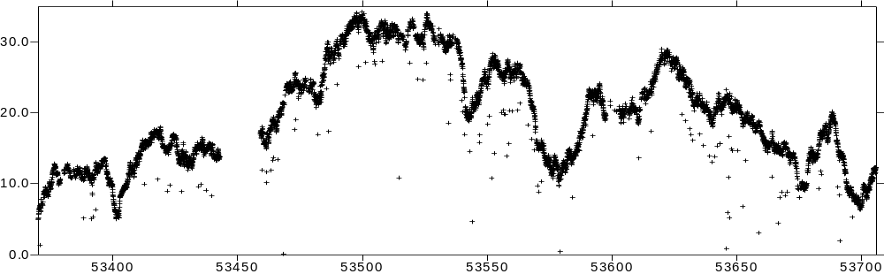
Raw X band Link/ns

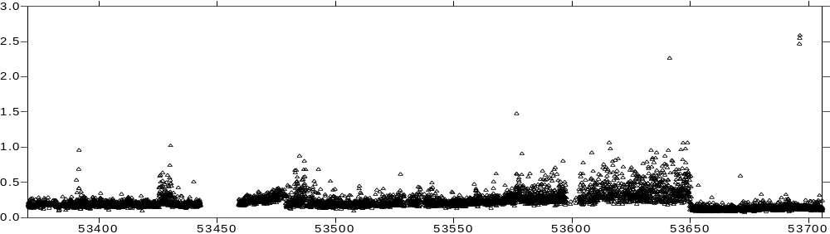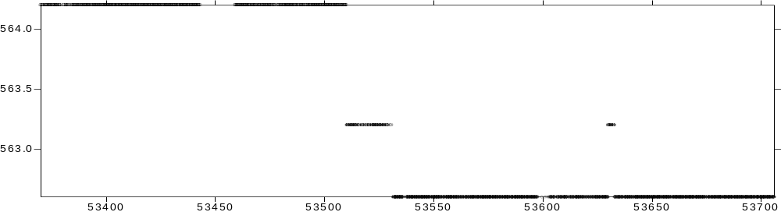
Estimated Error/ns
Calibration/ns
Figure 2-1 USNO-PTB X band raw data for 2005

3. Short term comparisons (< 5 days)

A set of 4 day’s data between the MJD 53679-53683 are used for this shourt term comparison. The statistics of the comparisons are listed in the Table 3-1 and the Fig. 3-1a and 1b followed as well as the Fig. II-1a, 1b, Fig. II-2a and 2b in the Annex II.

Table 3-1. Short term differences between TW KU-X bands-GPS P3 links / ns

Links | Numb. | Min | Max | Mean | Sigma
TW X-KU bands | 85 | -0.103 | 2.585 | 1.256 | 0.570
TW KU – GPS P3 | 41 | -8.394 | -4.855 | -6.729 | 0.768
TW X – GPS P3 | 85 | -6.628 | -4.781 | -5.476 | 0.428

From the sigma (standard deviations) in the above table, we see that the GPS P3 is much closer to the TW X band than to the KU band. A careful look at the Figures 3-1a (left) and 3-1b, we can see a clear diurnal variation up to 3 ns in the KU data. This can be observed in both of the comparisons of the KU band to the X band and the KU band to the GPS P3 AV data (Fig. II-2a and 2b). The uncertainties uA given in the BIPM Circular T Section 6 are 0.5 ns for TW and 0.7 ns for GPS P3 CV. We know that AV is more accurate than CV [1]. Because GPS and TW are two completely independent techniques, the GPS P3 AV is a good reference for this comparison. The plot of the Time Deviation (Fig. 3-1b) confirms the same diurnal tendency of the periodic disturbances.

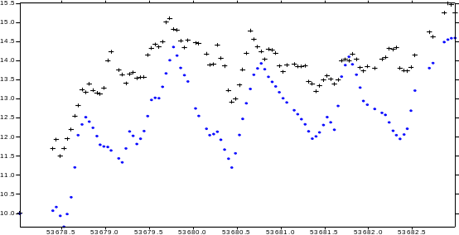
X band
USNO-PTB
KU band
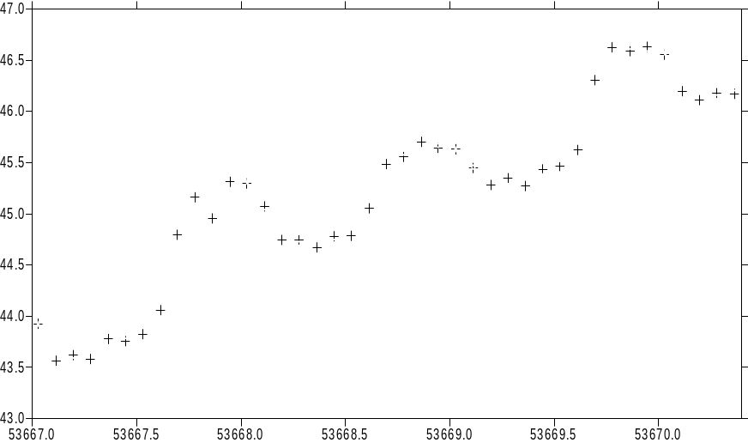
KU band
NIST-NPL

Fig. 3-1a Diurnal variation in the TW KU band links of
USNO-PTB (left) and NIST-NPL (right) / ns

The diurnal variations in the KU band links exist not only in the USNO-PTB baseline for the period of Mjd 53679 - 53682 on question as proved above. Figure 3-1a (right) shows the TW KU band link of the baseline NIST-NPL driven by the two HM clocks during the Mjd 53667-53670.5 A diurnal variation can be seen clearly. Obviously, these disturbances do not come from the clocks. Some environmental influences based, systematic effects present probably in the TW equipment concerned soft-hard wares. T. Parker of Nist talked about this phenomenon in his presentation during the 13TH CCTF TW WG Meeting at VSL, Delft, 15-16th 2005.

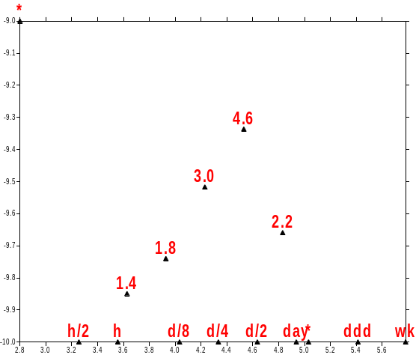
Time Deviation Scale s⁻¹⁰
Fig. 3-1b Time deviation (0.1 ns) corresponding the Fig. 3-1a (left)
(Diurnal variation in the TW KU band link of USNO-PTB)

By the short term analysis, we can conclude that the X band data are more stable, less noisy than the KU band, especially less sensible to the diurnal disturbances.

4. Middle term comparisons (a standard TAI month)

The length of the middle term selected is corresponding to the period of a standard TAI month, on average 30 – 35 days. The TAI 0511 (Nov. 2005) data are used. All the results can be found in the Annex III. Here is a summary. In Table 4-1 and Fig. 4-1, we show the main results of the comparisons between the KU band and X band for the period of TAI 0511.

Table 4-1 Middle term comparison of the Time Deviation and the Sigma
of the TW KU and X band links / ns

Links | 2h | 8h | ~ 1 day | ~3 days | Sigma
KU band | 0.30 | 0.52 | 0.59 | 0.93 | 0.362
X band | 0.13 | 0.32 | 0.47 | 0.98 | 0.149
Difference % | 57% | 38% | 20% | -5% | 41%

Table 4-2. Middle term comparison between TW KU-X band-GPS P3 links / ns

Links | Numb. | Min | Max | Mean | Sigma
TW X-KU bands | 674 | -1.216 | 2.623 | 1.018 | 0.870
TW KU – GPS P3 | 324 | -8.394 | -3.351 | -6.219 | 1.128
TW X – GPS P3 | 674 | 0.061 | 3.148 | 1.517 | 0.587

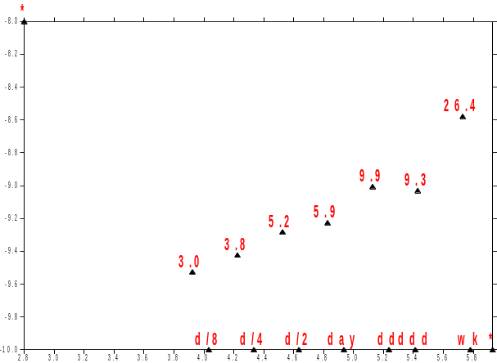
USNO-PTB TW KU band link
Time Deviation Scale s⁻¹⁰
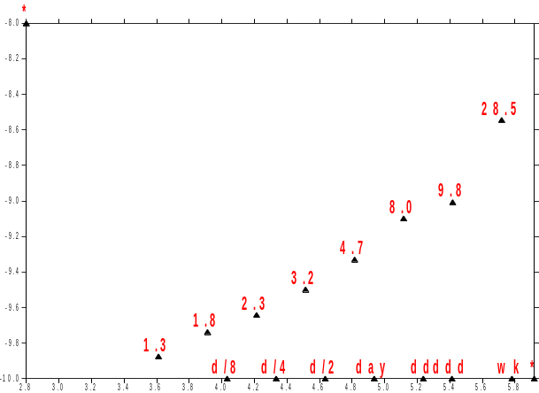
USNO-PTB TW X band link
Time Deviation Scale s⁻¹⁰

Fig. 4-1 Comparison of Time Deviation of the two bands (0511)

We re-computed all the first 11 monthly links in 2005 and the statistics results are as similar as those concluded by the analysis of the short and middle terms. Table 4-1 and 4-2 are the statistics of the links for the TAI month 0511. The sigma in Table 4-1 shows the “noisy level” of the two bands’ links [4]. The KU band has a sigma of 0.362 ns that is two times noisy as the X band with a sigma of 0.149 ns. The comparison of the link stability given by the Time Deviations in Figure 4-1a and 1b gives the same conclusion that the X band link is more stable than the KU band, due to probably the diurnal disturbances.

To confirm this analysis, the Table 4-2 lists the comparisons with each other between the links of the KU band, the X band and the GPS P3 AV. The sigma between the X and KU band links is 0.870 ns. The sigmas between the P3 link with the KU and with the X bands are respectively 1.128 ns and 0.587 ns. As far as we have observed till now, not any obvious diurnal variations, up to 3~4 ns, are found in the P3 AV links. The comparisons given in Table 4-2 confirm that the KU band is affected really by a periodical error source. However the up-down amplitude of the diurnal variations are not constant, depending likely on the local environmental conditions. Further studies are required.

For more and detailed information, see Annex III.

5. Long term comparisons (one year)

In this section, we make comparisons between the USNO-PTB TW KU with X bands and the GPS MC AV links for a period of about the whole year 2005. Here we use the GPS MC instead of the P3 link because:

- as mentioned above, we used already the P3 to bridge the discontinuities of KU band
- the P3 data have probably some unknown disturbances in June and July
- for long term stability of one year, the P3 and MC are similar (Jiang and Petit TM 143)

More and detailed information about the comparisons are shown in Annex IV. Please note that the measurement density of KU band changed during the year 2005 (from 4 to 12 points per day in Oct.). The Time Deviations concerned given in the Annex IV may not be exact.

We give here a summary of the long term analysis:

Table 5-1. Long term comparison of TW KU-X bands and GPS MC links / ns

Links | Numb. | Min | Max | Mean | Sigma
TW X-KU bands | 1820 | -19.711 | -13.659 | -16.331 | 1.085
TW KU – GPS MC | 1820 | -18.719 | -12.576 | -15.195 | 1.160
TW X – GPS MC | 5935 | -3.331 | 4.064 | 1.029 | 0.914

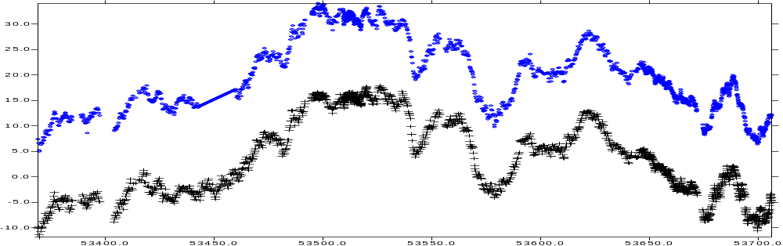
X band
KU band
Fig. 5-1a 2005 one year comparison of TW KU with X bands / ns

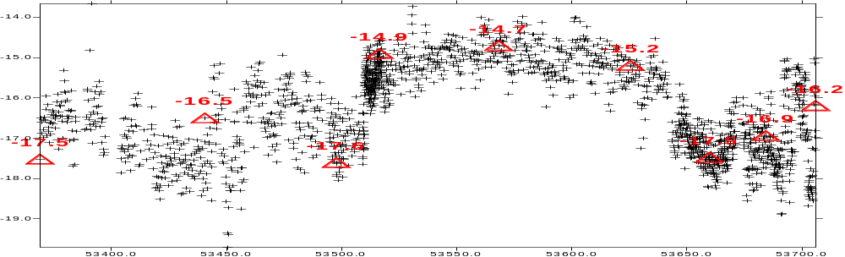
Fig. 5-1b 2005 one year difference of TW KU and X bands / ns

Table 5-1 gives the statistics of the differences shown in Figures 5-1, 5-2 and 5-3: the sigma is 1.085 ns for the differences of the TW KU - X bands (Figures 5-1a and 1b); 1.160 ns for TW KU band – GPS (Figures 5-2a and 2b) and 0.914 ns for TW X band – GPS (Figures 5-3a and 3b). Based on this one year’s long term analysis, we can conclude that at one ns level the KU band and X band are nearly identical in view of long term stability.

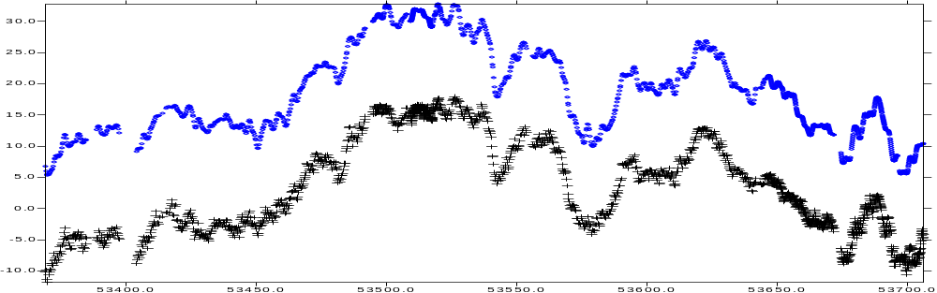
KU band
X band
Fig. 5-2a 2005 one year comparison of TW KU band with GPS MC AV / ns

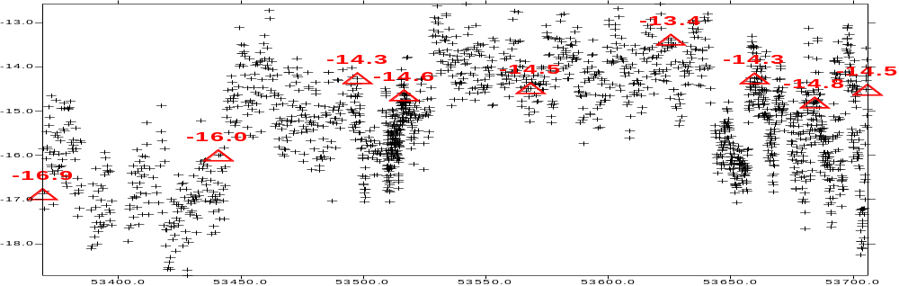
Fig. 5-2b 2005 one year difference of TW KU band and GPS MC AV / ns

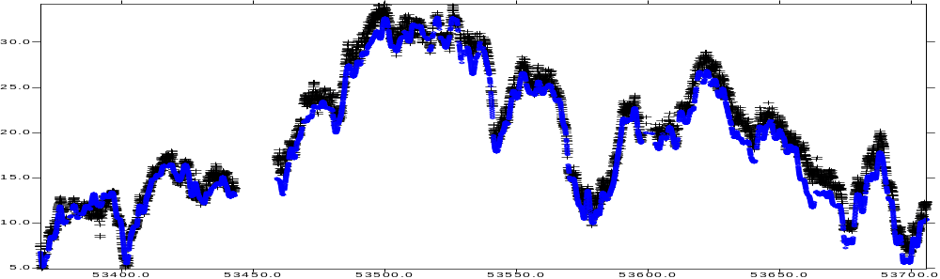
X band
GPS MC AV
Fig. 5-3a 2005 one year comparison of TW X band with GPS MC AV / ns

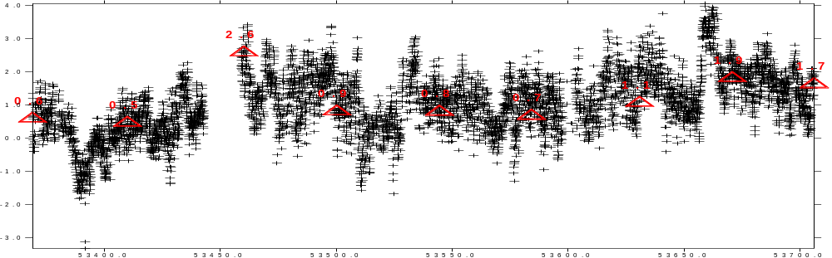
Fig. 5-3b 2005 one year difference of TW X band and GPS MC AV / ns

6. Conclusion

The time links of the baseline USNO-PTB is studied. TW KU (2 ~ 12 points/day) and X band (24 points/day) data are compared with each other. The both are compared to the GPS data. Three different terms are studied: short term (< 5 days), middle term (one month) and long term (one year).

In the year 2005, the TW KU band data were affected by 3 discontinuities up to some tens’ ns. To make the comparisons, the KU band links were bridged by the GPS P3 links. The bridging errors are estimated to be about 0.5 ns. In conclusion:

- For long term comparison, the differences between the KU band and X band, the KU band and GPS, the X band and GPS are similar: about 1 ns (one sigma)
- For the middle term comparison, the Time Deviation and residual analysis show that the X band data are more stable and less noisy and much closer to the GPS data
- For the short term comparison, we see clearly that the KU band data are affected by a diurnal periodical disturbance. This exists not only in the baseline USNO-PTB but also in other baselines, like NIST-NPL. The amplitudes of this diurnal variations are not constant. Up to 4 ns up-down variations are observed, likely depending on the local environmental conditions

The X band data are more advantageous than the KU band data to generate the TAI

Reference

[1] Jiang Z. and G. Petit: Time transfer with GPS All in View. IN: Proc. ATF 2004
[2] Personnel communications between Jiang (BIPM), Demetrios Matsakis (USNO) and Andreas Bauch and Dirk Piester (PTB): matsakis.demetrios@usno.navy.mil, Andreas.Bauch@ptb.de, zjiang@bipm.org, Dirk.Piester@ptb.de
[3] Download from USNO: ftp://tycho.usno.navy.mil/twstt/PTX/usno-ptb.xband.gz, ftp://ftp.ptb.de/pub/time/x-Band/
[4] Jiang: Smoothing and interpolation techniques for a TW measurement series - in TAI calculation, ppt presentation at the 13th CCTF TW WG Meeting, 15-16th Nov. 2005, VSL, Delft, Netherlands
[5] Jiang: TM 141: USNO-PTB TW X-band Time Link - New functions of the Tsoft

Annexes

Annex I Discontinuities of KU band vs. continuity of X band in 2005

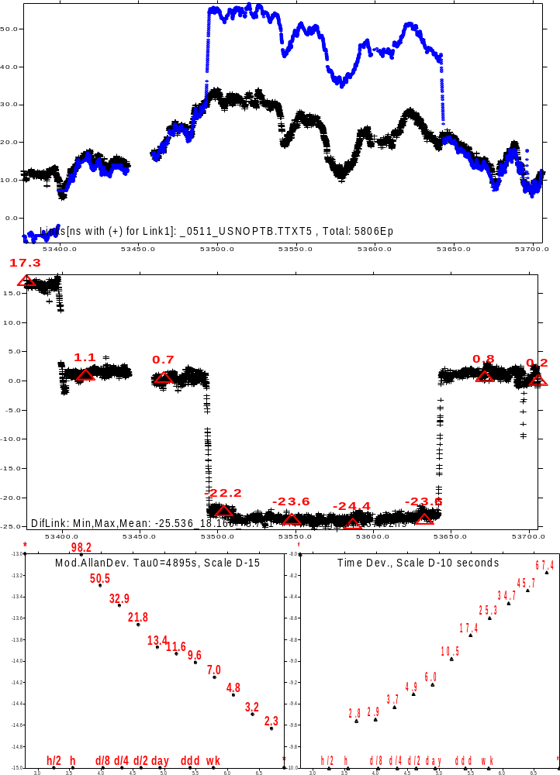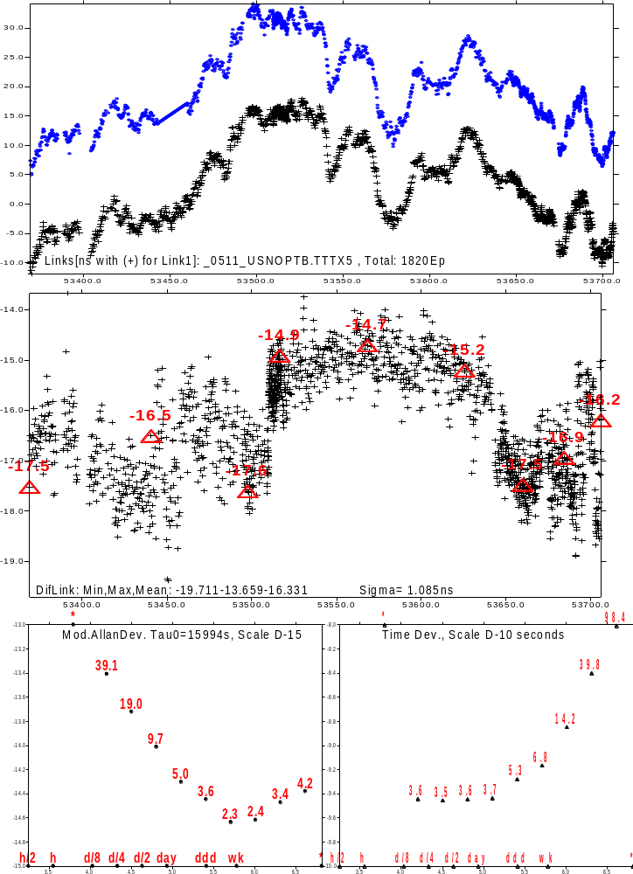
Fig. I-1a 2005 TW X band – KU band (raw)
Fig. I-1b 2005 TW X band – KU band (bridged)

Annex II Short term comparisons

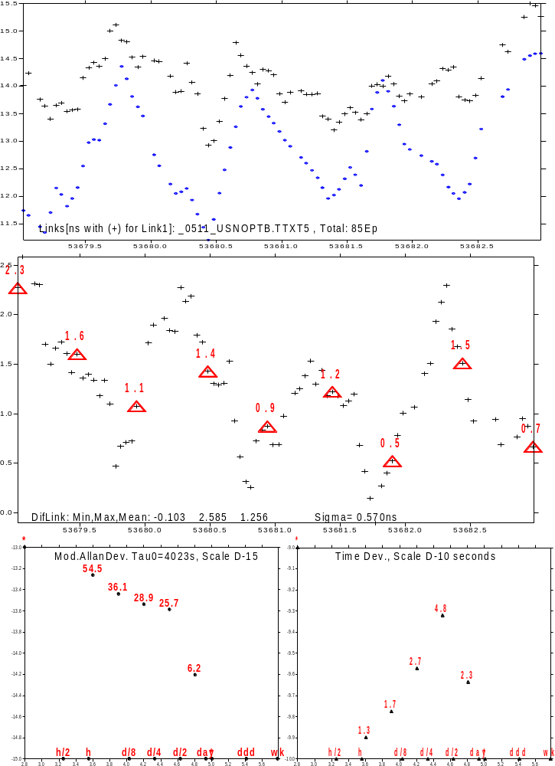
X band
KU band
KU band - X band

Diurnal variations in the TW KU Band links
Fig. II-1b 3 days’ TW 0511 KU band of NIST-NPL
Fig. II-1a 4 days’ TW: X band – KU band USNO-PTB

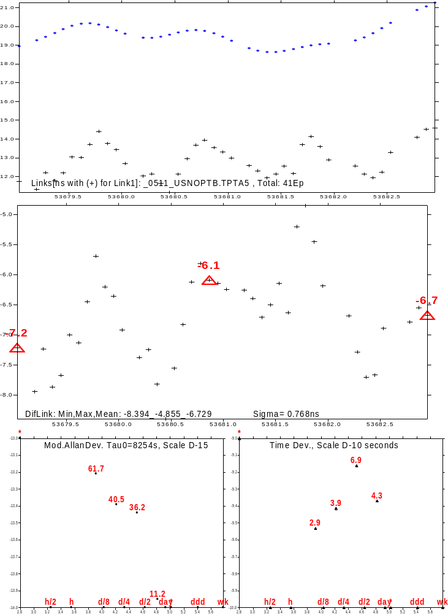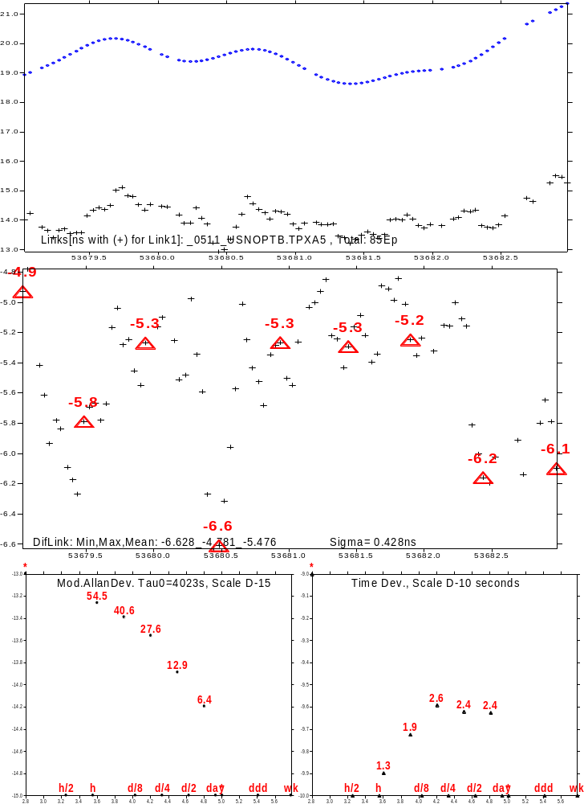
KU band
X band
GPS P3
GPS P3
Fig. II-2a 4 days’ TW KU band – GPS P3 AV
Fig. II-2b 4 days’ TW X band – GPS P3 AV

Annex III Middle term comparisons

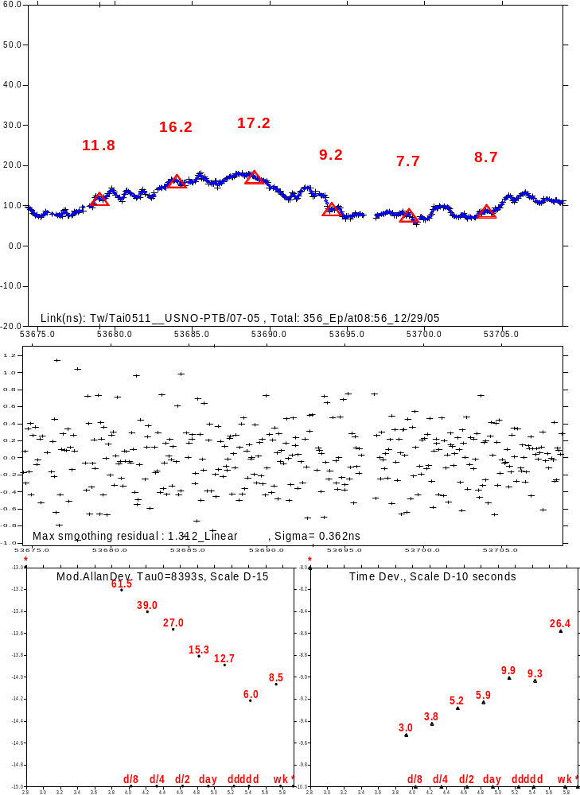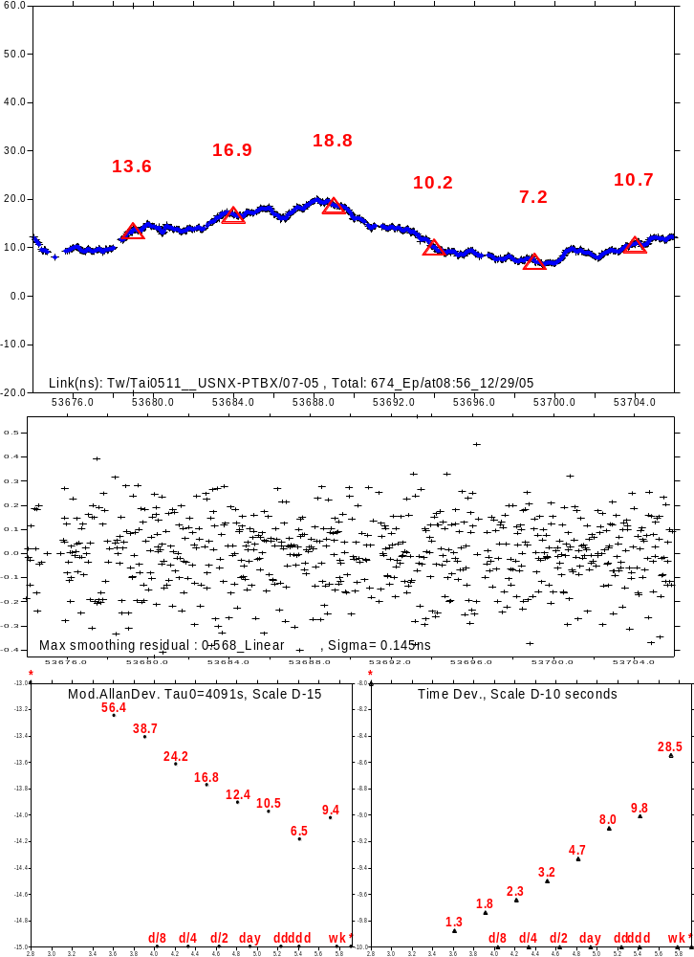
Fig. III-1b TW 0511 a month link X band USNO-PTB
Fig. III-1a TW 0511 a month link KU band USNO-PTB
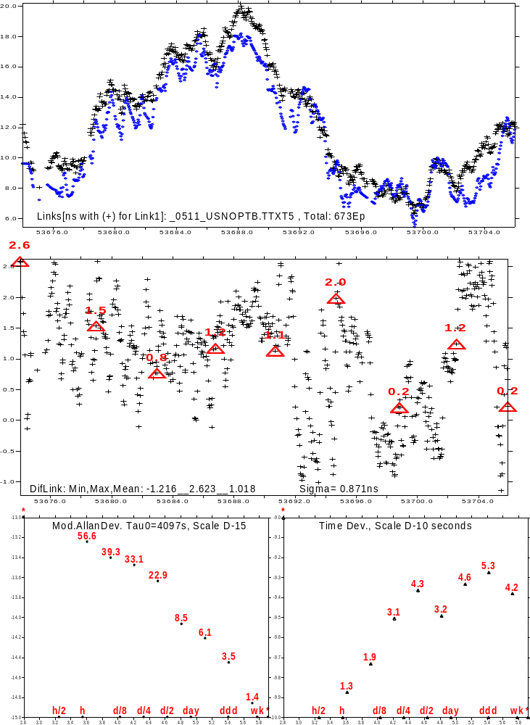
X band
KU band
Fig. III-2 TW 0511 one month comparison of KU and X bands

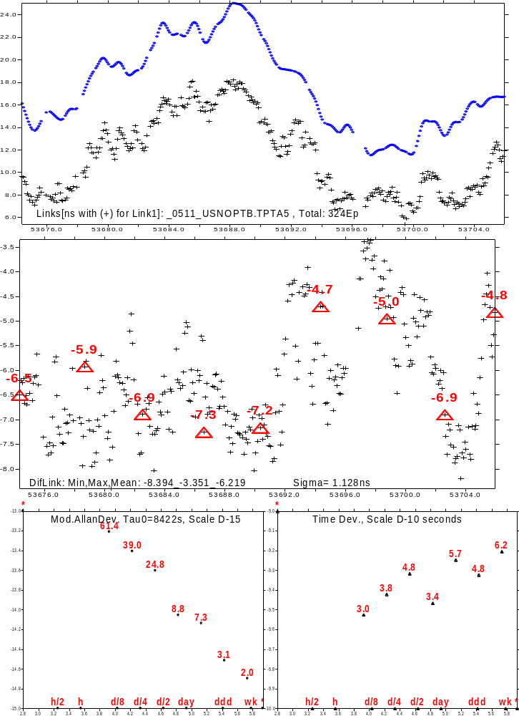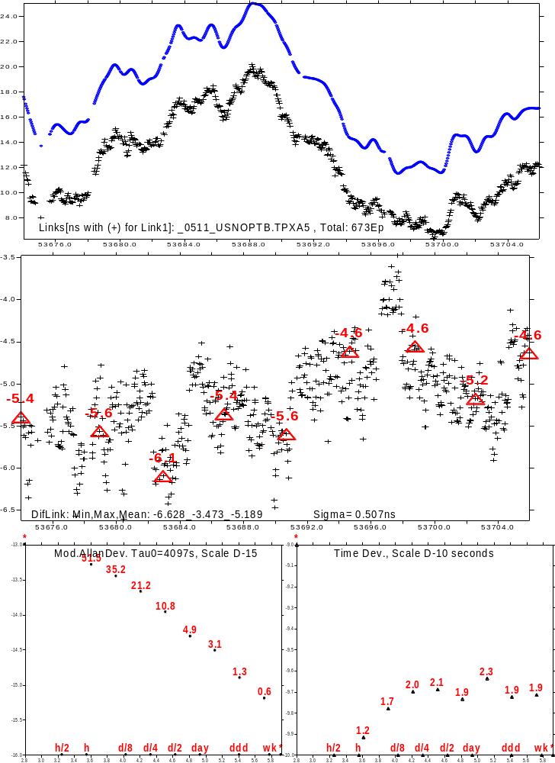
P3
P3
Fig. III-3a Comparison of KU band to GPS P3 AV
Fig. III-3b Comparison of X band to GPS P3 AV

Annex IV Long term comparisons

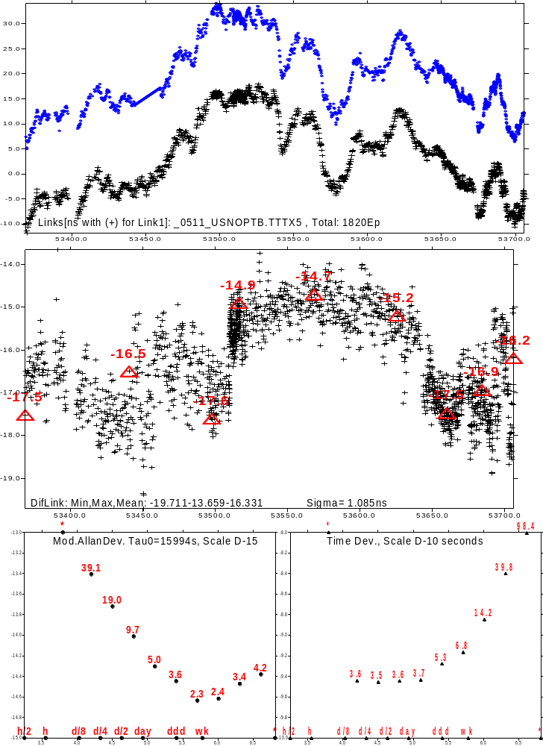
KU band
X band
Fig. IV-1 TW 2005 one year comparison of KU and X bands

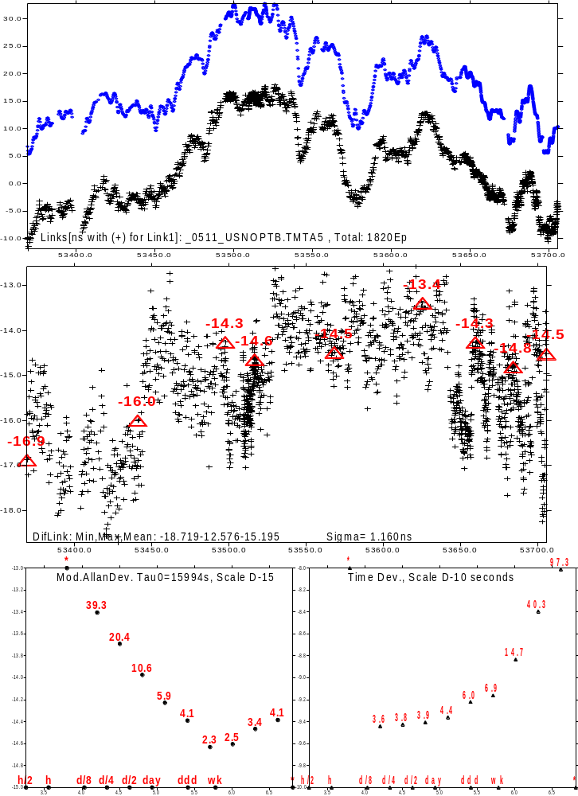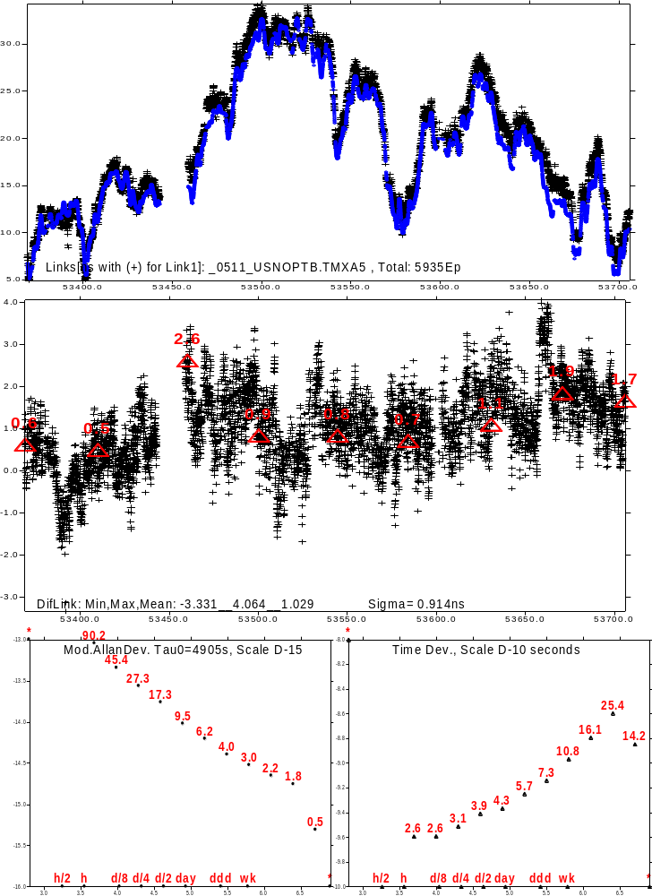
Fig. IV-2a 2005 Comparison of KU band to GPS MC AV
Fig. IV-2b 2005 Comparison of X band to GPS MC AV
GPS MC
GPS MC
X band
KU band

