- Description of equipment and operations
An internal relative calibration of three GNSS receivers has been performed with respect to a local reference receiver. The reference receiver (SP06) is previously calibrated within CAL_ID 1014-2019. Two of the calibrated receivers (SP01 and SP02) have been calibrated earlier within the same CAL_ID 1014-2019 but due to an antenna change a new calibration was necessary. Receiver SP07 (by RISE suggested BIPM code) has not been calibrated before.
The calibration is performed using measurements of the TOTAL DELAY for each frequency (L1 and L2) with respect to the corresponding, calibrated delays of SP06. Only GPS (codes P1/C1W on L1 and P2/C2W on L2) was calibrated. Table 1 summarizes the receivers involved in the relative calibration as well as the measurement period.
Table 1. Summary information on the calibration
Institute | Status of equipment | Dates of measurements | Receiver type | BIPM code | RISE code | RINEX name
RISE | Calibrated  1014-2019 | Reference | PolaRx5TR | SP06 | SP06 | RIT1
RISE | New antenna | 59075-59081 | Javad LGGD | SP01 | SP01 | SP01
RISE | New antenna | 59075-59081 | Javad LGGD | SP02 | SP02 | SP02
RISE | Not calibrated | 59075-59081 | PolaRx5TR | SP07 | SP07 | RIT2

- Receiver installations
Table 2 summarizes the receiver installations. The reference clock for all receivers is UTC(SP) 1-PPS and 5/10 MHz sinusoidal signals. The Javad receivers uses 5 MHz and the PolaRx5TR receivers 10 MHz. All receivers are fed from the corresponding antenna via a power splitter indicated in the table by RISE internal name as given in the RISE equipment register. The antenna cable type is given for reference. The fixed antenna coordinates are used when creating CGGTTS data from RINEX data as explained in Section 3.
Table 2. Summary information on receiver installations
Receiver | RISE monument name | Antenna type/  Power splitter | Antenna cable type | Fixed antenna coordinates
 |  |  |  | X | Y | Z
SP06 | Pillar 2 | LEIAR25.R4  PS14 | Andrew Heliax FSJ1-50A | 3328988.29 | 761918.19 | 5369032.01
SP01 | Pillar 1 | TRM59800.00  PS1 | Andrew Heliax LDF2-50A | 3328984.40 | 761910.47 | 5369033.95
SP02 | Pillar 1 | TRM59800.00  PS1 | Andrew Heliax LDF2-50A | 3328984.40 | 761910.47 | 5369033.95
SP07 | Pillar1 | TRM59800.00  PS1 | Andrew Heliax LDF2-50A | 3328984.40 | 761910.47 | 5369033.95
- Data used
Data from 2020-08-14 to 2020-08-20 (MJD 59075-59081) were used for the relative calibration. RINEX (ver. 3.03) data were calculated from raw data collected from each receiver with software JPS2RIN (ver. 2.0.137) for the Javad receivers and software SBF2RIN (ver. 11.3.2) for the Septentrio receivers. CGGTTS data were calculated from RINEX data using the software RISEGNSS [1] developed at RISE.

- Results of raw data processing
Table 3 summarizes the calculated delay differences for each receiver relative to the calibrated reference receiver SP06. The results are presented as the mean difference of the Total Delay for each frequency/code relative to the calibrated values for SP06 (ΔTOTDLY) of CAL_ID 1014-2019. The statistical uncertainty u_{a} represented by the rms of the raw data processing, is given for each receiver pair. Annex A shows plots of raw data and Tdev analysis.
Table 3. Summary of the raw calibration results (all values in ns)
Pair | Date | ΔTOTDLY (P1/C1W) | u_{aP1} | ΔTOTDLY (P2/C2W) | u_{aP2}
SP06-SP01 | 59075-59081 | 242.7 | 0.12 | 251.5 | 0.13
SP06-SP02 | 59075-59081 | 244.1 | 0.12 | 250.3 | 0.15
SP06-SP07 | 59075-59081 | 231.6 | 0.12 | 228.0 | 0.08
- Uncertainty estimation
Table 4 summarizes the statistical uncertainty contributions for ΔTOTDLY for each receiver pair listed in Table 3. The statistical uncertainty u_{a} is represented by the RMS of the raw calibration results. These values are also given in Table 3.
Table 4. Statistical uncertainty contributions (all values in ns)
Pair | u_{aP1} | u_{aP2} | Description
SP06-SP01 | 0.12 | 0.13 | RMS of raw data difference
SP06-SP02 | 0.12 | 0.15 | RMS of raw data difference
SP06-SP07 | 0.12 | 0.08 | RMS of raw data difference
Table 5 summarizes the systematic uncertainty that is attributed to the calibration uncertainty of SP06 and the same for all receiver pairs. The total systematic uncertainty is calculated as
$u_{b,TOT}=\sqrt{\sum_{n}{u_{b,n}^{2}}}$
Table 5. Systematic uncertainty contributions (all values in ns)
Uncertainty | Value P1/C1W | Value P2/C2W | Description
u_{b,1} | 2.5 | 2.5 | Calibrated Total Delay of SP06 (1014-2019)
u_{b,2} | 0.5 | 0.5 | Aging of SP06 since 2019-03
u_{b,TOT} | 2.6 | 2.6

- Calibration results

Table 6 summarizes the calibration results. For reference, the present calibration values from CAL_ID 1014-2919 are given for SP06.

The combined uncertainty u_{CAL} is calculated as
$$u_{CAL}=\sqrt{u_{a}^{2}+u_{b}^{2}}$$
and the TOTDLY for P3 is calculated as P1 + 1.545*(P1-P2).

As the systematic uncertainty u_{b,TOT} dominates u_{CAL}, the combined uncertainty for the TOTDLY (P1, P2, and P3) and for all calibrated receivers given in Table 6 is 2.6 ns.

Table 6. Summary of relative calibration results (all values in ns)
Reference system | Cal_ID | Date | TOTDLY  (P1/C1W) | TOTDLY (P2/C2W) | TOTDLY (P3)
SP06 | 1014-2019 | 2019-03 | 273.5 | 269.7 | 279.4
Calibrated system |  | Date | TOTDLY (P1/C1W) | TOTDLY (P2/C2W) | TOTDLY (P3)
SP01 |  | 2020-08 | 242.7 | 251.5 | 229.1
SP02 |  | 2020-08 | 244.1 | 250.3 | 234.5
SP07 |  | 2020-08 | 231.6 | 228.0 | 237.2

References
[1] K. Jaldehag, P. Jarlemark, and C. Rieck, “Further Evaluation of CGGTTS Time Transfer Software, “in Proc. of the 2019 Joint Conference of the IEEE International Frequency Control Symposium and European Frequency and Time Forum (EFTF/IFC), Orlando, Florida, USA, 2019.

RISE Research Institutes of Sweden AB
Measurement Science and Technology - Time and Optics
Performed by
__Signature_1 | __Signature_2
Kenneth Jaldehag

ANNEX A: Plots of raw data and Tdev analysis

SP01
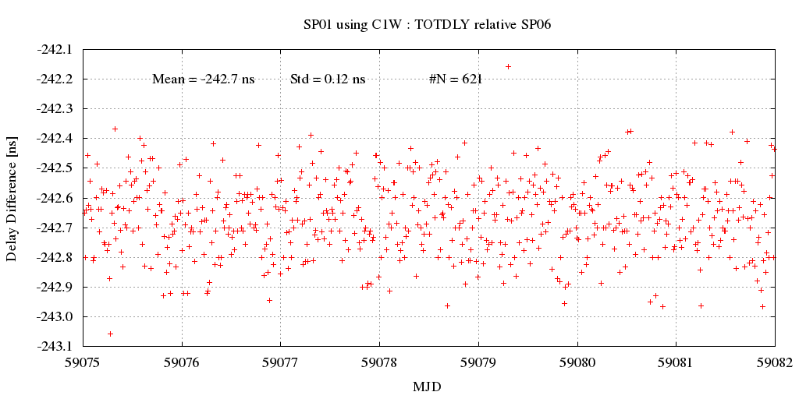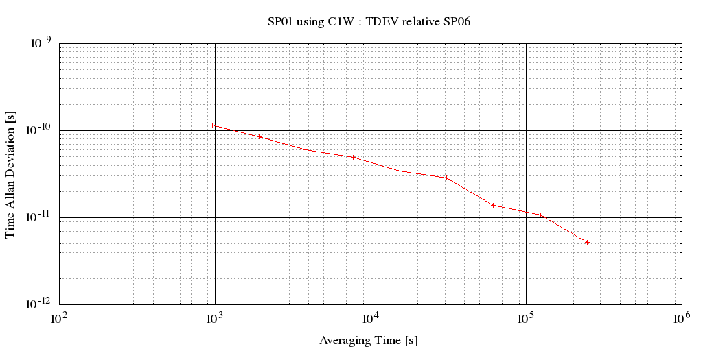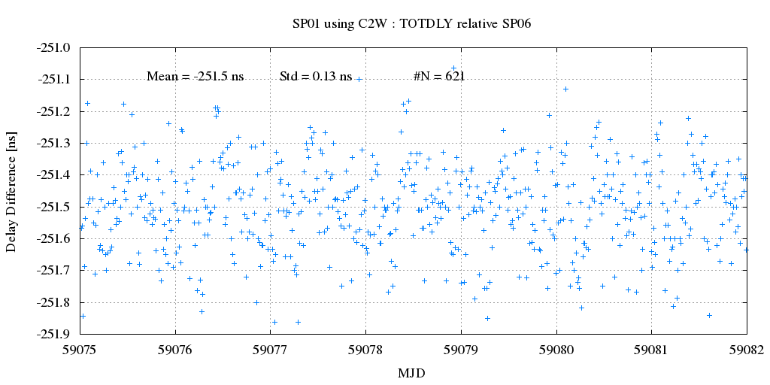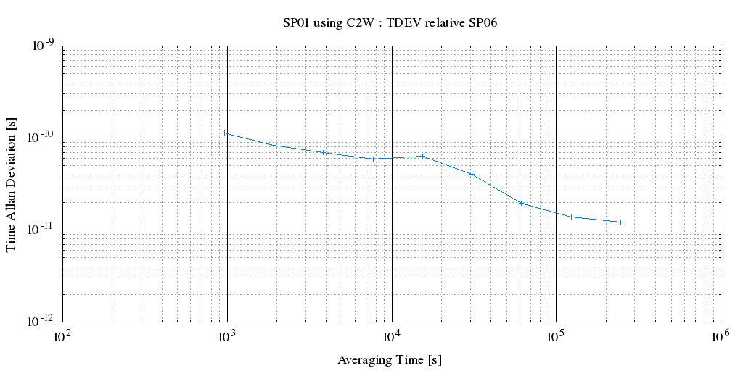
SP02
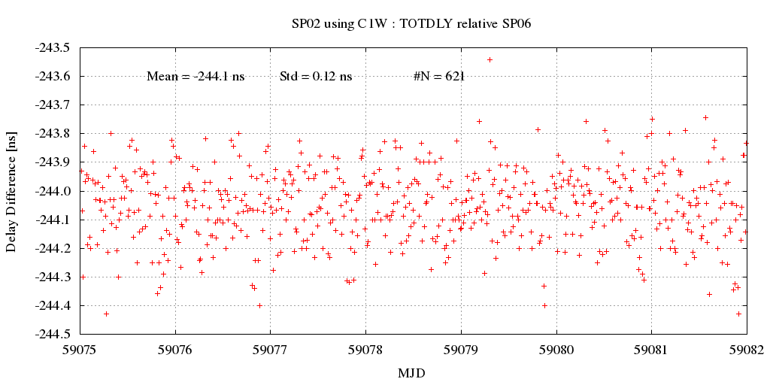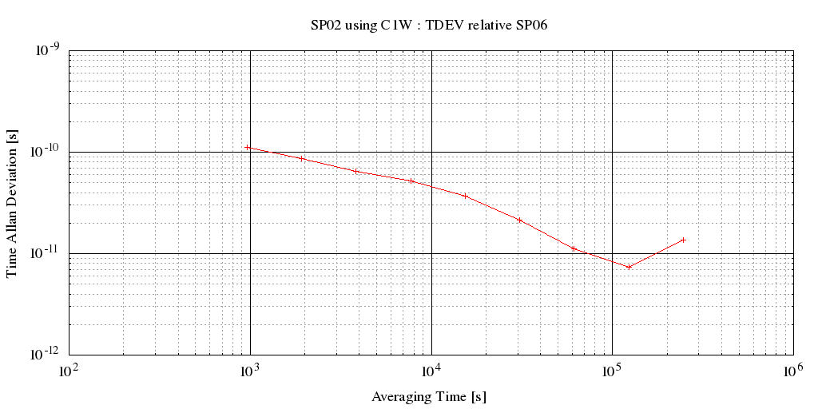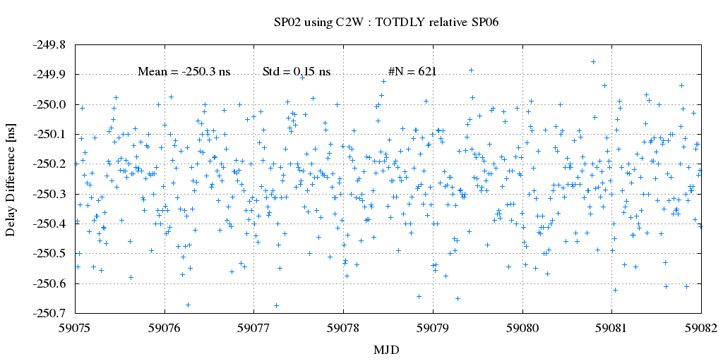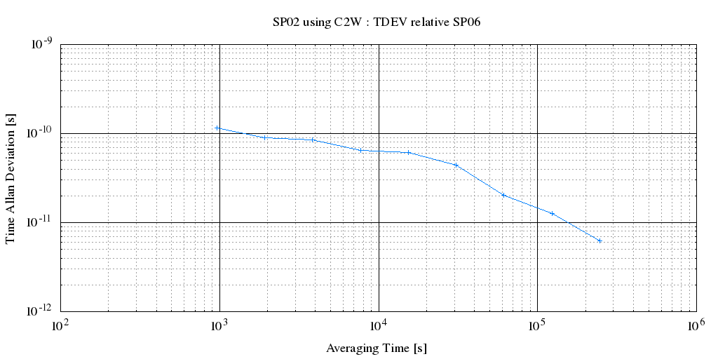
SP07
